Experimental demonstration of vectorial spin-orbital Hall effect of light

A.Porfirev¹, S. Khonina¹, A. Ustinov¹, N. Ivliev¹ and I. Golub²
¹Image Processing Systems Institute of RAS—Branch of the FSRC “Crystallography and Photonics” RAS, Samara, Russia
²School of Advanced Technology, Algonquin College, Ottawa, Canada
e-mail:porfirev.alexey@gmail.com

Spin-orbital Hall effect of light Hall effect of light is known as a one of the most prominent effects due to breaking the symmetry of a light field. It is obtained when an asymmetric light beam possessing spin or orbital angular momentum (SAM or OAM) is tightly focused and the effect is manifested in a shift of barycenter/center of gravity of light in the transverse focal plane. Here, we investigate asymmetric beams shifted from the optical axis. An asymmetric input beam with SAM and/or OAM will obviously have a non-uniform input angular momentum (AM) with transverse and longitudinal components [1, 2]. Since the AM components depend on electric field components, the focal plane electric field distribution has to reflect the presence of AM and thus has to differ from the symmetrical focal plane distribution exhibited when focusing a linear polarized asymmetric input beam. This is achieved by shifts of the barycenters of the field components in the focus in order to produce the required AM components.
There are materials that can be used for direct visualization of the longitudinal component of light. For example, our recent studies have shown the high sensitivity of azobenzene molecules to this component of laser radiation [3]. In this work, we experimentally demonstrated, for the first time, to the best of our knowledge, the spin-orbit Hall effect of light upon tight focusing in free space. We have shown that in spin-orbital Hall effect of light upon tight focusing of an asymmetric beam, different Cartesian components in the focus are shifted, perpendicular to the symmetry breaking axis by different amounts and in different directions (see Fig. 1). These findings elucidate the Hall effect of light and may broaden the spectrum of its applications. The work was supported by the Russian Science Foundation grant No. 22-79-10007.

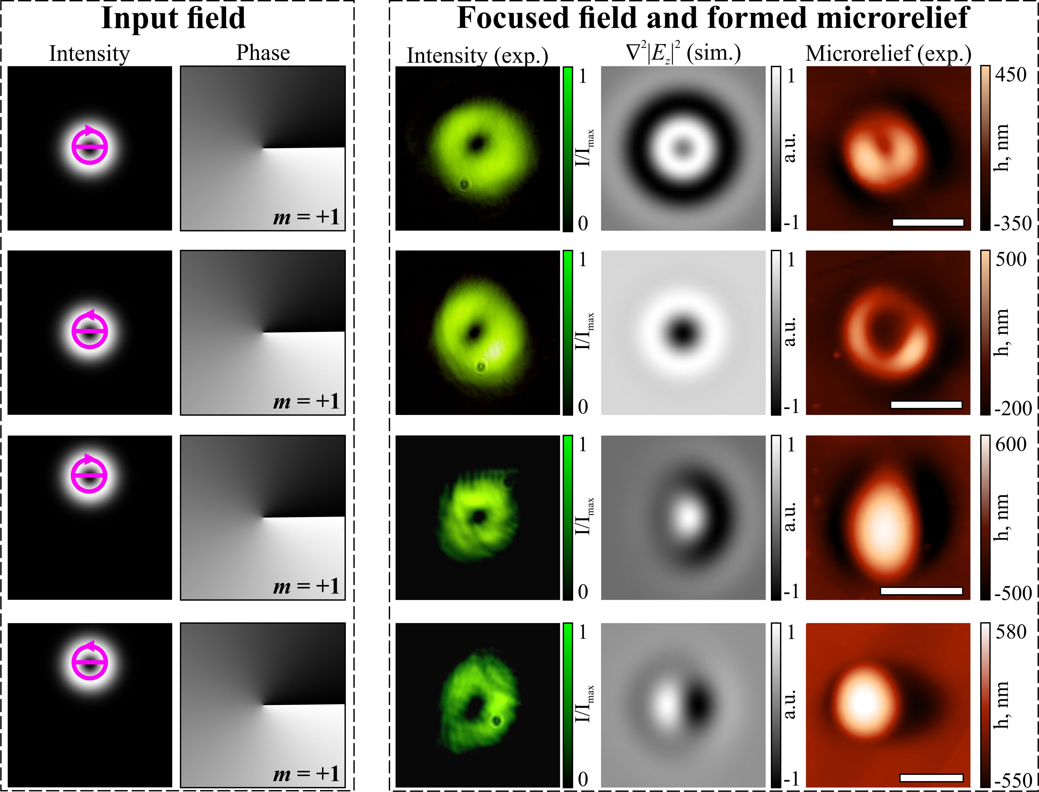

Figure 1. Laser patterning of an azopolymer thin film with right- and left handed circularly polarized on- and off-axis OV beams of ±1 order.

REFERENCES
[1] K. Bliokh, M.A. Alonso, E.A. Ostrovskaya, A. Aiello, Phys. Rev. A 82, 063825 (2010).
[2] W. Zhu, W. She, Opt. Lett. 39, 1337 (2014).
[3] A. Porfirev, S. Khonina, N. Ivliev, A. Meshalkin, E. Achimova, A. Forbes, Sci. Rep. 12, 1 (2022).

