Optical interconnects and filters based on waveguide arrays

Jelena Krsic¹, Mirjana Stojanovic¹, Kolja Bugarski^{1,2}, Nikola Stojanovic³, Aleksandra Maluckov¹,
Peter Veerman⁴, Jovana Petrovic¹
¹Vinca Institute of Nuclear Sciences, National Institute of the Republic of Serbia, University of Belgrade, Serbia
²School of Electrical Engineering, University of Belgrade, Serbia
³Deutsches Zentrum für Luft- und Raumfahrt (DLR),Berlin, Germany
⁴Portland State University, Oregon, US
E-mail: mirjana.stojanovic@vin.bg.ac.rs

Rapidly increasing demand for higher data bandwidths has motivated exploration of new communication channels based on spatially multiplexed in-fibre and on-chip coupled light guides [1]. However, the conventionally used periodically arranged coupled waveguides display complicated light propagation patterns, ranging from quasiperiodic to nearly chaotic. Taking a different approach, we spectrally engineer interwaveguide coupling to instigate self-imaging of the input light state at the array output and thus enable construction of novel high-fidelity interconnects [2]. Simple implementation via modulation of the interwaveguide separations makes these interconnects realizable in all fabrication platforms.
Moreover, the wavelength dependent self-imaging opens up possibilities for construction of new multiplexing devices [3]. Here, we present designs of band-pass filters and dichroic splitters for VIS and NIR and propose the strategies for selection of their central wavelengths and bandwidths.

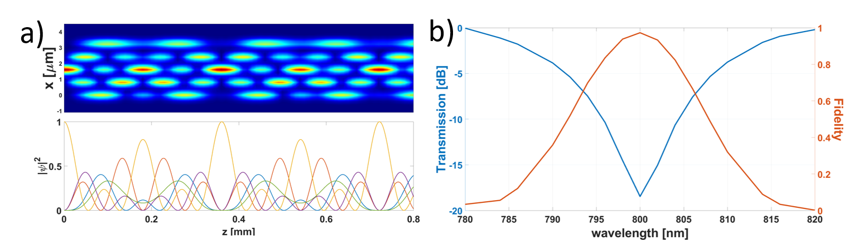

Figure 1. a) Self-imaging in a SiN array composed of 5 waveguides. b) Transmission and fidelity of transfer after the 1st revival period at z = 0.36 mm [3].

REFERENCES

[1] B.J. Puttnam, G. Rademacher, R.S. Luís, Optica 8, 1186 (2021).
[2] J. Petrovic, J. Veerman, Ann. Phys. 392, 128 (2018).
[3] J. Petrovic, J. Krsic et al., J. Opt. Las. Technol. 163, 109381 (2023).

