Anti-cancer and imaging potential of fluorescent black carrot Carbon Dot nanoparticles

M. D. Nešić¹, J. Filipović Tričković², A. Valenta Šobot², J. Žakula³, L. Korićanac³, I. Popović ¹, J. Soto⁴, M. Algarra⁵, V. Ralić¹, A. Abu el Rub¹, M. Stepić¹, and M. Petković¹

¹ Center for Light-Based Research and Technologies COHERENCE, Department of Atomic Physics, Vinča Institute of Nuclear Sciences, National Institute of the Republic of Serbia, University of Belgrade, Belgrade, Serbia
² Department of Physical Chemistry, Vinča Institute of Nuclear Sciences, National Institute of the Republic of Serbia, University of Belgrade, Belgrade, Serbia
³ Department of Molecular Biology and Endocrinology, Vinča Institute of Nuclear Sciences, National Institute of the Republic of Serbia, University of Belgrade, Belgrade, Serbia
⁴ Department of Inorganic Chemistry, Faculty of Sciences, University of Málaga, Málaga, Spain
⁵ INAMAT2—Institute for Advanced Materials and Mathematics, Department of Science, Public University of Navarre, Pamplona, Spain

e-mail: maki@vin.bg.ac.rs

Carbon dots (CDs) are biocompatible, fluorescent, water-soluble, and stable nanoparticles with a high potential to be used for vast biomedical applications [1,2]. We explore the application of CDs produced from natural sources, black carrots, as anti-cancer and imaging agents.
These nanoparticles suppress cell growth of three different cancer cell lines, cervical (HeLa), pancreatic (PANC-1), and melanoma (A375) cell lines in vitro. However, the cytotoxic effect against A375 cells stands out, with only 20% of viable cells left after treatment (Fig.1(a)), antimetastatic potential, and a selectivity index higher than two, which indicates that the efficacy against melanoma cells is significantly greater than the toxicity against non-malignant cells (MRC-5).
Furthermore, after the cellular uptake, green fluorescence was visible in the cytosol of A375 cells (Fig. 1 (b)). On the other hand, the DAPI stain for DNA was visible as a blue light in the cell nucleus. Moreover, cells with a higher intensity of green fluorescence in the nucleus, Fig. 1 (c) indicated with arrows, were the cells with condensed chromatin in the mitotic phase of the cell cycle (Fig. 1 (d) and (e)), which indicates that CDs interact with chromatin and that they could be used as a marker of cells mitosis and proliferation.
In summary, we have demonstrated the great anti-cancer potential of black carrot CDs, for image-guided anti-cancer therapy of melanoma that can be used to recognize cell proliferation.
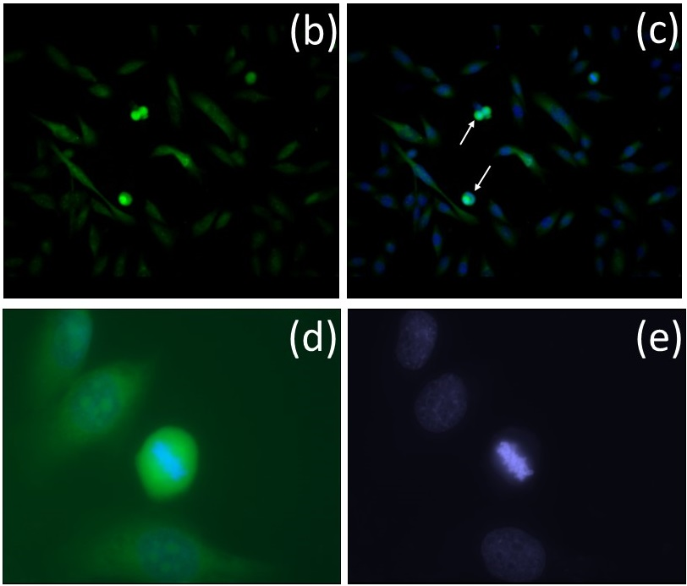
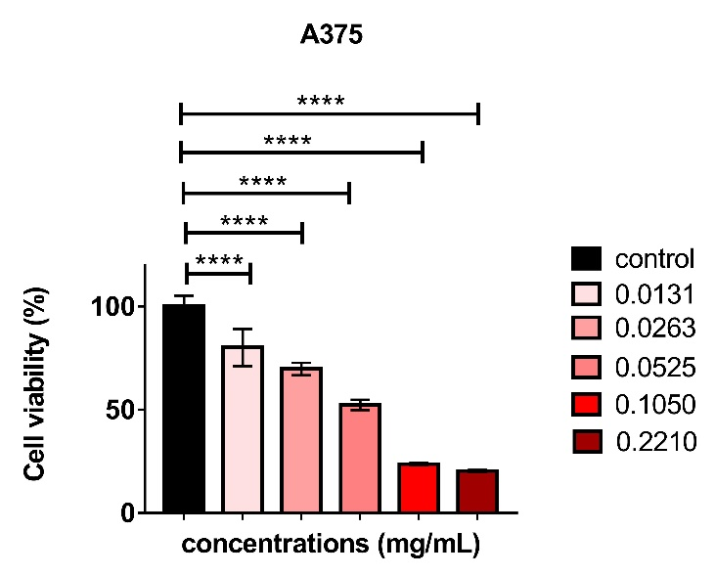
(a)

Figure 1. CDs cytotoxicity (a) and Fluorescence Microscopy image of A375 cells treated with CDs, stained with DAPI, and acquired with green (b) and merged blue and green channels (20x magnification). 100x magnified region of cell with a higher intensity of green fluorescence (d), also acquired with blue channel (e).
REFERENCES
[1] J. Liu, R. Li, B. Yang, ACS Cent. Sci. 6, 2179 (2020).
[2] H. Ehtesabi, Z. Hallaji, S. Najafi Nobar, Z. Bagheri, Microchim. Acta. 187, 150 (2020).

ACKNOWLEDGMENTS; M.A. thank the Spanish Ministry of Science and Innovation (MCIN/AEI/10.13039/501100011033) through the project PID2021-122613OB-I00.

