**Non-Linear Excitation Fluorescence Imaging through**

**Two-Photon Laser Polymerized Microlenses**

G. Chirico1, M. Marini1, R. Martínez Vázquez2, R.Osellame2, A. Nardini3, C. Conci3, E. Jacchetti3, D. Panzeri1, L. Sironi1, M. Bouzin1, M. Collini1, D. Inverso4, B.S. Kariman5, E. Kabouraki6, M. Farsari6, , G. Cerullo5 and M.T. Raimondi3

*1 Dept. of Physics, Università di Milano-Bicocca, Milan, Italy*

*2 Institute for Photonics and Nanotechnologies (IFN)-, CNR Politecnico di Milano, Milan, Italy*

*3 Dept. of Chemistry,Materials and Chemical Engineering “Giulio Natta”, Politecnico di Milano, Milan, Italy*

*4 Div. of Immunology, IRCCS San Raffaele Scientific Institute, Vita-Salute San Raffaele University, Milan, Italy.*

*5 Dept. of Physics, Politecnico di Milano, Milan, Italy*

*6 Forth- Institute for Electronic Structure and Lasers, Heraklion, Crete, Greece*

e-mail:Giuseppe.chirico@unimib.it

# We report on methods for laser fabrication of microlenses by 2 Photon Polymerization (2PP) and their use for non-linear excitation microscopy. These lenses can help, once implanted, to reduce the spherical aberrations induced by the tissue in *in vivo* imaging.

Microlenses have already been fabricated by 2PP [1] but with too low numerical aperture to allow non-linear excitation microscopy. Therefore, up to now, no attempt has been made to use laser fabricated microlenses for non-linear excitation fluorescence microscopy of biological samples.

We show that microlenses with high numerical aperture (0.4) and large diameter (280 $μm$), can be fabricated with a medium throughput, about 8 minutes/lens, by limiting the 2PP fabrication to a ≃ 5 $μm$ thick outer crust, followed by a post-development volume polymerization. This procedure leads to sufficient optical quality (roughness ≃ 80nm) to use the lenses for fluorescence confocal and two-photon excitation microscopy. We report on the use of the microlenses for fluorescence non-linear excitation microscopy of cells cultures (Figure 1) and thick specimens [2].

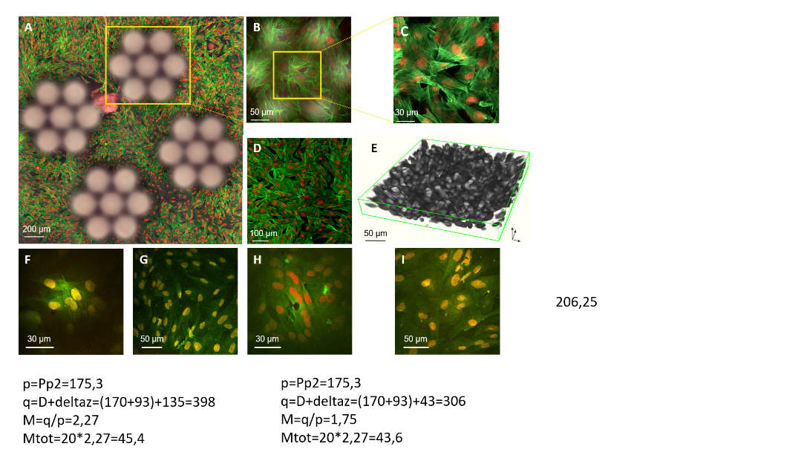

**Figure 1. A:** Confocal image of human fibroblasts (FITC-phallodin, cytoskeleton and DRAQ5/Hoechst, nuclei staining). **B**: fluorescence confocal image through a microlenses array. **C**: Cropped scan area through a single microlens. **D**: Full field-of-view confocal microscope image of cells at the glass coverslip focal plane (20x dry objective for **A-D**). **E**: 3D reconstruction of cells through an array of microlenses. **F-I:** Fluorescence images of the cells under two-photon excitation ($λ=800 nm)$. **F**: Fluorescence image through the microlenses coupled to a 20x dry objective. **G**: Control image through the 20x dry objective. **H**: Image of the cells through the microlenses coupled to a 25x water immersion objective. **I:** Control image through the 25x water immersion objective.

This work opens the possibility to use implanted micro-lenses for non-linear excitation of tissues, allowing the direct and continuous optical inspection of biological dynamics in vivo.

REFERENCES

[1] D. Gonzalez-Hernandez, B. Sanchez-Padilla, D. Gaileviˇcius, et al. *Adv. Optical Mater*., 2300258, 2023.

[5] M. Marini, A. Nardini, R. Martínez Vázquez et al. *Adv. Fun. Mater.* 2213926, 2023.

Acknowledgments.This project has received funding from the EU Horizon 2020 programme (G.A. No 964481)**.**