Selective ablation and laser induced periodical surface structures (LIPSS) produced on (Ni/Ti) nano layer thin film with ultrafast laser pulses
S. Petrović¹, B. Gaković¹, C. Siogka², D. Milovanović³, G. Tsibidis²
¹Vinča Institute of Nuclear Sciences, Belgrade, Serbia
²Institute of Electronic Structure and Laser (FORTH), Heraklion, Greece
³Institute of General and Physical Chemistry, Belgrade, Serbia

Nano layer thin films (NLTF), composed of alternating layers of various materials, are widely used in modern nanotechnology. Using ultrafast lasers for processing is a precise non-contact method. Single pulses can be used to remove NLTF from the substrate or to accurately and selectively ablate one or more layers of the film's surface. Selective ablation can only be achieved at specified values of the laser beam's properties for a given material [1-3]. On practically any material, a laser beam can be used to produce the universal phenomena known as "laser-induced periodic surface structures" (LIPSSs). They are created by exposing the sample's surface to multi-pulse irradiation and have a variety of applications [4,5]. The existence of an interface between the two nano layers can influence both processes.
The interaction of ultrafast laser pulses with Nickel/Titanium (Ni/Ti) thin film was investigated. The NLTF, composed of ten alternating Ni and Ti layers, was deposited on silicon (Si) substrate by ion-sputtering. A single and multi-pulse irradiation was done in air with focused and linearly polarized laser pulses (wavelength 1026 nm and pulse duration 170 fs). For achieving selective ablation, the single pulse energy was gradually increased from near the ablation threshold to a level that completely removed the NLTF. The pulse energy for LIPSS creation was close to the ablation threshold of the NLTF. The laser induced morphology and the elemental composition changes were examined with microscopy, optical profilometry and energy dispersive X-ray spectroscopy. To interpret the experimental observations, theoretical simulation has been performed to explore the thermal response of the NLTF after irradiation with single laser pulses.
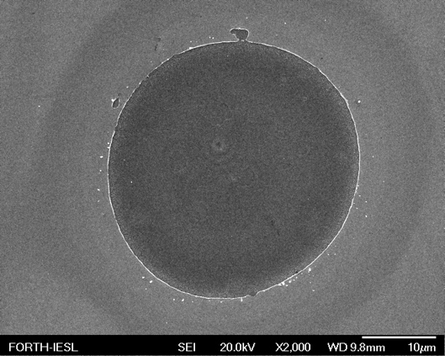
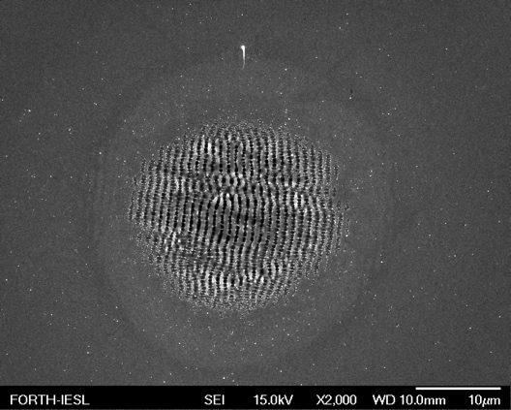

Figure 1. SEM micrographs of the (Ni/Ti) surface after single pulse ablation of the first Ni layer at fluence of 0.2 J/cm² (left), and LIPSS formation after 10 pulses at 0.08 J/cm² (right).

REFERENCES
1. Chengping Wu and L. V. Zhigilei, Applied Physics A, 114 (2014) 11–32.
2. B. Gaković et al., Journal of Applied Physics, 122 (2017) 223106.
3. B. Gaković et al., European Physical Journal D, 75 (2021) 288.
4. S. Petrovic et al., Phys J D, 75 (2021) 304.
5. J. Bonse and S. Gräf, Laser Photonics Rev.,14 (2020) 2000215.

