Metal ion implanted TiN thin films: Induced effects on structural and optical properties

M. Popović¹, M. Novaković¹, D. Pjević¹, D. Vaňa², D. Jugović³, P. Noga²
¹Department of atomic physics, Vinča Institute of Nuclear Sciences - National Institute of thе Republic of Serbia, University of Belgrade, Belgrade, Serbia
²Slovak University of Technology in Bratislava, Faculty of Materials Science and Technology in Trnava, Advanced Technologies Research Institute, Trnava, Slovakia
³Institute of Technical Sciences of SASA, Belgrade, Serbia
e-mail:majap@vinca.rs

The ion implantation technique has a number of advantages over conventional methods for the improvement of thin films that offer the various possibilities of their use in different industrial and technological fields. Herein, we present the effects of metal ion implantation on the structural and optical properties of TiN thin films. TiN films of 170 nm thickness were grown by d.c. reactive sputtering on Si (100) wafers and then irradiated at 5×10¹⁶ ions/cm² with either Au, Ag, or Cu ions by using two different energies per each implanted metal. The results showed that as deposited TiN crystallizes in form of fcc cubic structure, with the crystallites preferentially oriented along the (111) plane. For all implanted layers the cubic crystallographic structure was preserved, but compared to as deposited TiN the crystallites were smaller and the lattice was contracted. Besides, the surface compositional analysis of as deposited sample showed the coexistence of TiN, TiO₂ and TiO_{x}N_{y} phases and this was related to the surface oxidation of the films due to the exposure to air. After implantation, the results were almost similar for all metals, showing an increase in TiO₂ contribution and the formation of pure metallic Au and Ag phases, while copper is in the Cu²⁺ state, which is attributed to Cu(II)-oxide and Cu(OH)₂. The microstructural characteristics including defect formation, changes in the crystallite size and lattice contraction, and also growth of different metallic phases during implantations were correlated with the findings of the optical characterization of the implanted films. For as deposited film we found energy gap of 2.91 eV, which was lower than the value typical for TiN. After implantation the gap was shifted to higher energies, while at the visible part of the region, additional energy levels, at photon energies below 2.9 eV were observed. Further, all implanted films showed degraded photocatalytic activity compared to as deposited TiN, among which Cu-implanted samples exhibited the best photocatalytic performances. The lower photocatalytic activity of Au and Ag implanted films compared to Cu implantations was ascribed to larger structural defects and formation of less favorable electronic states.

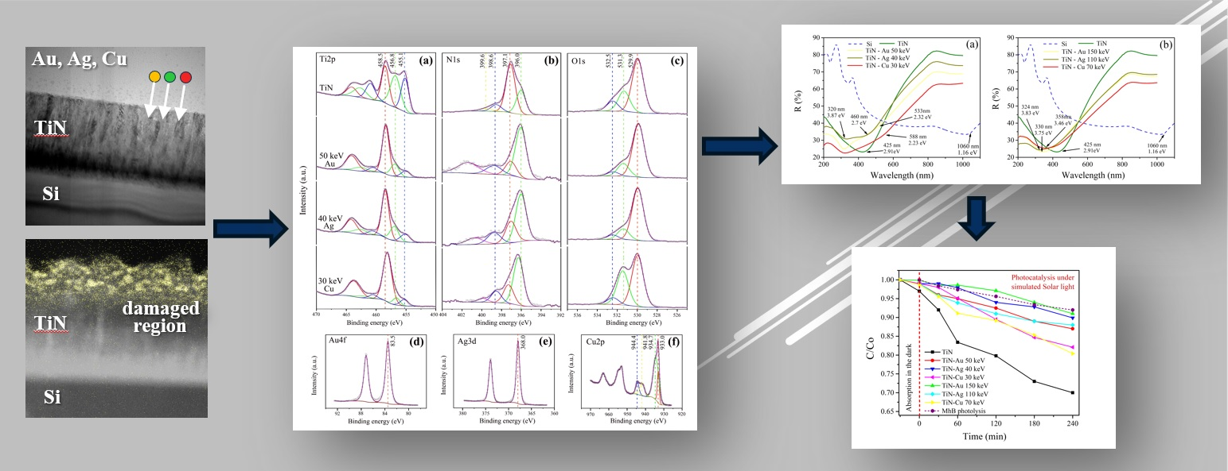

Figure 1. The results of structural, compositional and optical analyses of Au, Ag and Cu implanted TiN thin films.

