Carbon quantum dots/silver based metal organic framework composites in light enhanced wound healing

I. Popović¹, A. Valenta Šobot², J. Filipović Tričković², L. Korićanac³, J. Žakula³, V. Ralić¹, A. Abu el Rub¹, M. Algarra⁴, M. Petković¹, M. Stepić¹, M. D. Nešić¹
¹ Center for Light-Based Research and Technologies COHERENCE, Department of Atomic Physics, Vinča Institute of Nuclear Sciences, National Institute of the Republic of Serbia, University of Belgrade, Belgrade, Serbia
² Department of Physical Chemistry, Vinča Institute of Nuclear Sciences, National Institute of the Republic of Serbia, University of Belgrade, Belgrade, Serbia
³ Department of Molecular Biology and Endocrinology, Vinča Institute of Nuclear Sciences, National Institute of the Republic of Serbia, University of Belgrade, Belgrade, Serbia
⁴ INAMAT2—Institute for Advanced Materials and Mathematics, Department of Science, Public University of Navarre, Pamplona, Spain

e-mail: ivavukicevic@vin.bg.ac.rs

In recent years researchers have developed new strategies to enhance the effectiveness of wound healing by combining nanoparticles and infra red (IR) light. For example, some studies have shown that nanoparticles can be used to enhance the absorption of near-infrared laser (NIR) light by tissues, leading to increased healing rates [1].
The influence of NIR light on proliferation, collagen production, and wound healing was tested on: keratocytes (HaCaT) and fibroblasts (MRC-5) cells that are used as model systems of human skin equivalents that comprise an epidermal and a dermal compartment of skin. Also, these cells were treated with carbon quantum dots/silver-based metal-organic framework composites (Ag-MoFs-NCDs and Ag-MoFs-SCDs), which previously showed high antibacterial activity [2], without and with laser light.
Firstly, we have found the most convenient and effective CW laser intensity (16 mW/cm²) and illumination time (3 minutes), which is not too high and short enough to influence human cells' proliferation and metabolism positively. Additional chemical treatment with Ag-MoFs-NCDs and Ag-MoFs-SCDs results in a further increase in human cell viability. Our measurements showed that the proliferation index in laser-illuminated cells and cells treated with Ag-MoFs-SCDs was at the level of the untreated control. Furthermore, Ag-MoFs-SCDs treatment and laser illumination induced a mild, insignificant increase in cellular proliferation. On the other hand, Ag-MoFs-NCDs treatment led to a more pronounced, albeit not significant increase, in cellular proliferation, while Ag-MoFs-NCDs treatment combined with laser illumination significantly increased proliferation.
Also, we have detected a mild change in collagen level estimated by hydroxyproline assay, which may indicate a positive outcome of combined laser illumination and treatment, taking into account that after 48 hours, a change in cell's response to the treatment could be noticed. Finally, based on migration assay, we observe a complete wound closure after 48 hours in fibroblast cells treated with Ag-MoFs-NCDs and near-infrared laser light, Fig. 1.
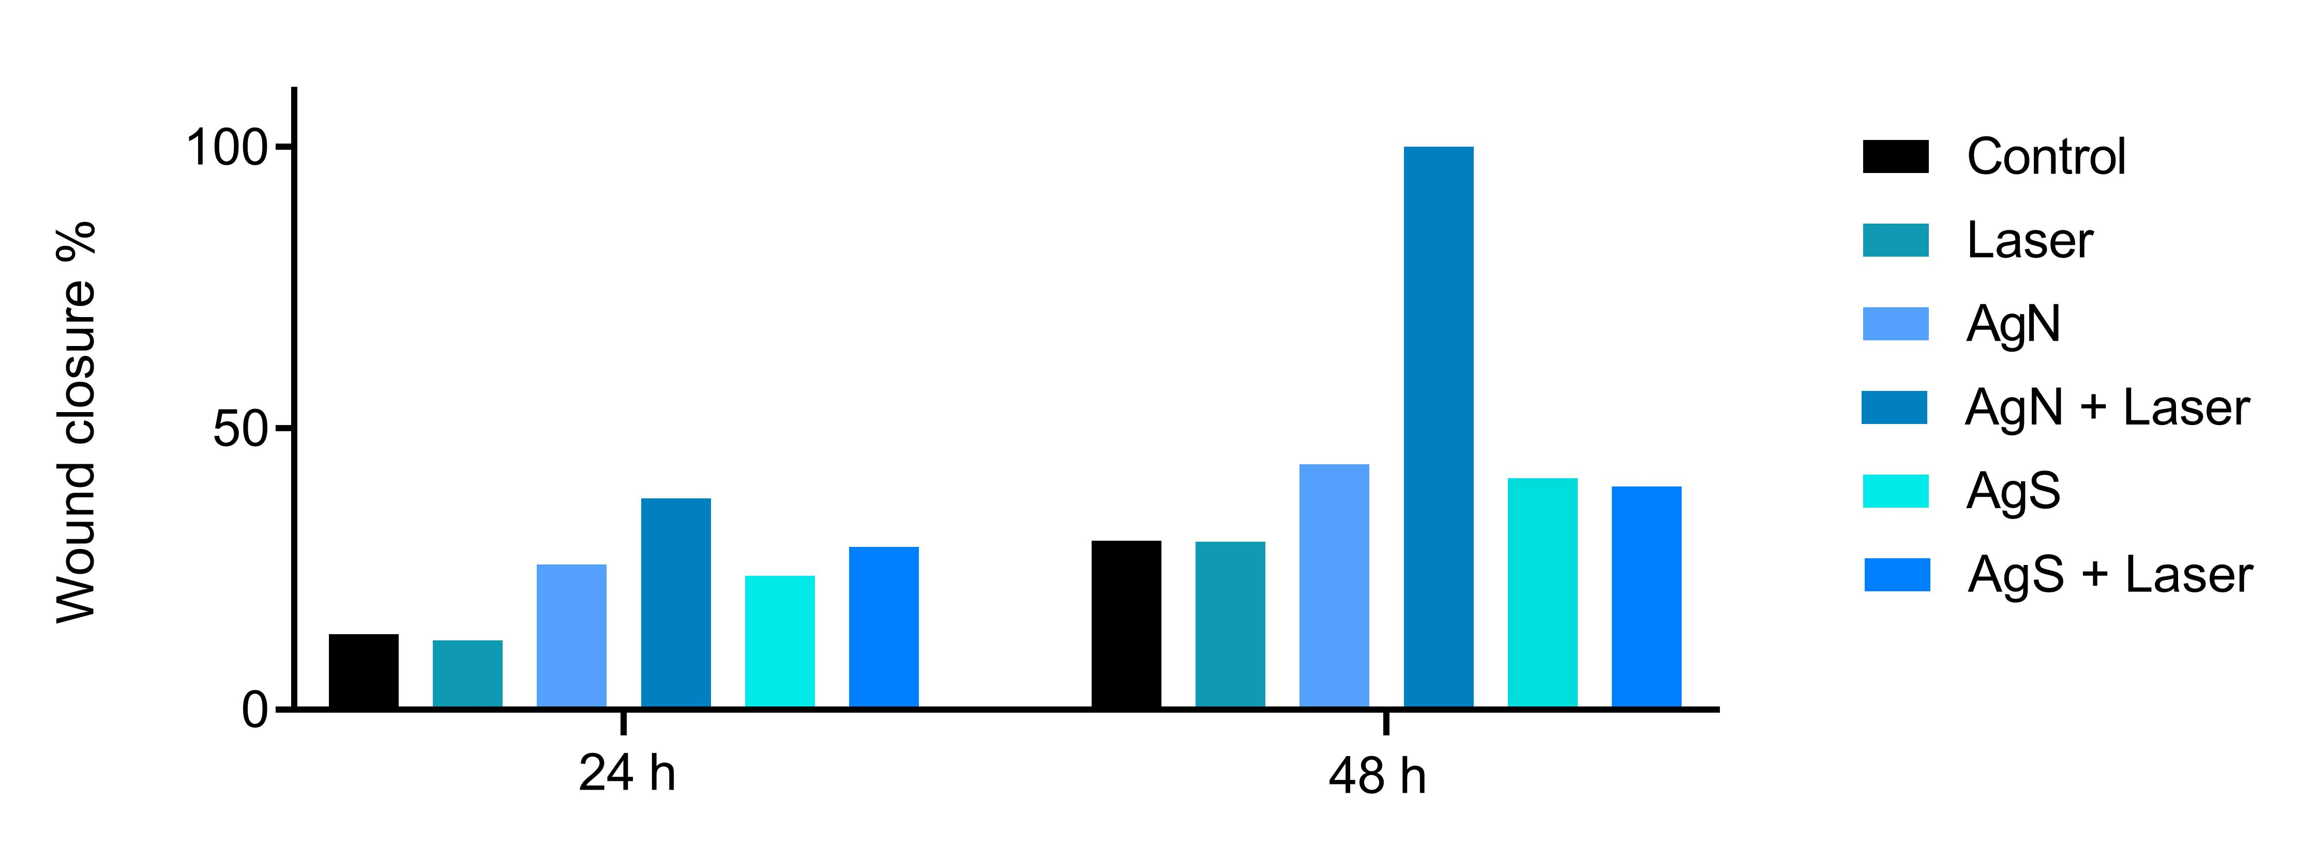

Figure 1. Percentage of wound closure after 24 hours (a) and 48 hours (b).
REFERENCES
[1] Y. Qiao et al., ACS Appl. Mater. Interfaces. 10, 1 (2018).
[2] N. A. Travlou et al., Appl. Bio Mater. 1, 693 (2018).

ACKNOWLEDGMENTS M.A. thank the Spanish Ministry of Science and Innovation (MCIN/AEI/10.13039/501100011033) through the project PID2021-122613OB-I00

