Multiport splitters based on waveguide arrays

Kolja Bugarski^{1,2}, Paloma Vildoso^{3,4}, Mirjana Stojanovic¹, Aleksandra Maluckov¹,
Goran Z. Mashanovich^{2,5}, Rodrigo A. Vicencio^{3,4}, and Jovana Petrovic¹

¹Vinca Institute of Nuclear Sciences, National Institute of the Republic of Serbia, University of Belgrade, Serbia
²School of Electrical Engineering, University of Belgrade, Serbia
³Departamento de Física, Facultad de Ciencias Físicas y Matemáticas, Universidad de Chile, Chile
⁴Millenium Institute for Research in Optics - MIRO, Chile
⁵Optoelectronics Research Centre, University of Southampton, UK
E-mail: kolja.bugarski@vin.bg.ac.rs

Conventional designs of multiport splitters rely on concatenation of directional couplers or multimode interference [1, 2]. However, the splitters show a considerable insertion loss and fast bandwidth drop with the number of ports. Inverse nanodesigns enable broad-bandwidth semiconductor splitters, however, at high fabrication and design costs [3, 4].
In this work, we present fast and low-cost inverse designs of multiport splitters with near-zero insertion loss and respectable bandwidth. Designs are based on adjustments of the separations or lengths of waveguides composing a linearly coupled waveguide array.
By tailoring the separations to achieve self-imaging of the input light pattern, a series of 1×N splitters can be achieved prior to the revival [5, 6]. To demonstrate the technique, the power splitters were fabricated in a borosilicate wafer by femtosecond laser writing method [7]. The splitters show zero insertion loss within the experimental error, bandwidth of 20−60 nm around a wavelength of 640 nm and low imbalance < 0.5 dB [8]. Their footprint scales exponentially with the waveguide separation, which can be reduced to the limit of mode confinement. The footprint reduction is particularly pronounced in waveguides with high refractive index contrast, such as those in SOI, where we design the splitters with the footprint as small as 6 µm².
The proposed splitters offer new possibilities for path-entanglement generation, multipath interferometry on chip and spatial mode multiplexing.

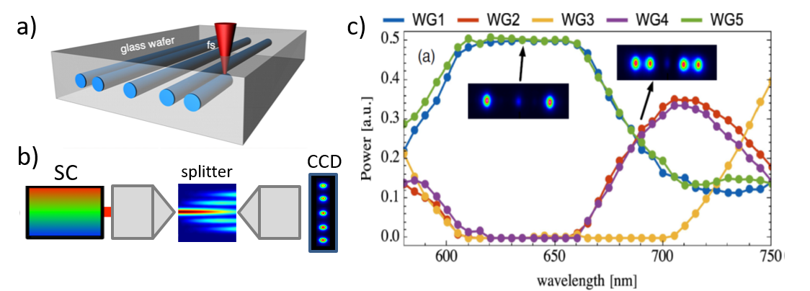
Figure 1. (a) Femtosecond laser writing technique. (b) Splitter testing setup and output light intensity recorded on CCD. (c) Demonstration of the splitter multifunctionality.
REFERENCES
- J. Wang, S. Paesani et al. Science 360 (2018), 285-291.
- L. B. Soldano, E. C. Pennings, J. Lightwave Technol. 13 (1995), 615-627.
- H. Xie, Y. Liu et al., IEEE Photon. J. 10 (2018), 1.
- A. Y. Piggott, J. Petykiewicz et al. Sci. Rep. 7 (2017), 1.
- J. Petrovic, Opt. Lett. 40 (2015) 139-142.
- J. Petrovic, J. Krsic et al., J. Opt. Las. Technol. 163 (2023) 109381.
- D. Guzmán-Silva, G. Cáceres-Aravena, R. A. Vicencio, Phys. Rev. Lett. 127 (2021), 066601.
- P. Vildoso, R. A. Vicencio, J. Petrovic, Opt. Express 31 (8), 12703-12716.

