Coupled vortex generator in active multi-core fibers

P.P. Beličev¹, G. Gligorić¹ and A. Maluckov¹
¹Vinča Institute of Nuclear Sciences, National Institute of the Republic of Serbia,
University of Belgrade, Belgrade, Serbia
e-mail:petrab@vin.bg.ac.rs

Optical vortex is a coherent localized structure carrying energy around the pivot point. It is characterized by an optical angular momentum (OAM) mathematically described by azimuthal phase term exp(ilφ). Here, the integer number l stands for the winding number or topological charge of the vortex [1]. Particularly interesting are vortices generated in discrete systems [2]. They are specified by quantized topological charge and exhibit inherent robustness on perturbations within the system [3].

One of the structures that support discrete vortices is multi-core fiber (MCF) [4]. Here, we study MCF structure composed of two concentric hexagonal rings, A and B (Fig. 1). Beside equal coupling constants among nearest sites of A and B ring, we also consider a presence of artificial flux (Φ) which affects coupling between sites in the A ring [5]. The presence of artificial flux does not change the topological charge of vortices, only shifts their corresponding eigenvalues. Moreover, vortex excitation in one of the rings produces a regular periodical energy exchange between A and B rings in a form of stable breathing coupled-vortex structure. In passive MCF the vortex excitation is necessary to propagate vortex through the system. However, including the saturable gain and linear loss in the MCF, the vortices of different topological charge can be excited even from the uniform background by tuning the flux value. Numerical simulations show high robustness of newly formed vortices, which offers possibility to utilize the proposed setup as highly controllable vortex generator. Moreover, this can be of particular importance in the ring array based lasers [6,7].

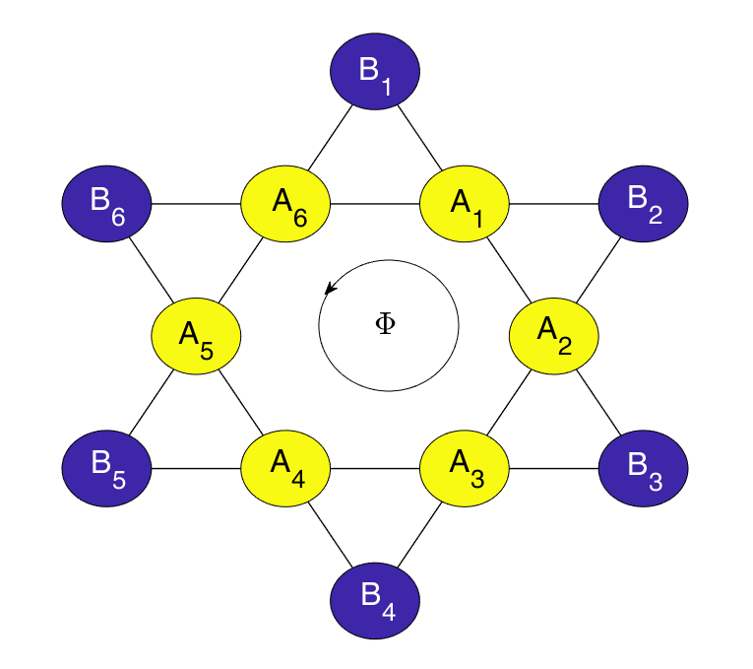
Figure 1. Schematic representation of nonlinear active MCF system with double rings A and B. Each ring has six cores. All couplings are equal (black solid lines between cores) and Φ represents artificial flux which additionally affects coupling between A sites.
REFERENCES
[1] A. Pryamkov et al., J. Eur. Opt. Soc. 17, 1 (2021).
[2] P.P. Beličev et al., Ann. Phys. 533, 2100108 (2021).
[3] M. Soskin et al., J. Opt. 19, 010401 (2017).
[4] Lj. Hadžievski et al., Light Sci. Appl. 4, 1 (2015).
[5] S. Longhi, Opt. Lett. 39, 5892 (2014).
[6] V. Dev and V. Pal, arXiv:2305.08410v1 (2023).
[7] V. Pal et al., Phys. Rev. Lett. 119, 013902 (2023).

