Preparing the bioactive surface of Ti/Zr/Ti system by femtosecond laser pre-patterning of substrate

¹Nevena Božinović, ¹V. Rajić, ²K. Savva, ¹J. Potočnik, ²E. Stratakis, ¹S. Petrović,

¹Vinča Institute of Nuclear Sciences, University of Belgrade, P.O.Box 522, 11001 Belgrade, Serbia
²Institute of Electronic Structure and Laser (IESL), Foundation for Research and Technology (FORTH), N. Plastira 100, Vassilika Vouton, 70013 Heraklion, Crete, Greece
e-mail: nevena.bozinovic@vin.bg.ac.rs

The experimental study of the dynamic femtosecond laser substrate pre-patterning of the Ti/Zr/Ti thin film system is reported. The design of surface pattering with the micrometre features in the form of spikes is investigated in order to improve the arrayed surface structures for biomedical applications. Femtosecond laser pulses were used to acquire black silicon surfaces decorated with conical structures (spikes) on crystalline silicon surfaces under 0.65 bar of SF₆ environmental atmosphere. After irradiation, the silicon surface exhibits high aspect ratio spikes, which have conical shapes of about 2 μm height, 40° angle opening, 13x10⁶ cm⁻² density that remains approximately uniform across the processed area. Results show that the base of the induced conical structures has an elliptical shape with a major (long) and minor (short) axis on the horizontal plane. It is revealed that the orientation of the long axis of the ellipsis is polarization-dependent with the long axis oriented always perpendicularly to the electric field of the laser beam. Spike formation has been attributed to a complex mechanism initiated by partial material melting and subsequent capillary wave formation driven by surface tension gradients within the molten region. On pre-patterned Si substrate were deposited novel composite thin films which are contained from two layers of Ti and subsurface distributed Zr layers (thickness of 10 nm) by ion sputtering to the total thickness of 300 nm. The composition, surface morphology and wetting properties were analyzed by scanning electron microscopy (SEM-EDS), profilometry and wettability measurements.
The formation of micro-patterns with spikes array of composite Ti/Zr/Ti thin film systems was used to observe the effects of morphology on survival, adhesion and proliferation of the MRC-5 cell culture line. To determine whether Ti/Zr/Ti thin films have a toxic effect on living cells, an MTT assay was performed. The relative cytotoxic effect as a percentage of surviving cells showed that there was no difference in cell number between the Ti/Zr/Ti thin films and the control cells. There was also no difference in the viability of the MRC-5 cells.

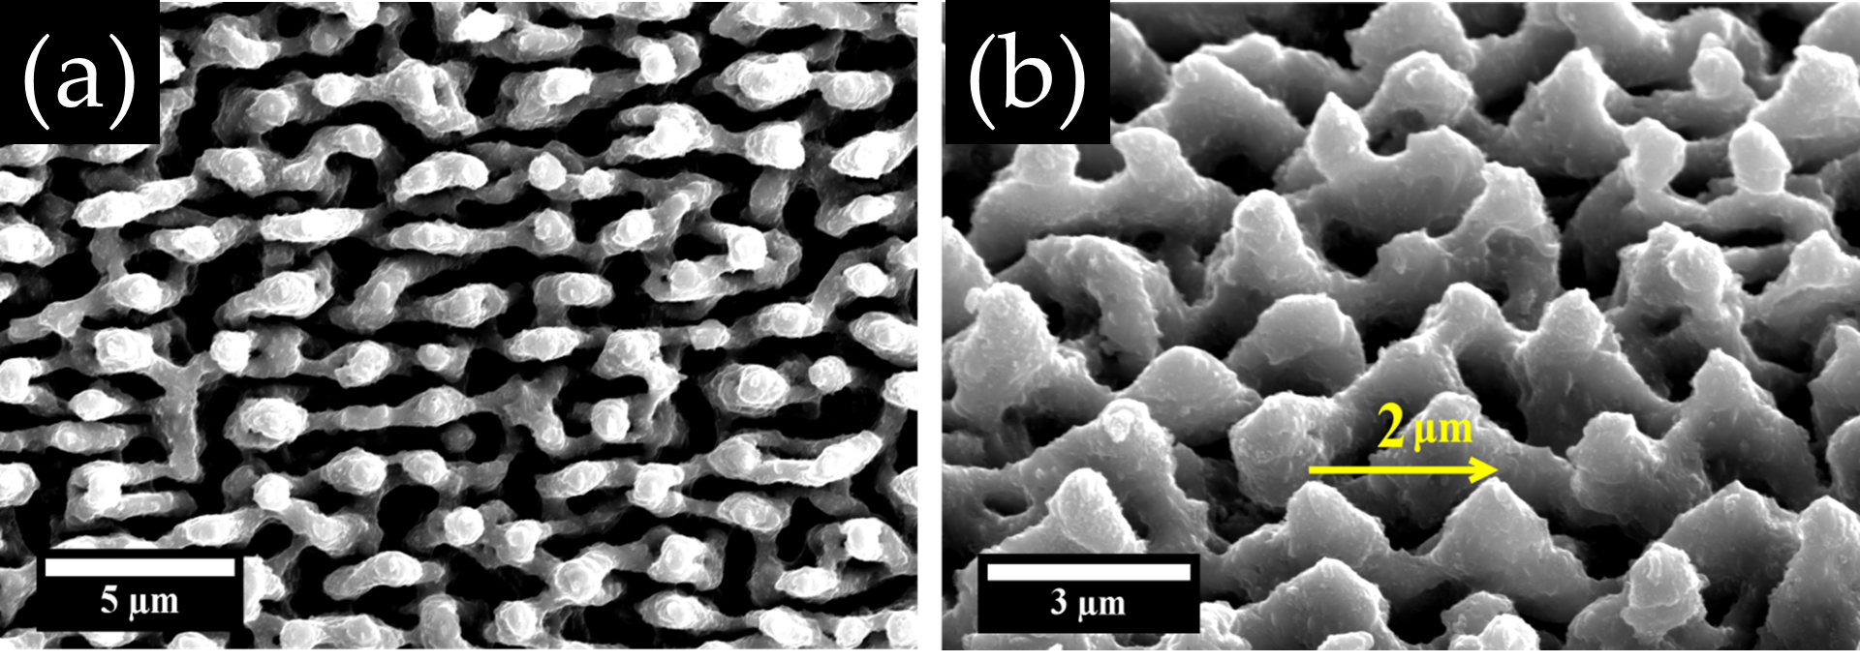
Figure. FESEM micrograph of conical spikes produced on Si (100) by femtosecond laser pulses in SF₆ at a pressure of 420 Torr viewed a) from the normal incident angle b) planar view. The distance between spikes was noted with a yellow arrow.

