OAM mode quality comparisons for discrete EM radiating sources

J.Z. Trajković¹, A.Ž. Ilić¹, S.V. Savić², N. Maletić³, E. Grass^{3,4}, and M.M. Ilić²
¹Institute of Physics Belgrade, University of Belgrade, Serbia
²School of Electrical Engineering, University of Belgrade, Serbia
³IHP – Leibniz-Institut für innovative Mikroelektronik, Frankfurt (Oder), Germany
⁴Humboldt-Universität zu Berlin, Berlin, Germany
e-mail: jelena.trajkovic@ipb.ac.rs

Electromagnetic (EM) waves carrying the orbital angular momentum (OAM) are currently being considered for use in optical wireless communications, as well as wireless communications at terahertz and millimeter wave frequencies [1], [2]. The apertures radiating with their entire surfaces, often used in the optical domain, produce very high quality OAM EM waves. However, partial radiating apertures and discrete OAM wave sources, considered here, facilitate OAM source reconfiguration as well as multiplexing of different OAM modes through a single aperture. Moreover, at terahertz and millimeter wave frequencies, powering and phasing of discrete OAM EM wave sources often becomes increasingly more complex and costly, especially for a very large number of elements of radiating antenna arrays. Therefore, it is of interest to use low-cost, low-profile, efficiently powered and phased antenna arrays consisting of a limited number of elements, while optimizing the OAM mode quality.

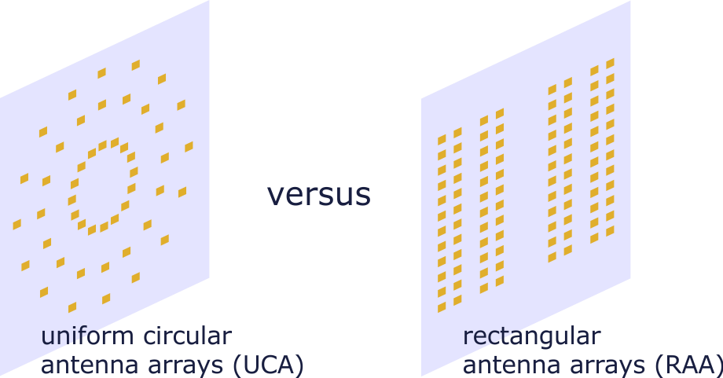
Figure 1. Uniform circular antenna arrays (UCA) are often used to produce the OAM EM waves at millimeter wave frequencies. Rectangular antenna arrays (RAA) could offer some additional flexibility to the designer; however, the calculation of the RAA element phase shifts is more complex, and additional optimization might be required to attain similar OAM mode quality in comparison with the UCA.
Utilization of uniform circular antenna arrays (UCA) as discrete OAM EM wave sources has been successful in the millimeter wave frequency band; phasing of the UCA is quite straightforward and symmetrical antenna arrangements are advantageous from the OAM mode quality viewpoint. However, the OAM EM wave sources for use in wireless communications have to be electrically large [2], [3], to allow the desired system performance. From that point of view, either uniform or non-uniform rectangular antenna arrays (RAA) provide additional flexibility to the designer and could benefit from the well-developed theory and implementation methods of conventional antenna arrays [4]. We compare the OAM mode quality of different antenna array arrangements at millimeter wave frequencies to define the prerequisites for the RAA for attaining high wireless data transfer performance.

REFERENCES
[1] A.E. Willner, G. Xie, L. Li, et al, J. Opt. 18, 074014 (2016).
[2] A.Z. Golubović, S.V. Savić, A.Ž. Ilić, M.M. Ilić, Int. J. Electron. Commun. (AEÜ) 165, 154643 (2023).
[3] A.Ž. Ilić, J.Z. Trajković, S.V. Savić, M.M. Ilić, J. Phys. A: Math. Theor. 56, 255701 (2023).
[4] Y.H. Cho, W.J. Byun, Electron. Lett. 55, 503–504 (2019).

