Free-space OAM wave transmission: a short dipole modeling study

A.Ž. Ilić¹, J.Z. Trajković¹, S.V. Savić², and M.M. Ilić²
¹Institute of Physics Belgrade, University of Belgrade, Serbia
²School of Electrical Engineering, University of Belgrade, Serbia
e-mail: andjelijailic@ieee.org

Orbital angular momentum (OAM) multiplexing is, since recently, considered to be one of the key technology enablers for enhancing wireless and free-space optical communications channel capacity, whether implemented separately or in combination with existing multiplexing techniques. The OAM wave generation systems have been a topic of a number of recent publications. The actual possibilities and limitations of the free-space OAM wave transmission have also been investigated in several studies, e.g. [1]–[4]. The results have pointed out the most probable utility of the free-space OAM waves for short-range transmission distances that are on the order of magnitude of the Rayleigh distance. However, there are just a few in-depth investigations into the properties of such short-range OAM wave transmission. Here we report on the recently proposed use of the short (Hertz) dipole method customized for the detailed analysis of the OAM waves [5]. Employing that method and focusing on the uniform circular antenna arrays (UCA), as a very representative example of easily reconfigurable discrete OAM wave sources, we studied the properties of the short-range transmission at different frequencies, for different UCA electrical sizes, and different distances from the source plane [5]. Guidelines for using the proposed methodology and the obtained results in the future designs of free-space communication systems employing OAM multiplexing were provided.

As expected, short (Hertz) dipole modeling proved highly efficient and versatile in an investigation of electrically large discrete OAM EM wave sources. A general framework of combining the short dipole method with full-wave numerical EM modeling for the analysis of arbitrary antenna arrays or other OAM wave radiating structures was also presented.

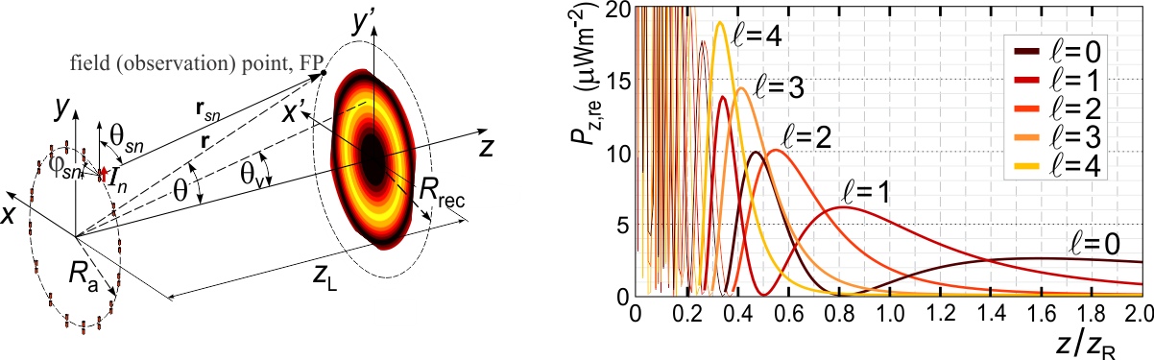
Figure 1. Short (Hertz) dipole modeling, computationally efficient for electrically large discrete EM wave sources (plot on the left). The vortex angle, $θ_{v}$, corresponds to the OAM EM field maximum. The link distance is denoted as $z_{L}$. Dependence of the axial Poynting vector for x = 0, y = Rrec =$z_{L}$tan($θ_{v}$), on the distance from the source plane, z, is plotted on the right (Rrec represents the radius of receiving UCA). The Rayleigh distance is denoted as $z_{R}$. The optimal receiving distance, i.e., link range, corresponds to the axial coordinates of OAM EM field maxima.
REFERENCES
[1] A.F. Morabito, L. Di Donato, T. Isernia, IEEE Antennas Propag. Mag. 60(2), 59–67 (2018).
[2] A. Sawant, I. Lee, B.C. Jung, E. Choi, IEEE Wirel. Commun. 28(1), 90–96 (2021).
[3] A.E. Willner, G. Xie, L. Li, et al, J. Opt. 18, 074014 (2016).
[4] A.Z. Golubović, S.V. Savić, A.Ž. Ilić, M.M. Ilić, Int. J. Electron. Commun. (AEÜ) 165, 154643 (2023).
[5] A.Ž. Ilić, J.Z. Trajković, S.V. Savić, M.M. Ilić, accepted for publication in J. Phys. A: Math. Theor.

