Characterization and Performance Evaluation of a Dual Loop Sagnac Interferometer as Sensing System for Intrusion Location Detection

M. Vasiljević Toskić¹, J. S. Bajić¹, L. Manojlović² and B. Batinić¹
¹University of Novi Sad, Faculty of Technical Sciences, Department of Power, Electronic and Telecommunication Engineering, Novi Sad, Serbia
2Zrenjanin Technical College, Zrenjanin, Serbia
e-mail:markovt@uns.ac.rs
The importance of securing critical areas such as airports, military bases, and power plants has driven the development of optical fiber-based sensors, aiming to meet the requirements for long-range sensitivity, robustness, reliability, and simplicity in detecting unwanted intrusions and disturbances. However, the limitations associated with cost, continuity, and reliability in traditional intrusion detection methods emphasize the significance of advancing sensor technologies in this field. Due to their high sensitivity to vibrations and temperature discrimination, optical fiber interferometers employing the Sagnac loop configuration have proven to be effective methods for distributed intrusion detection and localization [1,2].

In this paper, the modification of an optical system based on the Sagnac interferometer is investigated, building upon the concepts presented in the previous research. Various aspects of the proposed sensing system are presented in previous research, including system topology, operational principles, mathematical relationships, hardware configuration, and signal processing software [3]. The testing approach is enhanced by the integration of two devices: mini-shaker Type 4810 and Red Pitaya STEMlab 125-14 board for the detailed characterization and performance validation of the sensor system. By integrating the mini-shaker Type 4810 into the optical system, controlled vibrations are generated, allowing for a comprehensive characterization of the sensor system's response to stimuli of various frequencies, amplitudes, and patterns. Utilizing the Red Pitaya STEMlab 125-14 board for the light source excitation and as data aqusition device simplifies the experimental setup, offering a cost-effective and efficient solution for performance validation.
This proposed experimental setup allows for the precise assessment of the system's sensitivity, stability, reliability and overall performance.
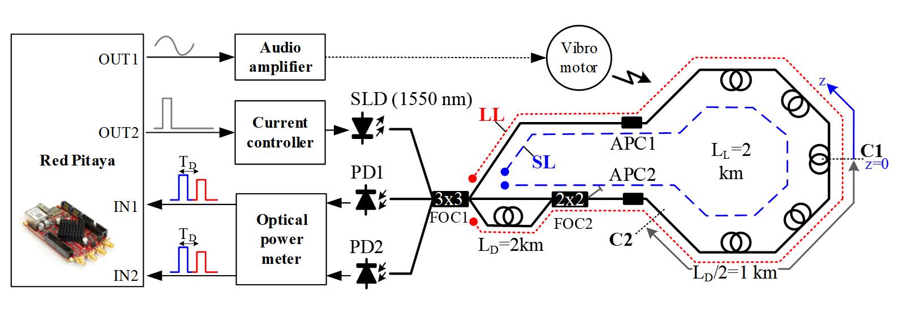
Figure 1. Experimental setup used in this work.
REFERENCES

[1] G. Sun, D.S. Moon, Y. Chung, IEEE Photonics Technollogy Letters (2007).
[2] G. Sun, H. Tang, Y. Hu, Y. Zhou, IEEE Photonics Technollogy Letters (2012)
[3] M. Vasiljevic Toskic, J. Bajic, L. Manojlovic , B. Batinic, M. Arbanas, VIII International School and Conference on Photonics – Photonica21 (2021).

