Low-Cost Raspberry Pi based Imaging System for Analysis of Fiber Specklegram Sensors

L. Brestovacki¹, M. Golubovic¹, J. Bajic¹, A. Joža¹ and V. Rajs¹
¹ University of Novi Sad, Faculty of Technical Sciences, Department of Power, Electronic and Telecommunication Engineering, Novi Sad, Serbia
e-mail:lenkabrestovacki@uns.ac.rs

Fiber optic sensors are becoming highly popular due to their multiplexing capability, compactness, and electromagnetic field immunity [1]. For determining strain and stress impact especially promising are Fiber Specklegram Sensors (FSS) regarding their high sensitivity and possibility of low-cost implementation in electronics [2, 5]. In this paper, one low-cost imaging system for FSS based on Raspberry Pi is presented. The aim of this research is to investigate the influence of mechanical deformations on specklegram by comparing referent specklegram (when the fiber is not deformed) and specklegram taken for deformed fiber. In Figure 1 the experimental setup of the proposed system for analysis of Fiber Specklegram Sensors is presented. A spatially coherent light source emits light waves with different but constant phases of the same frequency and amplitude through a 50µm multimode (MM) optical fiber. Due to modal interference, one may notice a speckle pattern as the light modes propagate. Since high intensity of light can cause sensor saturation, the attenuator is required for decreasing light intensity. Mechanical deformation made in this experiment can vary the angle and intensity of force. By manually making deformations it is observed that the geometrics of speckles are different for different deformations. For extracting information on the activity of the tested sample of the recorded light intensity distribution is used a statistical approach. Statistical analysis is almost mandatory for the study of dynamic speckle phenomena [3]. Therefore, the use of machine learning for tracking feature changes is proposed.

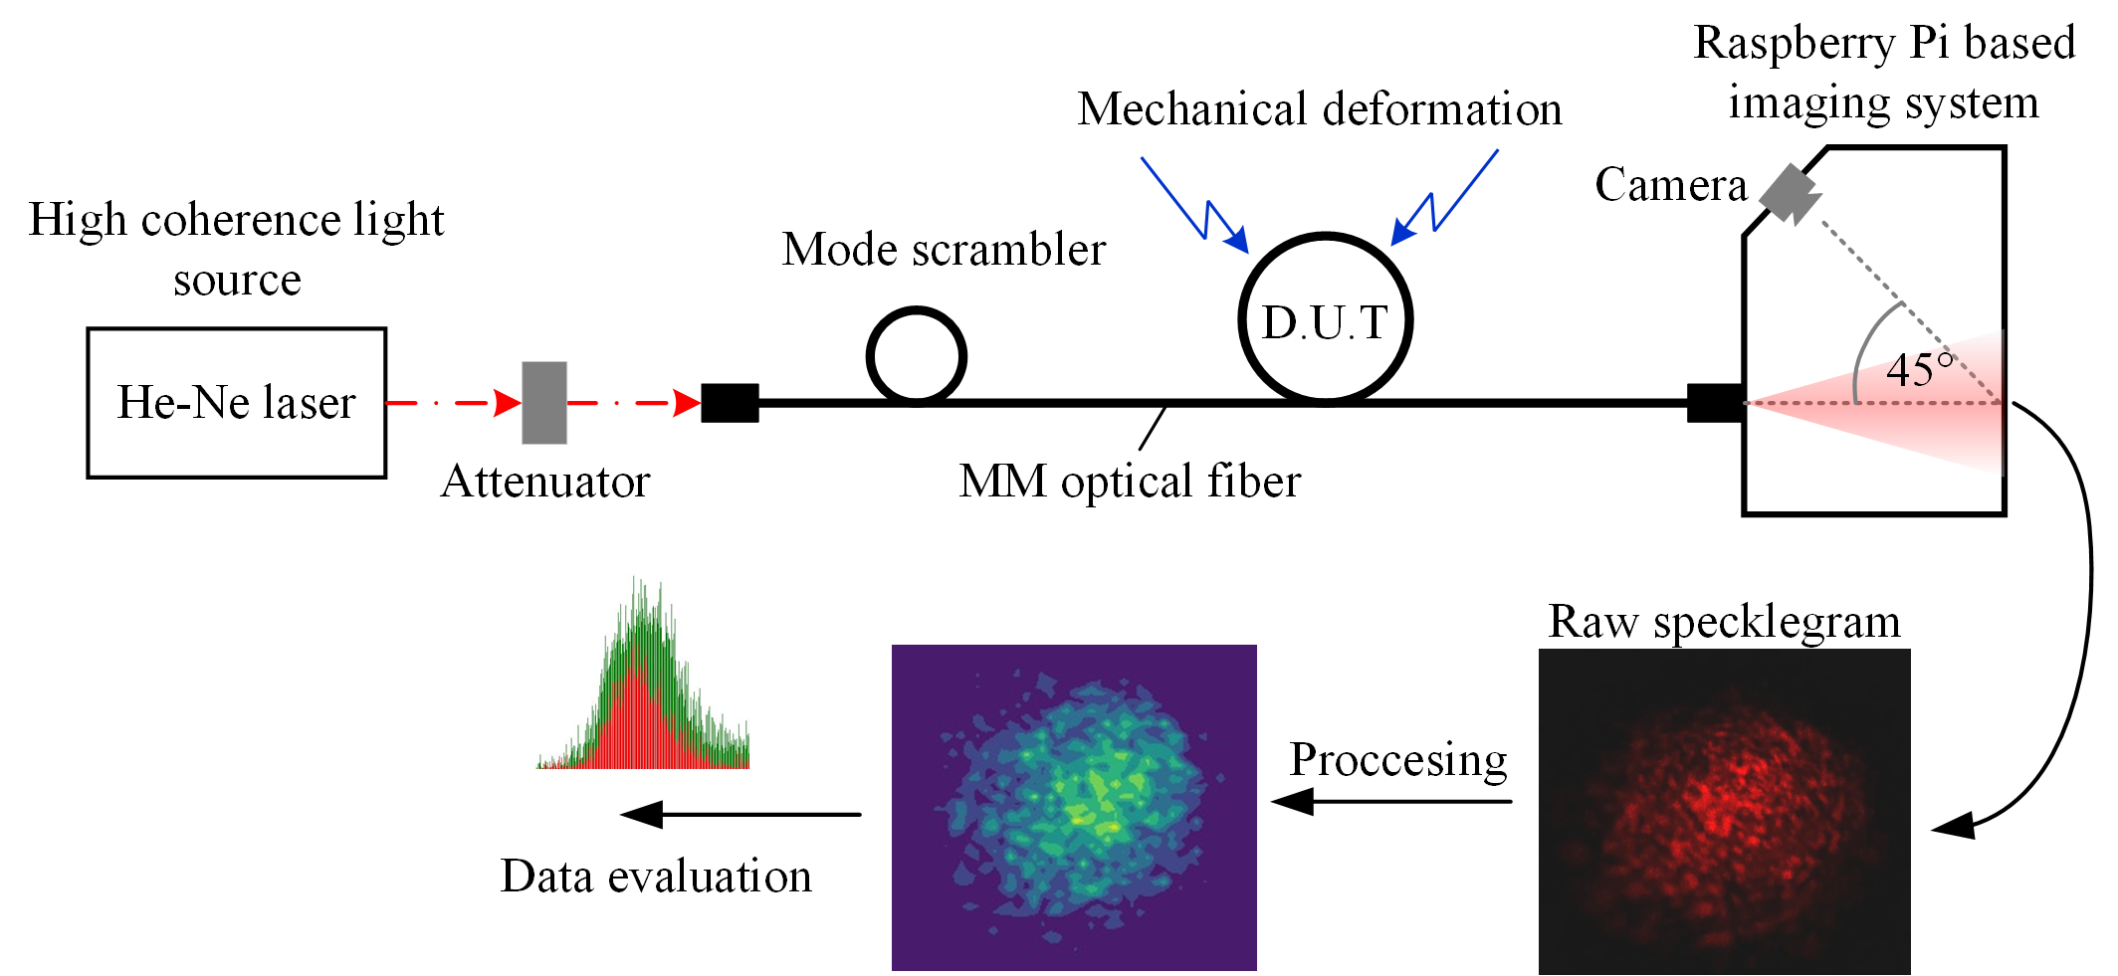

Figure 1. Experimental setup used in this work.
For taking images Raspberry Pi camera module v2 NoIR is used, while image processing is performed on Raspberry Pi model 3, 1GB.

REFERENCES
[1] A. G. Leal-Junior, A. Frizera, C. Marques, M.J. Pontes, IEEE Sensors Journal (2019).
[2] E. Fujiwara, L. E. da Silva, T. H. R. Marques, C. M. B. Cordeiro, Optical Engineering (2018)
[3] P. Etchepareborda, A. Federico, G. H. Kaufmann, Applied Optics (2010)
[4] E. Fujiwara, Y. T. Wu, M. F. M. Santos, E. A. Schenkel, C. K. Suzuki, IEEE Sensors Journal (2017)
[5] L. Rodriguez-Cobo, M. Lomer, A. Cobo, J. Lopez-Higuera, Sensors and Actuators A: Physical (2013)

