Characterization and Testing of Fiber Optic Curvature Sensor as an Optical Mode Converter for Deformation Measurement

S. Babić¹, J. S. Bajić¹, M. Vasiljević Toskić¹, A. Joža¹ and V. Rajs¹
¹ University of Novi Sad, Faculty of Technical Sciences, Department of Power, Electronic and Telecommunication Engineering, Novi Sad, Serbia
e-mail: sladjana.babic@uns.ac.rs

Shortly after the discovery of optical fibers it was realized that optical fibers, except reliable data transmission, also possess excellent sensing capabilities. Main advantages of fiber optic sensors are: flexibility, immunity to electromagnetic interference, excellent resolution, wide measurement range, water and corrosion resistance, low-cost, small dimensions etc. A great number of fiber optic curvature sensors (FOCS) belong to the group of fiber optic sensors that are based on light intensity modulation. During the light propagation through the fiber, if the fiber bends, mode conversion occurs. Some of the light rays exit the optical fiber, leading to a decrease in light intensity at the fiber output.

In order to increase the sensitivity of the optical fiber to bending, V-shaped notches are etched into the fiber forming a sensitive zone [1-3]. This sensitive zone can be also used for determining the bending direction, which is an advantage compared to other curvature sensors. In this paper, a fiber optic curvature sensor implemented using plastic optical fiber with a sensitive zone is tested. Essentially, the measurement is based on detecting changes in the output intensity distribution depending on the deformation (curvature) of the fiber. The testing is performed in function of different notch depth, their spacing and the angle at which they are etched into the fiber, in order to assess the impact of these parameters on the sensor’s performance. The results presented in paper [2] indicate that the optimal number of notches is 55. Therefore, in this measurement, a sensitive zone including about 50 notches is investigated. Additionally, in paper [1], it is demonstrated how the position of the FOCS sensitive zone, whether it is on the concave or convex side of the bent fiber, affects the output signal. This aspect is also tested in this experiment, where deformations are applied in both directions.

In Figure 1 the experimental setup used in this work is shown. LED is used as a light source, and its intensity can be controlled. Therefore, the influence of the source intensity on the measurements is tested. Additionally, a mode converter is placed between the LED and FOCS. Its role is to excite multiple modes and ensure that the same radiation distribution is injected into all tested sensors. Unlike in paper [4], where a quadrant photodetector was used, here the output intensity distribution is recorded using a CCD sensor, where the mode conversion can be clearly observed. Due to this capability, the FOCS sensor is also referred to as an optical mode converter or mode filter.

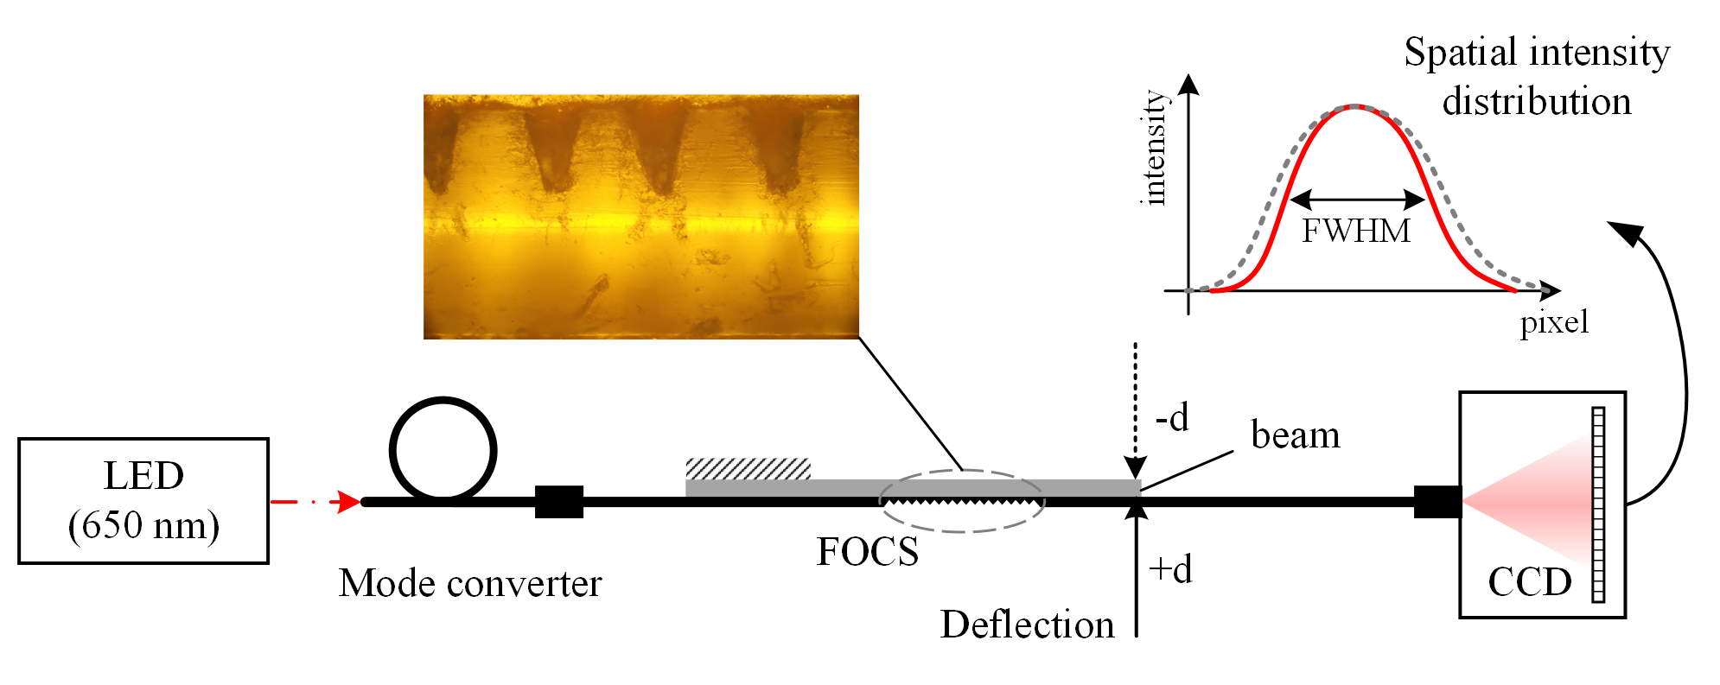
Figure 1. Experimental setup for the characterization and testing of the proposed FOCS sensor.
REFERENCES
[1] H. Di, Optics & Laser Technology (2014)
[2] Y. Fu, H. Di , Optics & Laser Technology (2011)
[3] Y. Fu, H. Di, R. Liu, Optics & Laser Technology (2010)
[4] J. S. Bajić, M. Z. Marković, A. Joža, D. Vasić, T. Ninkov, Sensors and Actuators A: Physical (2017)

