Excursion of a Biophysicist to the Quantum World

András Dér
Institute of Biophysics, Biological Research Centre
H-6726 Szeged, Temesvári krt. 62, Hungary
e-mail:der.andras@brc.hu

Novel imaging techniques utilizing nondegenerate, correlated photon pairs sparked intense interest during the last couple of years among scientists of the quantum optics community and beyond. It is a key property of such ‘‘ghost imaging’’ or ‘‘quantum interference’’ methods that they use those photons of the correlated pairs for imaging that never interacted with the sample, allowing detection in a spectral range different from that of the illumination of the object. Extensive applications of these techniques in spectroscopy and microscopy are envisioned, however, their limited spatial resolution to date has not yet supported real-life microscopic investigations of tiny biological objects. In the lecture, a modification of the method based on quantum interference [1] will be outlined (”SIMUP”), by using a seeding laser and confocal scanning, that allows the improvement of the resolution of imaging with undetected photons by more than an order of magnitude [2]. Examples of its application in the microscopy of biological samples will also be presented.

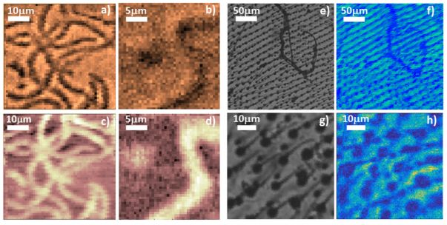

Figure 1. Amplitude (a and b) and phase (c and d) images of Spirulina filaments at different scan areas and step sizes (50 µm by 50 µm and 1 µm in a) and c), while 25 µm by 25 µm and 0.5 µm in b) and d), respectively). Normal microscopic (e and g) and SIMUP amplitude images (f and h) of a wasp wing at different scan areas and step sizes for the latter (250 µm by 250 µm and 5 µm, and 50 µm by 50 µm and 0.5 µm, respectively).

REFERENCES
[1] G. B. Lemos, V. Borish, G. D. Cole, S. Ramelow, R. Lapkiewicz, A. Zeilinger, Nature, 512:7515, 409-412 (2014)
[2] A. Búzás, E.K. Wolff, M.G. Benedict, P. Ormos, A. Dér, IEEE Access 8, 107539-107548 (2020)

