Nanophotonics: an enabling tool for basic research and technology

R. Quidant ¹
¹ Nanophotonic Systems Laboratory, Department of Mechanical and Process Engineering, ETH
Zurich, Switzerland
rquidant@ethz.ch

Twenty years of extensive research in the field of nanooptics have enabled us to considerably advance light control on the nanometer scale. Following the early peak of inflated expectation, the assets of nanooptics over other technologies, along with its limitations, became clearer. More recently, the field has entered into the slope of enlightenment in which its actual contribution to both basic research and novel technologies has been better identified. In this talk, following a general introduction on the main assets of nano-optics, we will review different aspects of our research where nano-optical resonators, both metallic and dielectric, are used as an enabling technology, which benefits a wide range of scientific disciplines, all the way from Lab-on-a-chip technology [1-4], reconfigurable planar optics [5,6] to additive manufacturing [7,8].

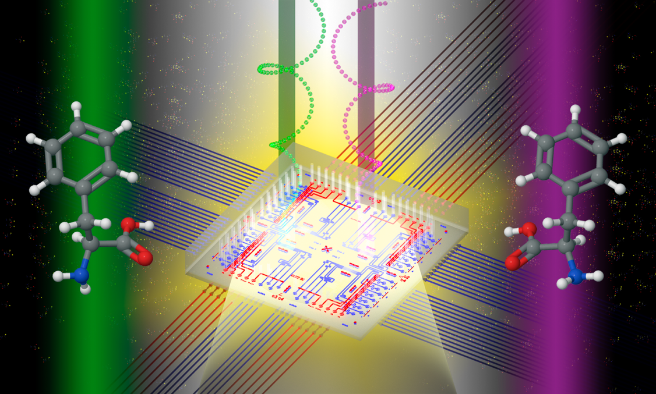

Figure 1. 3D sketch of on-chip chiral biosensing using dielectric nanoresonators
REFERENCES

[1] O. Yavas, M. Svedendahl, P. Dobosz, V. Sanz, R. Quidant, Nano Lett. 17, 4421 (2017)
[2] O. Yavas, M. Svedendahl, R. Quidant, ACS Nano 13, 4582 (2019)
[3] J. García-Guirado, M. Svedendahl, J. Puigdollers, R. Quidant, Nano Lett. 20, 585 (2020)
[4] B. Ciraulo, J. Garcia Guirado, I. de Miguel, J. Ortega, R Quidant, Nature Comm. 12, 2001 (2021)
[5] A. Afridi, J. Canet, L. Philippet, J. Osmond, P. Berto, R. Quidant, ACS Photonics 5, 4497 (2018)
[6] P. Berto, L. Philippet, J. Osmond, C. F. Liu, A. Afridi, M. Montagut, B. Molero, G. Tessier, R. Quidant, Nature Photon. 13, 649 (2019)
[7] A. Powell, A. Stavrinadis, I. de Miguel, G. Konstantatos, R. Quidant, NanoLett. 18, 6660 (2018)
[8] A. Powell, A. Stavrinadis, S. Christodoulou, R. Quidant, G. Konstantatos, NanoLett. 20, 3485 (2020)

