A new tool for measuring local temperature gradients on a submicron scale

A. Romshin¹, Vadim Zeeb², Artem K. Martyanov¹, Igor I. Vlasov¹
¹Prokhorov General Physics Institute of the Russian Academy of Sciences, Vavilov str. 38, Moscow 119991, Russia
²Institute of Theoretical and Experimental Biophysics of the Russian Academy of Sciences, Pushchino, Moscow Region 142292, Russia
e-mail: alex_31r@mail.ru

Nanodiamonds hosting temperature-sensing centers constitute a closed thermodynamic system. Such a system prevents direct contact of the temperature sensors with the environment making it an ideal environmental insensitive nanosized thermometer. Here we describe a new practical implementation of ultra-local thermometer based on a 500-nm luminescent nanodiamond embedded into the inner channel of a glass submicron pipette. All-optical detection of temperature, based on spectral changes of the emission of “silicon-vacancy” centers with temperature, is used (Fig. 1b). We demonstrate the applicability of the thermometric tool to the study of temperature distribution near a local heater from aggregate of aluminum particles (Fig. 1a), placed in an aqueous medium. The experimental values of temperatures are shown in Fig. 1c. Nanodiamond thermometer reproducibly “senses” temperature changes of 2.1 °C degrees over 200 nm and is capable of monitoring strong temperature gradients ΔT/ΔX on the submicron scale (the drop ΔT≈15 °C is detected within ΔX≈500 nm near X=1 µm). Until now, temperature measurements on the submicron scale at such high gradients have not been performed. The new thermometric tool opens up unique opportunities to answer the urgent paradigm-shifting questions of cell physiology thermodynamics.

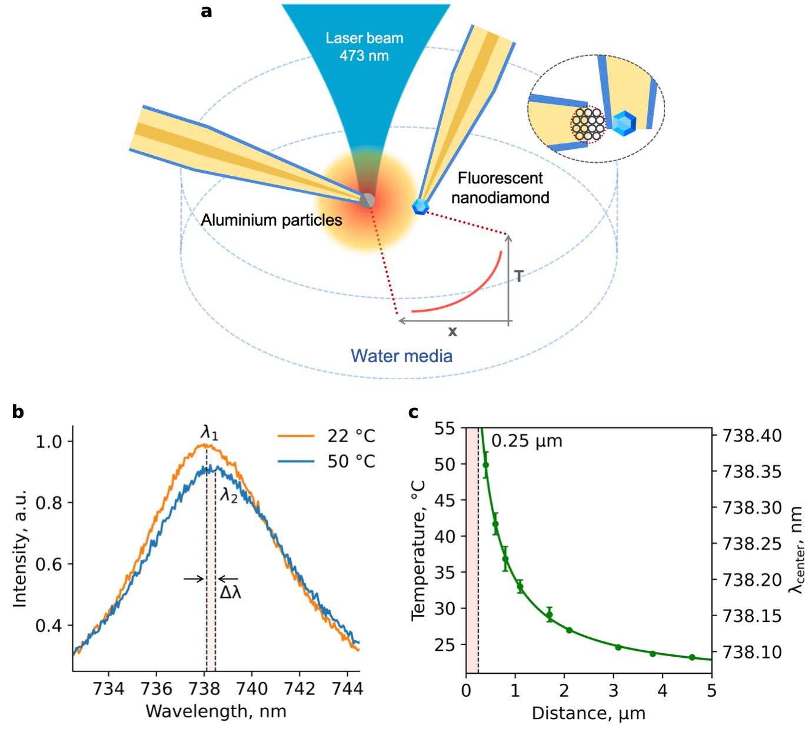

Figure 1. Schematics of temperature distribution evaluation near the local heater: the relative position of the thermometer, heater and laser beam in a cuvette with water (a); PL spectra of the diamond thermometer, measured at different distances from the heater, the positions λ1 and λ2 of SiV ZPL maxima correspond to 22 °C and 50 °C, respectively (b); dependence of the SiV ZPL position and the temperature on the distance X between the heater surface and the center of the thermometer, dashed line at X=0.25μm corresponds to the distance between the heater surface and the center of the thermometer when they touch each other. The number of measurements in each green point is 7. Corresponding error bars (standard deviations) are minimal (0.3 °C) at distances of 2-5 μm and reach a maximum of 2.5 °C at X=0.41 μm (c).
REFERENCES
[1] Baffou, G., Rigneault, H., Marguet, D., & Jullien, L. A critique of methods for temperature imaging in single cells. Nature methods, 11(9), 899-901 (2014).

