Neodymium-doped ZnO nanoparticles for NIR II biomarkers

N. Tarasenka¹, V. Kornev¹ and N. Tarasenko¹
¹B.I. Stepanov Institute of Physics of the National Academy of Sciences of Belarus
Minsk, Belarus
e-mail: natalie.tarasenka@dragon.bas-net.by

Recently, design and preparation of the nanoparticles (NPs) suitable for labeling of the living cells has become an important task of modern nanotechnology. Among the requirements to this type of nanomaterials is their biocompatibility and luminescence in the NIR region because biological tissues have a maximum light transmission in the 850-1100 nm range [1]. This work is focused on the laser-assisted method for Nd-doped ZnO NPs preparation and testing their luminescent properties. ZnO nanocrystals doped with Nd³⁺ ions, which have several important luminescent bands in the NIR region, can be of interest for applications as luminescent biomarkers. The preparation method is based on laser ablation of zinc target in Nd(NO₃)₃ solution using ns-pulsed Nd:YAG laser (1064 nm, 10 ns, 10 Hz).
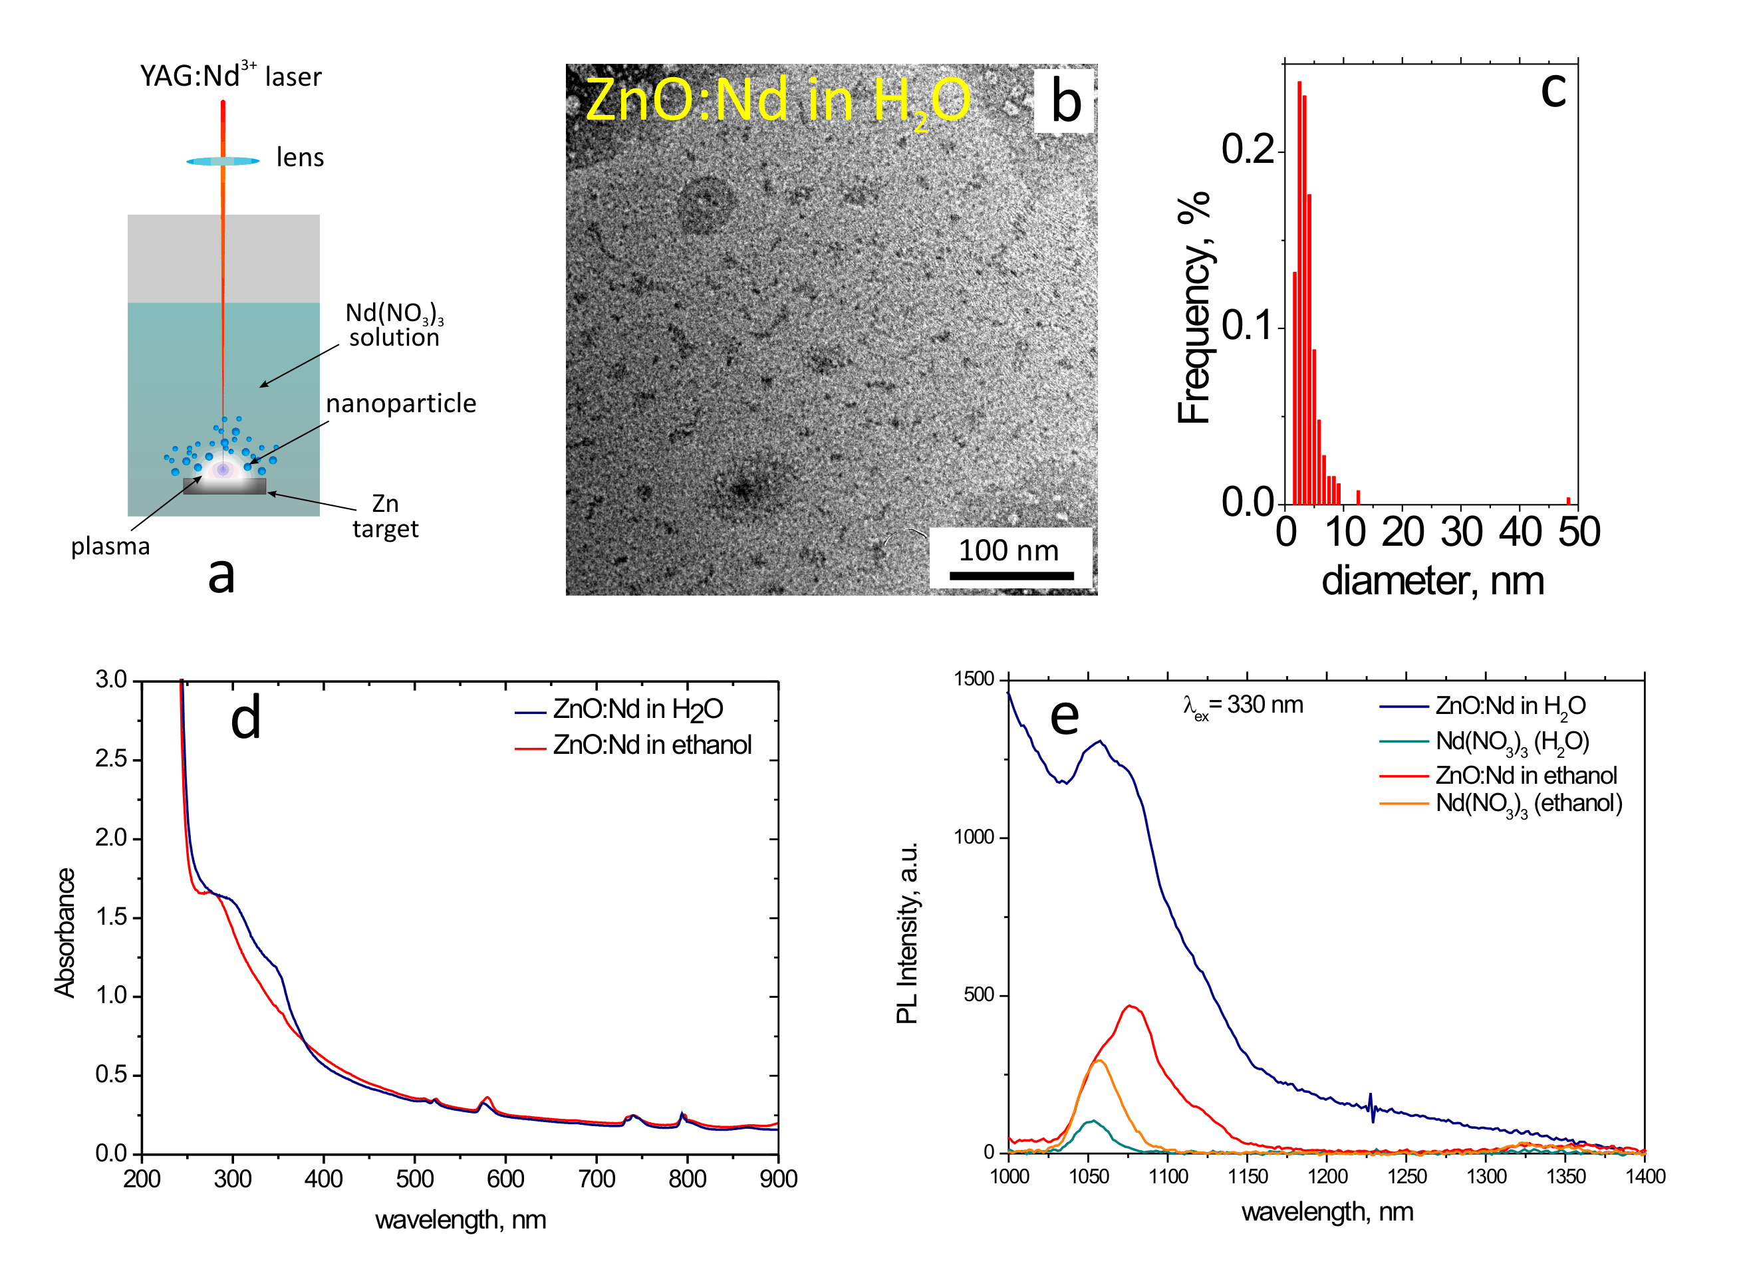

Figure 1. Scheme of the setup used for the ZnO:Nd nanoparticles preparation (a), TEM image of the particles prepared in water (b) and their size distribution (c). The figures (d) and (e) show the optical absorption and photoluminescnence spectra of the prepared colloids in water and ethanol.
It was shown that Nd³⁺ ions can be incorporated into ZnO NPs that is confirmed by the results of XRD, TEM characterization and observation of the characteristic NIR luminescence of Nd³⁺ ions in the obtained ZnO nanocrystals. Upon excitation at 578 and 808 nm, three luminescence bands were observed with centers at 887, 1060, and 1334 nm, attributable to the radiative transitions from the ground ⁴F_{3/2} level of Nd³⁺ to the ⁴I_{9/2}, ⁴I_{11/2} and ⁴I_{13/2} levels, respectively. The position and shape of these peaks in the recorded luminescence spectrum differ from the peaks of Nd₂O₃ nanocrystals spectrum, which confirms the inclusion of Nd³⁺ ions in ZnO nanocrystals instead of the formation of an impurity Nd₂O₃ phase. UV-Vis absorption spectra indicated a decrease in the optical band gap of the doped ZnO that can be attributed to the distortion of the crystal structure of zinc oxide upon doping due to the difference in the ionic radii of Nd³⁺ (0.99 Å) and Zn²⁺ (0.74 Å).
.
REFERENCES
[1] Y. Liu, W. Luo, R. Li, H. Zhu, X. Chen, Optics Express 17, 9748 (2009).

