Smart and Responsive Photonic Materials

D.S. Wiersma^{1,2,3}, D. Martella^{1,3,4}, S. Nocentini^{1,3}, and C. Parmeggiani^{1,3,4}
¹European Laboratory for Non-Linear Spectroscopy (LENS), Sesto Fiorentino, Italy
² Department of Physics and Astronomy, University of Florence, Sesto Fiorentino, Italy
³Istituto Nazionale di Ricerca Metrologica INRiM, Turin, Italy
⁴Department of Chemistry “Ugo Schiff”, University of Florence, Sesto Fiorentino, Italy

e-mail: wiersma@lens.unifi.it

Light responsive shape-changing polymers are able to mimic the function of biological muscles accomplishing mechanical work in response to selected stimuli. A variety of manufacturing techniques and chemical processes can be employed to shape these materials to different length scales, from centimeter fibers and films to 3D printed micrometric objects trying to replicate biological functions and operations. Controlled deformations shown to mimic basic animal operations such as walking, swimming, or grabbing objects, while also controlling the refractive index and the geometry of devices, opens up the potential to implement tunable optical properties. In addition, these materials provide an enormous potential for the development of fully optical neural networks that can be operated without computers or other forms of electronics.

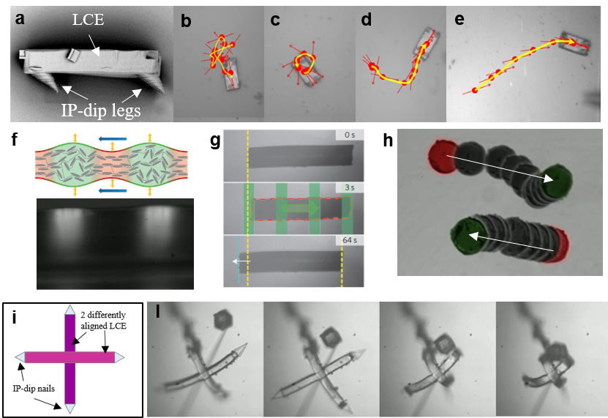

Figure 1. Examples of micro robots and actuators made from smart photonic materials. Upper panels (a-f): a micro walker and its surface dependent locomotion behavior. Middle panels (f-h): micro swimmers powered by structured dynamic light. Lower panels (i,l): micro hand structure and its catching a micro-object. The material can be made such that it triggers only upon certain colours and hence a micro hand can be made that automatically grabs particles with specific optical properties [from: Nocentini et al, Adv. Opt. Mat. 6, 2018].

REFERENCES
[1] D. Martella, S. Nocentini, C. Parmeggiani, and D.S. Wiersma, Photonic artificial muscles: from micro robots to tissue engineering, Faraday Discussions 223, 216-232 (2020).
[2] M Sitti, DS Wiersma, Pros and cons: Magnetic versus optical microrobots, Advanced Materials 32 (20), 1906766 (2020).

