**Bipartite lattice of domain wall junction states in photonic lattices**

Esteban Flores1, Francisco Muñoz2,3 and Rodrigo A. Vicencio1

*1Departamento de Física and MIRO, Facultad de Ciencias Física y Matemáticas, Universidad de Chile, Chile*

*2Departamento de Física, Facultad de Ciencias, Universidad de Chile, 9170124 Santiago, Chile*

*3Center for the Development of Nanoscience and Nanotechnology (CEDENNA), 9170124 Santiago, Chile*

e-mail:esteban.flores@ug.uchile.cl

The similarities between the Schrödinger equation in quantum mechanics and the paraxial wave equation in optics have allowed scientists to study quantum phenomena in photonic lattices [1,2]. The possibility of imaging the wave function directly using a CCD camera has emerged as a key advantage in optics in comparison to electronics systems [3].

This work suggests the observation of localized states of topological origin in waveguide arrays. In particular, we use a generalized Su-Schrieffer-Heeger (SSH) model [4,5]. The primitive cell of SSH model is composed of two sites interacting between an intracell (t) and an intercell (v) coupling constant. The hopping ratio defines the topology of edge wavefunctions from a trivial insulator to a topological insulator.

The generalized SSH consists in a domain wall defect created by concatenating SSH arrays with different topology. This generates localized states in the junctions that govern the near-zero energy physics. If the domain walls are replicated periodically, topologically protected modes and the band structure of the SSH model can be recovered in a longer scale [5]. In this context, the main purpose is to study the effect of the length of the chains and the number of repetitions of the different chains.

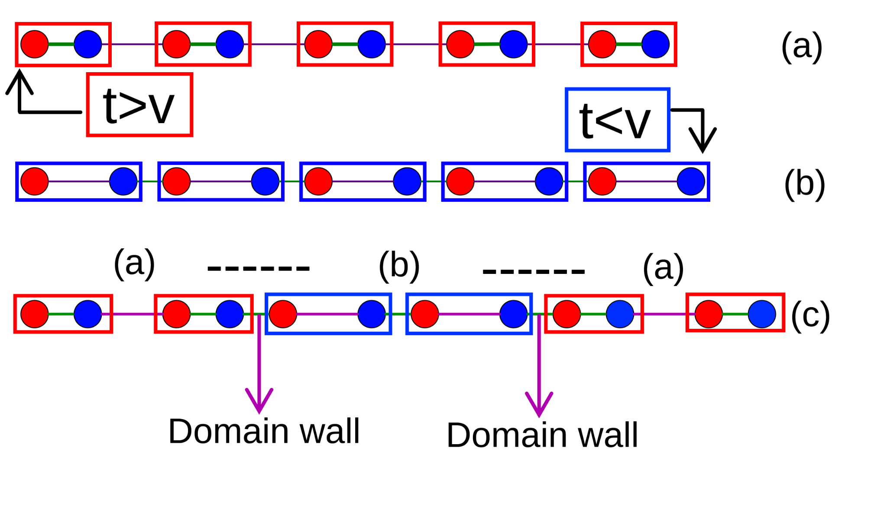

Figure 1. (a), (b) represents the SSH model for an intracell coupling greater than the intercell (t>v) and the opposite (v>t), respectively (each box is a unit cell). They have different winding numbers that define their topology. Both chains can be concatenated (c) and the junction between them is known as domain wall defect. This research focuses on the interaction between these defects.

REFERENCES

[1] F. Lederer et al., Phys. Rep. 463, 1 (2008).

[2] Malkova, N., Hromada, I., Wang, X., Bryant, G., Chen, Z., Opt. Lett. 34, 1633-1635 (2009).

[3] Szameit, A., Nolte, S. J. Phys. B: At. Mol. Opt. Phys. 43 163001 (2010).

[4] W. P. Su, J. R. Schrieffer, A. J. Heeger. PhysRevLett.42.1698 (1979).

[5] Munoz, F., Pinilla, F., Mella, J., Molina, M. Sci Rep 8, 17330 (2018).