Diamond-based nanocomposites as sources of fast X-ray luminescence
in the visible and near-IR range

V. Sedov¹, S. Kuznetsov¹, I. Kamenskikh², A. Martyanov¹, D. Vakalov³, V. Konov¹
¹Prokhorov General Physics Institute of the Russian Academy of Sciences, Moscow, Russia
² Physics Faculty of Lomonosov Moscow State University, Mosco, Russia
³ North Caucasus Federal University, Stavropol, Russia
sedovvadim@yandex.ru

Free-electron lasers allow the generation of coherent electromagnetic radiation in the X-ray range with very high peak power. Thus, there are new challenges in fabricating detectors and visualizers for the “hard” high-power radiation. Diamond is a perfect candidate for the role of X-ray transparent matrix not only due to low X-ray absorption but also due to its high thermal conductivity and chemical/radiation resistance.
Our approach is based on the integration of yttrium-aluminum or gadolinium-aluminum garnets doped with cerium (YAG:Ce and GAG:Ce, accordingly) in form of nanoparticles into robust and X-ray-transparent diamond matrix [1-4]. The solid garnet solutions were synthesized by co-precipitation from aqueous solution technique. Polycrystalline diamond films were grown in microwave plasma in the CVD reactor ARDIS-100. The thickness of composite films was in the range of 3-10 microns with a lateral size of up to 2 inches. The structure and properties of initial powders and obtained composites were studied by scanning electron microscopy, X-ray diffraction patterns, photoluminescence and X-ray luminescence.
The composite films show high-intensity X-ray luminescence with broadband peak at 550 nm (5d → 4f transition in Ce³⁺ ion), and a narrow peak of silicon-vacancy (Si-V) centers at 738 nm. The characteristic decay time was measured at τ_{Ce}<50 ns for cerium emission and at τ_{SiV}~1 ns for Si-V centers.
The proposed composite material may be engineered to show XRL of desired intensity: from low intensities for high-power free-electron lasers up, which allows preserving the energy of the incident X-ray beam, to high intensities for sensitive X-ray detectors. Thus, the luminescent diamond composites suggest a new way to control X-ray visualization for fast X-ray detectors and screens.
The reported study was funded by RFBR, project №20-32-70074.
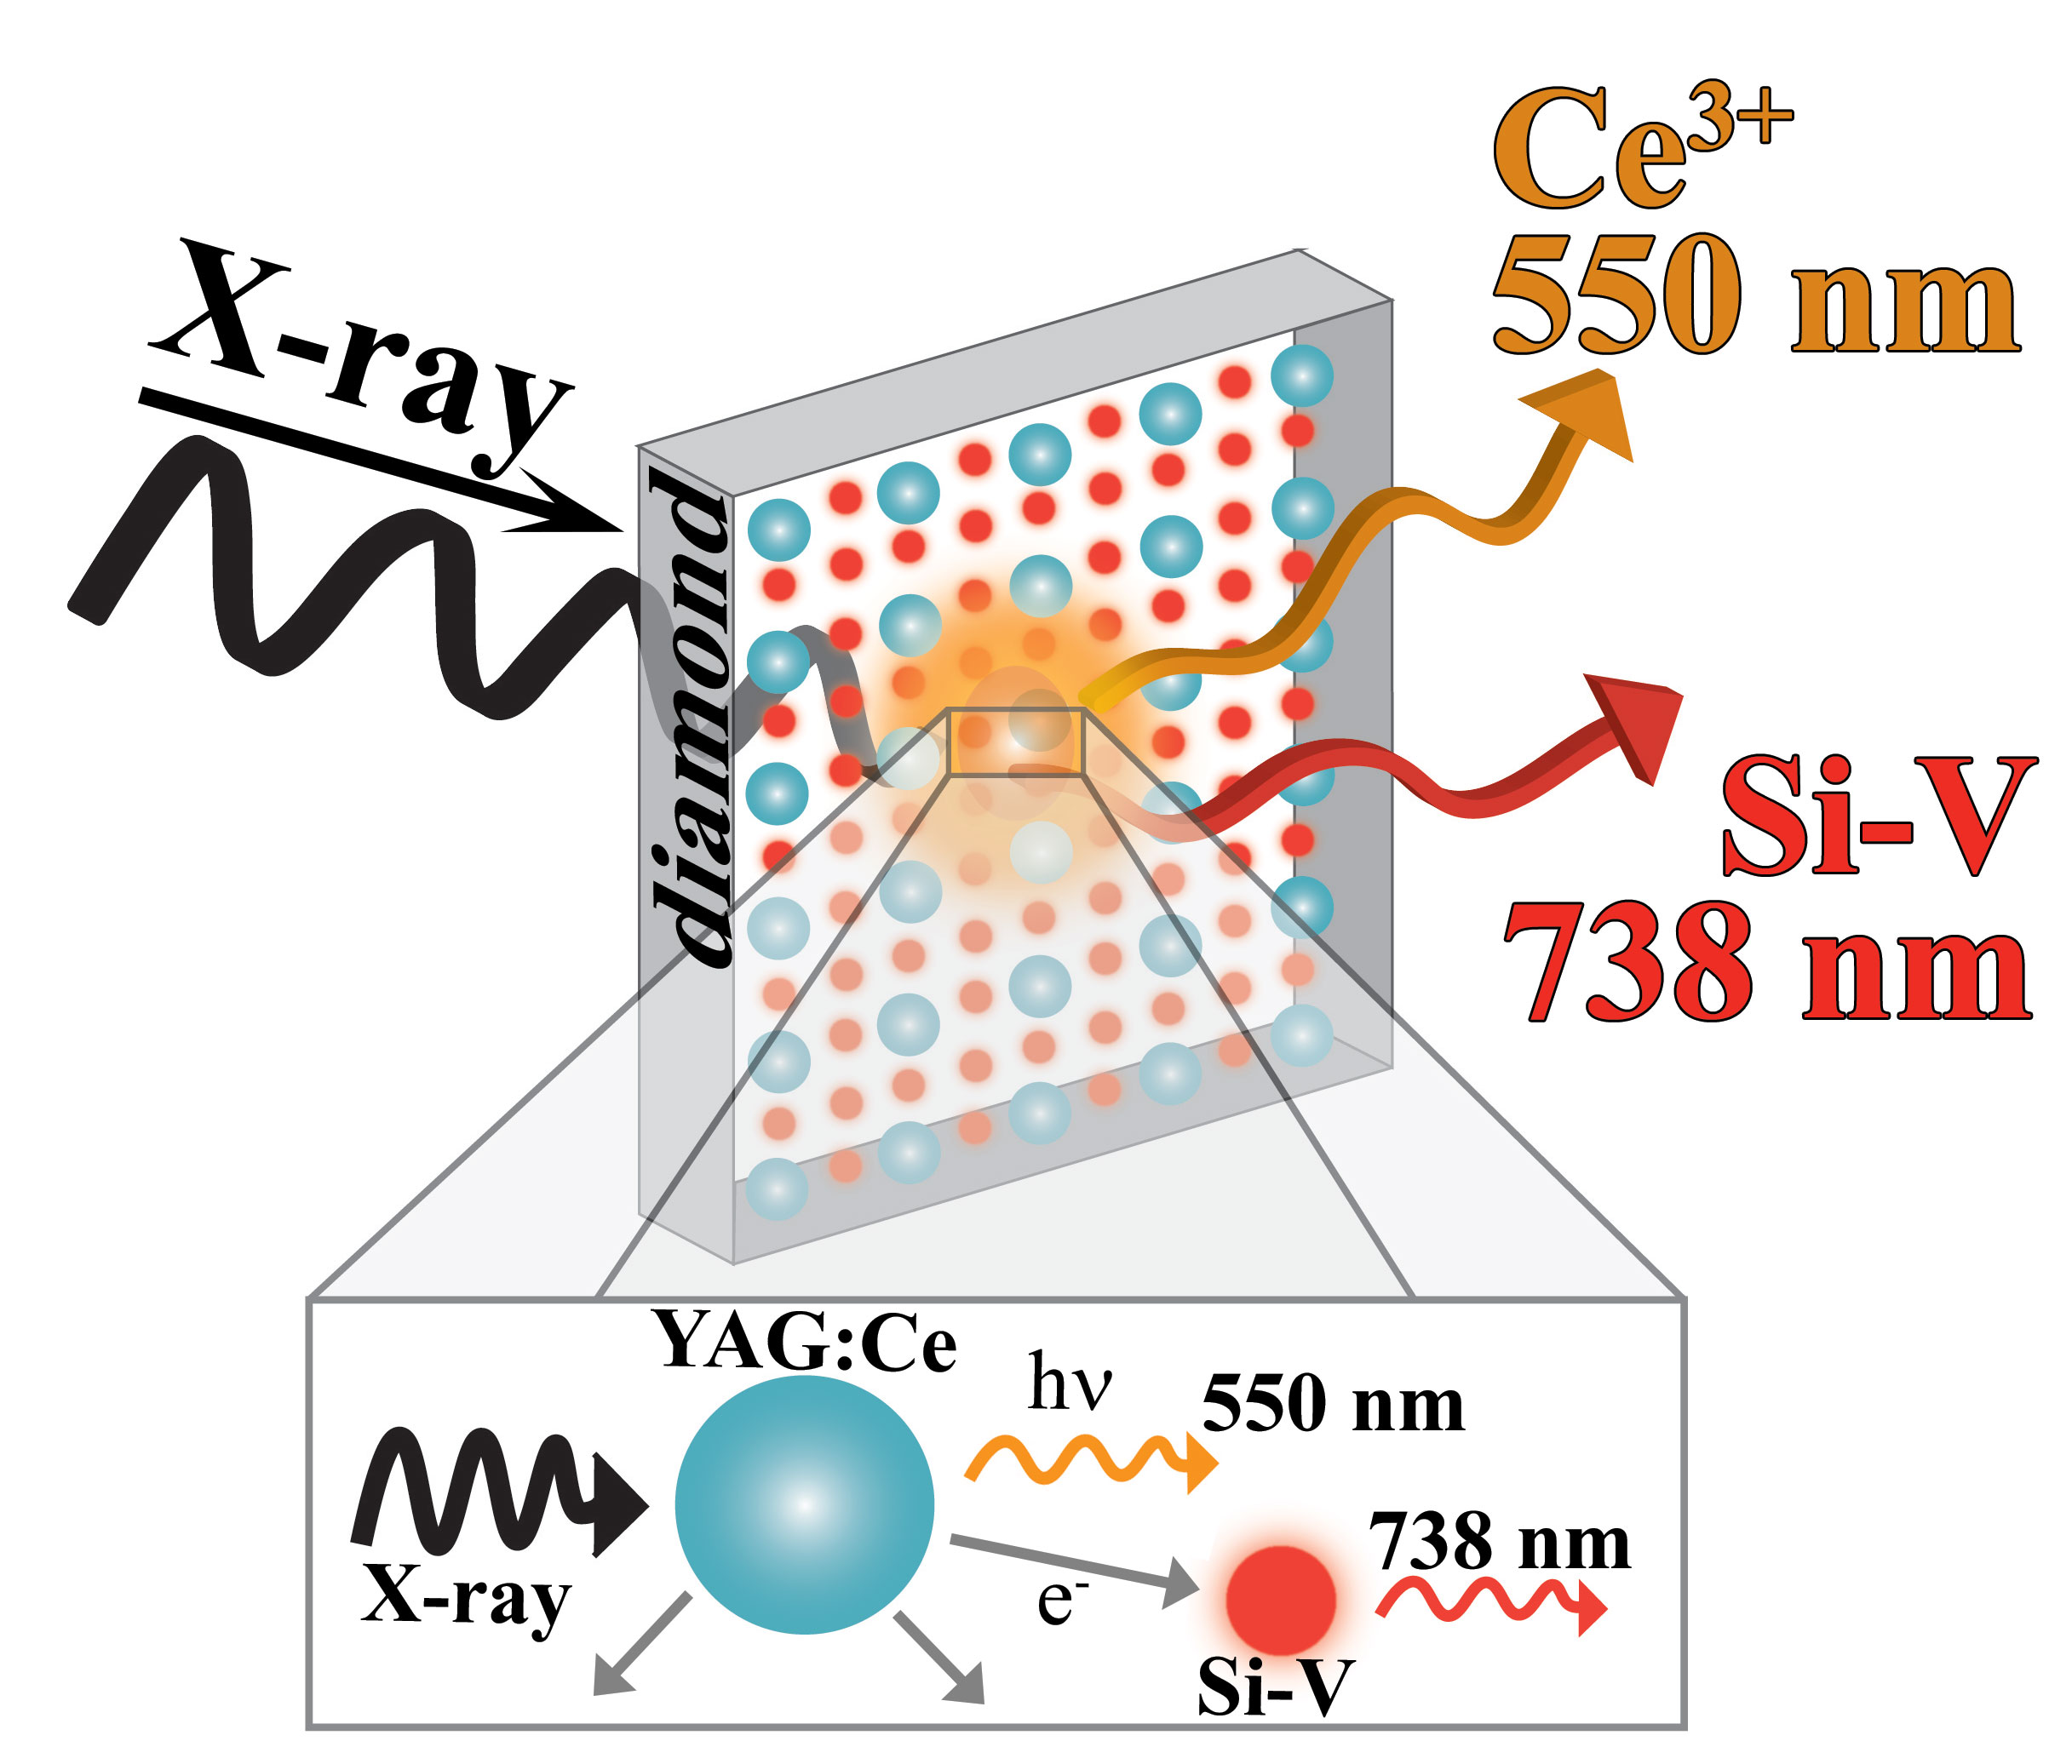
Figure 1. X-ray luminescence mechanism in “Diamond-YAG:Ce” composites.
REFERENCES
[1] V.S. Sedov, S.V. Kuznetsov, V.G. Ralchenko et al. Diam. Relat. Mater. 72, 47 (2017).
[2] V. Sedov, S. Kouznetsov, A. Martyanov et al. ACS Appl. Nano Mater. 3, 1324 (2020).
[3] S.V. Kuznetsov, V.S. Sedov, A.K. Martyanov et al. Ceram. Inter. 47, 13922 (2021).
[4] V. Sedov, S. Kuznetsov, I. Kamenskikh et al. Carbon 174, 52 (2021).

