Coupled waveguide arrays ring resonators

Paloma Vildoso, Scarlett Plaza, and Rodrigo A. Vicencio
Departamento de Física and MIRO, Facultad de Ciencias Física y Matemáticas, Universidad de Chile, Chile
paloma.vildoso@ug.uchile.cl

The study of optical ring resonators (RR) has had a great deal of attention from the scientific community the last years due to there are lot of possible applications for them in laser fabrication, interferometry, telecommunications, optical parametrical oscillators, among others [1]-[3]. There are several works describing the dynamics in systems fabricated in Silicon [4]-[6] as well as in Photonic Crystal configurations [7]-[9]. However, RR using waveguide arrays configurations have not been still developed and our main aim is to explore this possibility. Interestingly, although the coupling mechanism in between the input straight waveguide and the ring resonator itself is based on an evanescent coupling, no relation or analogy with coupled waveguide arrays has been stablish up to now.

In this work, we propose to theoretically and numerically investigate the possibility of a RR analog based on waveguide arrays (WARR). In order to implement this, we propose to use engineered coupling constants with functionality in the propagation coordinate z [see Fig.1(a)]. This is necessary to define a rotation direction as it would happen in a standard RR configuration producing a rotational power increment as shown in Fig.1(b). We compare our main findings with standard RR results in terms of transmission dependence with respect to the coupling in between the detection waveguide and the waveguide ring and, also, with respect to the specific ring size.

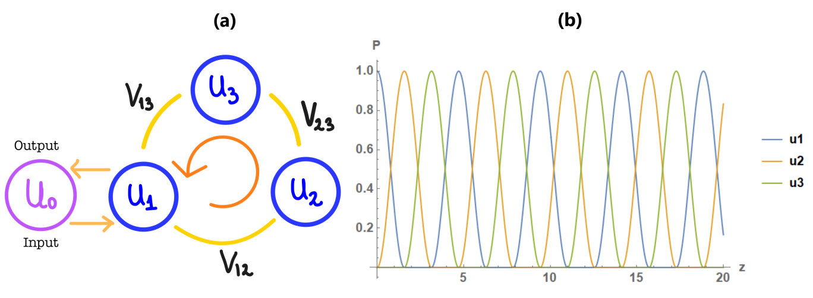

Figure 1. (a) WARR using three waveguides as a ring and other as a detection waveguide. (b) Power vs z for each waveguide in the ring.
REFERENCES

[1] C.L.Linsal et al, APL 106,131101(2015)
[2] Zhenyu Li, Jun Zou, Huihui Zhu et al, ACS Sensors 2020 5 (8), 2448-2456
[3] S. Azzini, D.Grassani,M.J. Strain et al, Opt. Express 20, 23100-23107 (2012)
[4] W.Bogaerts,P.De Heyn, T.Van Vaerenbergh et all, Laser Photonics Rev. 6, No. 1, 47–73 (2012).
[5] John D. Orlet and Ryan C. Bailey, Analytical Chemistry 2020 92 (2), 2331-2338
[6] A. Mirza, F. Sunny, S. Pasricha and M. Nikdast, 2020 Design, Automation & Test in Europe Conference & Exhibition (DATE), 2020, pp. 484-489, doi: 10.23919/DATE48585.2020.9116201.
[7] V. Dinesh Kumar, T. Srinivas, A. Selevarajan, https://doi.org/10.1016/j.photonics.2004.11.001.
[8] Zexuan Qiang, Weidong Zhou, and Richard A. Soref, Opt. Express 15, 1823-1831 (2007)
[9] Wei-Yu Chiu, Tai-Wei Huang, Yen-Hsiang Wu et al, Opt. Express 15, 15500-15506 (2007)

