Optical Phase Locked Loop for Quantum Cascade Laser Frequency Combs

Sandro Dal Cin¹, Johannes Hillbrand^{1,3}, Pitt Allmendinger², Pierre Jouy², Gottfried Strasser¹ and Benedikt Schwarz¹

¹ Institute of Solid State Electronics and Center for Micro- and Nanostructures, TU Wien, Vienna, Austria
² IRsweep AG, Laubisruetistrasse 44, 8714 Staefa, Switzerland
³Quantum Optoelectronics Group, ETH Zürich, Zürich, Switzerland
e-mail: sandro.cin@tuwien.ac.at

Dual comb spectroscopy employing Quantum Cascade Laser (QCL) frequency combs can be used to evaluate and analyze optical absorption features in the easily accessible radio-frequency (RF) domain. This conversion from the optical – to the RF domain has great potential for integration of spectroscopic applications like chemical sensing [1, 2]. A challenge hindering fast reproducible measurements is imposed by temperature fluctuations and electronic noise leading to often highly unstable heterodyne beating signals. We present a simple, yet reliable phase locking technique based on a dual feedback Optical Phase Locked Loop (OPLL). Stable locking bandwidths exceeding 600 kHz for a heterodyne QCL frequency comb setup were achieved (see Figure 1). For loop-filter parameter prediction, a simplified theoretical model is applied. The model relies on two initial measurements, namely the measurement of the phase-frequency-detector (PFD) sensitivity and frequency modulation gain of one frequency comb.
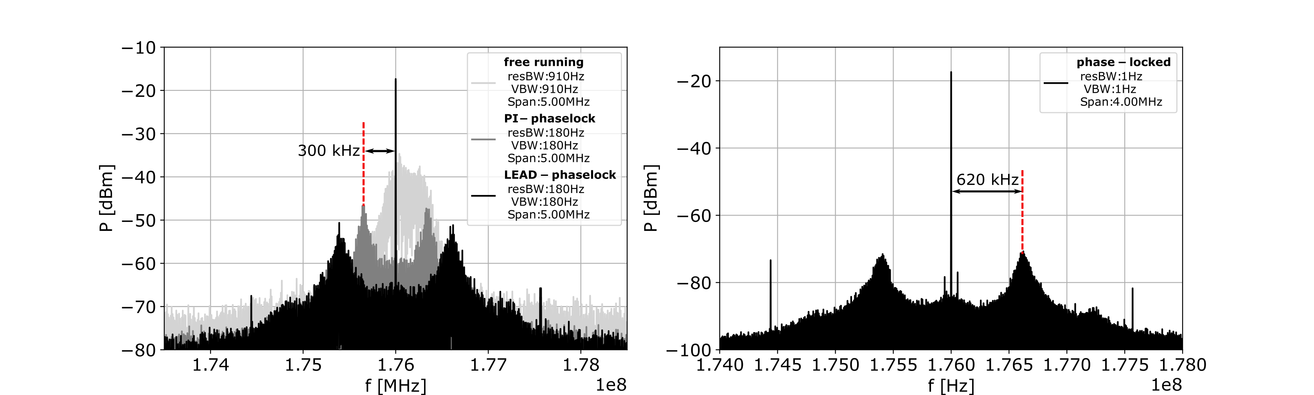

Figure 1. Left: Comparison of one free running beatnote comb tooth (light grey), 300 kHz locking bandwidth with slow loop-filter path active (grey) and 620 kHz locking bandwidth with slow and fast loop-filter path active (black). Right: Higher resolution plot of locked beatnote tooth with 620 kHz locking bandwidth

REFERENCES
[1] Geiser, M. et al. Single-shot microsecond-resolved spectroscopy of the bacteriorhodopsin photocycle with quantum cascade laser frequency combs. Biophys. J. 114, 173a (2018)
[2] Villares, G. et al. On-chip dual-comb based on quantum cascade laser frequency combs. Appl. Phys. Lett. 107, 251104 (2015).

