Transport properties and localized edge modes arising at imperfect kagome lattices

Guillermo Fadic, Diego Román, Javier Cubillos, and Rodrigo A. Vicencio
Departamento de Física and MIRO, Facultad de Ciencias Físicas y Matemáticas, Universidad de Chile, Chile
e-mails: guillermo.fadic@ug.uchile.cl, diego.roman.c@ug.uchile.cl

Physical lattices are generally assumed to be theoretically infinite, which implies that they are boundless. This theoretical assumption is impossible to recreate experimentally. Specific borders, which appear due to to the finite size of real lattices, could prove to be a useful tool in the search for localization of light in specific regions of a given photonic lattice [1]. Inspired by imperfect kagome photonic systems which are available in our laboratory [see Fig.1(a)], we aimed to study the borders of this lattice and the effect of removing some specific lattice sites. To do this, we analyzed the linear modes arising due to a modification of lattice borders and their dependence when considering different system sizes.
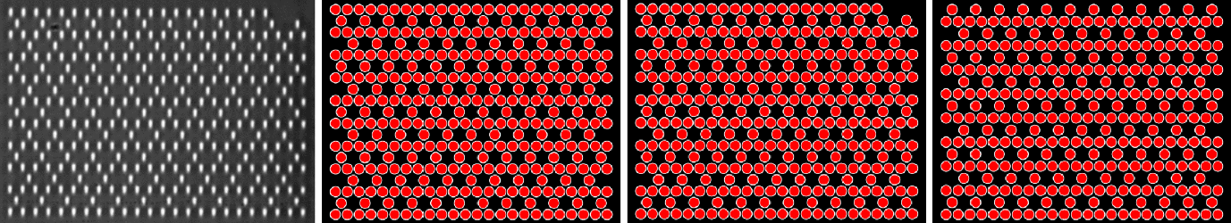
Figure 1. (a) White-light image of an imperfect kagome lattice (see top right corner). Transverse view of different kagome lattices: (b) Perfect, (c) corner-defected, (d) missing-–row kagome lattice.
Femtosecond-laser written waveguides [2], as the ones shown in Fig.1(a), have an elliptical profile which induces an effective anisotropy in coupling constants, destroying the well-known flat band properties of kagome lattices [3,4]. In this work, we are interested on studying the effect of anisotropy by considering non-symmetric diagonal and horizontal coupling constants. Additionally, we notice that a modification of lattice edges [see Figs.1(b)-(d)] gives rise to 1D-like line modes, edge localized modes and side-to-side light oscillations. Imperfections and defects could appear in photonic lattices fabricated using femtosecond-laser writing techniques. We take this not as a problem itself, but as a chance to study photonic lattices considering specific defects, which could offer new possibilities to observe enhanced localization as well as better transport on a given photonic system.

REFERENCES

[1] F. Lederer et al., Phys. Rep. 463, 1 (2008).
[2] A. Szameit et al., Opt. Express 13, 10552 (2005).
[3] Y. Zong et al., Opt. Express 24, 8877 (2016).
[4] R. Vicencio. Advances in Physics: X, 6, 1878057 (2021).

