Interband cascade lasers: overcoming intersubband transitions
in the valence band

H. Knötig¹, R. Weih², N. Opacak¹, S. Höfling^{3,4}, J. Koeth², G. Strasser¹ and B. Schwarz¹
¹Institute of Solid State Electronics and Center for Micro- and Nanostructures, TU Wien, Vienna, Austria
²nanoplus Nanosystems and Technologies GmbH, Gerbrunn, Germany
³Physikalisches Institut and Wilhelm Conrad Röntgen-Research Center for Complex Material Systems, University Würzburg, Germany
⁴SUPA, School of Physics and Astronomy, University of St Andrews, United Kingdom
e-mail:hedwig.knoetig@tuwien.ac.at

Interband cascade lasers (ICLs) [1] are gaining increasing attention as reliable laser sources in the mid-infrared spectral region. They are especially valued due to their low threshold current densities and low power consumption. Continuous-wave (cw) operation at room temperature has been demonstrated at wavelengths from 2.8-5.6 μm in the GaSb material system [2,3] with a performance sweet spot around 3-4 μm. However, extending this range towards longer wavelengths has proven difficult for ICLs, partly originating in a still insufficient understanding of the internal device physics.
Here, we present our recent results on the impact of intersubband absorption in the valence band on the performance of ICLs. We use a numerical model employing the eight-band k·p method to calculate the wavelength-dependent intersubband absorption in the W-quantum well (QW) of the ICL active region. The calculated electronic band structure of an exemplary W-QW is shown in Figure 1. Here, we use a generalized momentum matrix element model, which can explain all contributions to the absorption in the W-QW, regardless of being interband or intersubband transitions.
We experimentally observe a clear performance dependence on the thickness and composition of the Ga_{1−x}In_{x}Sb hole- QW, reflecting in the characteristic temperature T₀ as well as the threshold current density J_{th}, which is supported by our model. By careful design of the active W-QW the intersubband absorption in the valence band can be tailored and even completely avoided, allowing us to enhance ICL performance outside of the sweet spot 3-4 μm region, paving the way towards higher cw operating temperatures and output powers.

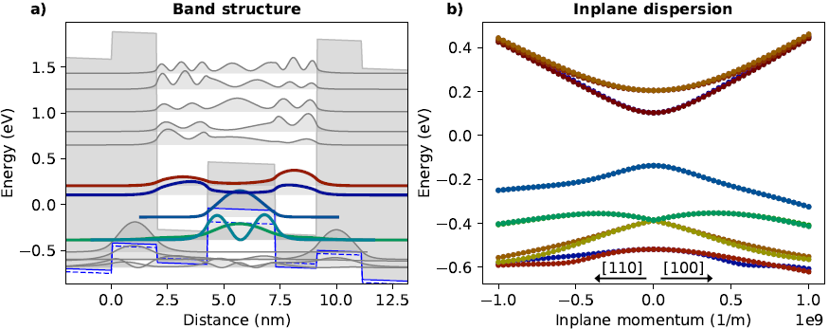
Figure 1. a) Calculated band structure at the Γ-point of an exemplary W-QW consisting of AlSb/ InAs/Ga_{0.65}In_{0.35}Sb/InAs/AlSb layers. b) Same band structure in dependence on wave vector k
REFERENCES
[1] J.R. Meyer et al., Photonics 7, 75 (2020).
[2] J. Scheuermann et al., Applied Physics Letters 106, 161103 (2015).
[3] W.W. Bewley et al., Optics Express 20, 3235 (2012).

