Mobility of localized solutions in a nonlinear graphene ribbon

Ignacio Salinas V., Camilo Cantillano, and Rodrigo A. Vicencio
Departamento de Física and MIRO, Facultad de Ciencias Físicas y Matemáticas, Universidad de Chile, Chile
e-mail: ignacio.salinas@ing.uchile.cl

We consider a quasi-one-dimensional graphene ribbon photonic lattice with Kerr-type nonlinearity. Its linear regime presents four dispersive (DBs) and two flat (FBs) bands. The system has two different compact solutions with amplitude different to zero in only four sites, which are known as localized linear FB modes [1]. When the nonlinearity is switched on, the FB modes continues into two families of compact nonlinear modes with the same amplitude and phase structure, and with no power threshold. We characterize different families of nonlinear localized solutions by inspecting their power, frequency, Hamiltonian and participation ratio as a way to predict different regions in parameter space where different nonlinear solutions could interact effectively by exciting them dynamically [2,3]. We also look for different regions of parameters where a coherent transport across the system could emerge. We find several regions where different stationary solutions perturbated by a phase gradient (kick/angle) show controlled mobility with low power radiation losses. We numerically observe how different localized solutions adiabatically transforms into others as dynamical sequence shows in Figure 1.

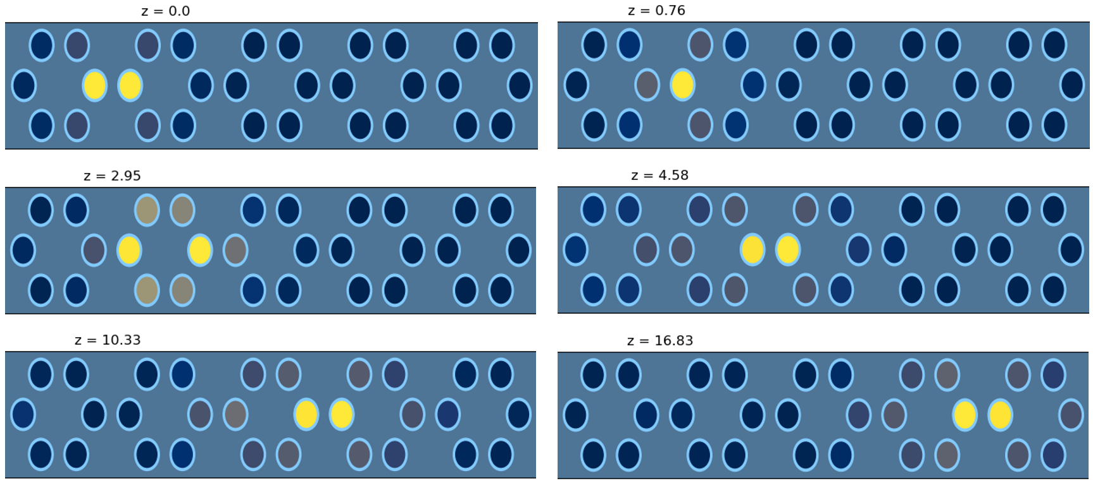

Figure 1. Intensity profiles at different propagation distances, showing mobility of a two-peaks solution.

REFERENCES

[1] C. Cantillano et al., New J. Phys. 20, 033028 (2018).
[2] B. Real and R. A. Vicencio, Phys. Rev. A 98, 053845 (2018).
[3] M. G. Stojanović, M. Stojanović Krasić, A. Maluckov, M. Johansson, I. A. Salinas, R. A. Vicencio and M. Stepić. Phys. Rev. A 102, 023532 (2020).

