Frequency combs generated by a Bloch gain induced giant Kerr nonlinearity

N. Opacak¹, S. D. Cin¹, J. Hillbrand², G. Strasser¹ and B. Schwarz¹
¹Institute of Solid State Electronics, Technische Universität Wien, Gußhausstraße 25-25a Vienna, Austria
²Institute for Quantum Electronics, ETH Zurich, 8093 Zurich, Switzerland
e-mail:nikola.opacak@tuwien.ac.at

Optical nonlinearities are known to coherently couple the amplitude and the phase of light, which can lead to the formation of perfectly periodic waveforms – known as frequency combs (FCs). Recently, self-starting frequency combs that do not rely on the emission of short pulses are appearing in numerous semiconductor laser types, among which is the quantum cascade laser. This novel type of combs is gaining vast attention from researchers due to their self-starting nature and compactness, making them an ideal platform for further development of spectroscopic applications. Their spontaneous formation was explained through an interplay of phenomenological nonlinearity and dispersion in the laser active region [1], although the actual physical processes remained unclear until now. Here we show that Bloch gain – a phenomenon described by Bloch and Zener in the 1930s – plays an essential role in their formation.

We develop a self-consistent theoretical model which couples every aspect of the laser operation – from the electronic band structure and carrier transport, to the spatio-temporal evolution of the electric field inside the laser cavity [2]. We demonstrate that a Bloch gain contribution is present in any laser and becomes dominant under saturation, shown in Fig. 1a). It deviates the gain strongly towards an asymmetric shape, which yields a giant Kerr nonlinearity of and explains the nonzero linewidth enhancement factor [3]. The induced Kerr nonlinearity serves as an efficient locking mechanism and results in the formation of FCs in Fabry-Perot laser cavities (Fig. 1.b). In ring resonators, it leads to the emission of localized structures [4], akin to dissipative Kerr solitons.

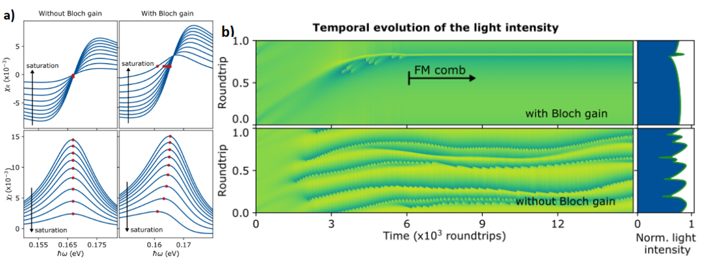

Figure 1. a) Complex susceptibility of the laser active medium with the increase of the laser intensity. b) Temporal evolution of the light intensity inside the laser cavity. Inclusion of the Bloch gain leads to the formation of a stable frequency modulated (FM) comb. Omitting it results in an unlocked state.
REFERENCES
[1] N. Opačak, B. Schwarz, Phys. Rev. Lett. 123, 243902 (2019).
[2] N. Opačak, S. D. Cin, J. Hillbrand et al., arXiv 2102.08167 (2021).
[3] N. Opačak, F. Pilat, D. Kazakov et al., arXiv 2104.05747 (2021).
[4] M. Piccardo, B. Schwarz, D. Kazakov et al. Nature 582, 360 (2020).

