Measuring the Spectrally-Resolved Linewidth Enhancement Factor

Florian Pilat¹, Nikola Opačak¹, Dmitry Kazakov^{1, 2}, Sandro Dal Cin¹, Georg Ramer³, Bernhard Lendl³, Federico Capasso², Gottfried Strasser¹ and Benedikt Schwarz^{1, 2}
¹ Institute of Solid State Electronics, TU Wien, Gusshausstrasse 25-25a, 1040 Vienna, Austria
² John A. Paulson School of Engineering and Applied Sciences, Harvard University, Cambridge, Massachusetts
³ Institute of Chemical Technologies and Analytics,TU Wien, Getreidemarkt 9/164, A 1060 Vienna, Austria
e-mail: florian.pilat@tuwien.ac.at

Semiconductor frequency comb lasers are gaining more and more attention in the last two decades due to their various applications such as high-precision spectroscopy for medical and chemical sensing. The devices are compact and electrically pumped - ideal for miniaturization and integration. The linewidth enhancement factor (LEF) plays a key role in the description of these devices and understanding the dynamic processes like laser linewidth broadening, modulation response and frequency comb formation [1]. Therefore, knowing its value in a real device is of utmost importance. However, as of yet, experimental schemes to determine the LEF were limited to measurements below the lasing threshold or single-mode laser operation. Here we present a novel and universally applicable modulation technique, capable of measuring the LEF of a laser source during operation [2]. For a frequency comb we can infer the LEF over the whole laser spectrum, for each comb mode, in a single-shot measurement. The technique utilizes “Shifted Wave Interference Fourier Transform Spectroscopy” (SWIFTS), a phase-sensitive measurement scheme [3]. Fig. 1a shows a sketch of the experimental setup.

Extensive Maxwell-Bloch simulations are applied to investigate the theoretical model [4]. Then an experimental demonstration is performed on a quantum cascade laser frequency comb. The frequency comb spectrum and the corresponding extracted LEF values are depicted in Fig. 1b.

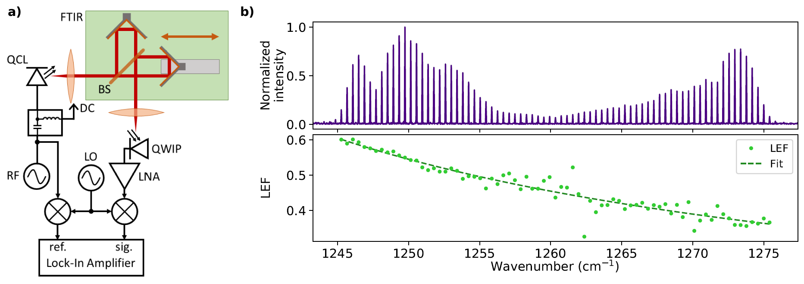
Figure 1. a) Sketch of the experimental setup, b) Intensity spectrum of the laser frequency comb (top), Spectrally-resolved LEF for each comb mode with fit (bottom).

REFERENCES
[1] M. Osinski et al, “Linewidth broadening factor in semiconductor lasers: An overview”, IEEE J. Quant. Electron., (1987)
[2] N. Opačak et al, “Spectrally resolved linewidth enhancement factor of a semiconductor frequency comb”, arXiv:2104.05747 [physics.optics], (2021)
[3] D. Burghoff et al, “Terahertz laser frequencycombs,” Nat. Photonics, (2014)
[4] N. Opačak et al, “Theory of Frequency-Modulated Combs in Lasers with Spatial Hole Burning, Dispersion, and Kerr Nonlinearity”, Phys. Rev. Lett., (2019)

