Subwavelength Optical Lattices

E. Gvozdiovas, P. Račkauskas and G. Juzeliūnas
Institute of Theoretical Physics and Astronomy, Vilnius University, Saulėtekio 3, Vilnius LT-10257, Lithuania
e-mail: gediminas.juzeliunas@tfai.vu.lt

Traditionally, optical lattices are created by interfering two or more light beams, so that atoms are trapped at minima or maxima of the emerging interference pattern depending on the sign of the atomic polarizability [1]. Optical lattices are highly tunable and play an essential role in manipulation of ultracold atoms [2–3]. The characteristic distances over which optical lattice potentials change are limited by diffraction and thus cannot be smaller than half of the optical wavelength λ. Yet the diffraction limit does not necessarily apply to optical lattices [4-7] relying on coherent coupling between atomic internal states. It was demonstrated theoretically [4,5] and experimentally [6] that a periodic array of sub-wavelength barriers can be formed for atoms populating a long lived dark state of the Λ-type atom-light coupling scheme. The Λ scheme has a single dark state, so no spin (or quasi-spin) degree of freedom is involved for the atomic motion in the dark state manifold affected by the sub-wavelength barriers.

In the present talk we will discuss various ways of producing subwavelength optical lattices. In particular, we demonstrate that a tripod atom light coupling scheme shown in Fig. 1 can be used to create a lattice with spin-dependent sub-wavelength barriers [8,9]. The tripod scheme is characterized by two dark states playing the role of quasi-spin states. Inclusion of the spinor degree of freedom provides new possibilities for controlling the spectral and kinetic properties of atoms in the lattice. The tripod lattice can be realized using current experimental techniques.

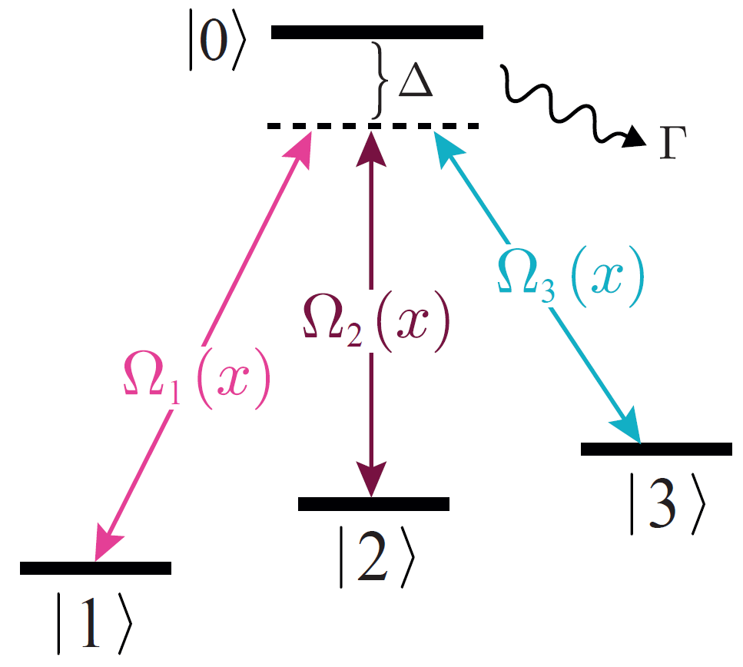

Figure 1. Tripod atom-light coupling scheme.

REFERENCES

[1] I. Bloch, Nature Physics 1(1), 23 (2005).
[2] M. Lewenstein et al., Advances in Physics 56(2), 243 (2007).
[3] I. Bloch, J. Dalibard and W. Zwerger, Rev. Mod. Phys 80, 885 (2008).
[4] M. Łącki et al., Phys. Rev. Lett. 117, 233001 (2016).
[5] F. Jendrzejewski et al., Phys. Rev. A 94, 063422 (2016).
[6] Y. Wang et al, Phys. Rev. Lett. 120, 083601 (2018).
[7] R. P. Anderson et al, Physical Review Research 2, 013149 (2020).
[8] E. Gvozdiovas, P. Račkauskas, G. Juzeliūnas, https://arxiv.org/abs/2105.15148.
[9] P. Kubala, J. Zakrzewski and M. Łącki, https://arxiv.org/abs/2106.04709.

Acknowledgement. This work was supported by the Lithuanian Research Council, Grant number S-MIP-20-36.

