**Experimental observation of edge states in dimerized Stub photonic lattices**

G. Cáceres-Aravena1, B. Real2, C. Cid, D. Guzmán-Silva1, and R.A. Vicencio1

1*Departamento de Física and MIRO, Facultad de Ciencias Física y Matemáticas, Universidad de Chile, Chile* 2*Université de Lille, CNRS, Laboratoire de Physique des Lasers Atomes et Molécules (PhLAM), Lille, France*e-mail: gabriel.caceres@ug.uchile.cl

Inspired by the work of Su-Schrieffer-Heeger [1], we study theoretically and experimentally a dimerized Stub lattice, as shown in Fig.1(a). This lattice has a flat band [2] at βz **=** 0for any value of δ=t1/t2 and edge localized states for δ<1 at βz **= +-t3**, as shown in Fig. 1(b). By suing a femtosecond-laser written technique [3], we fabricate several photonic lattices as the one shown in Fig.1(c). We analyze these photonic lattices using an experimental setup sketched in Fig. 1(d), where we excite edge “wn” waveguides and observe localization for δ<1 and transport for δ>1. Fig.1(e) summarizes all our experimental results and show quite clearly the predicted transition. Numerical edge states are shown in Figs.1(f) and (g), for βz=1 and βz=-1, respectively. Finally, we find a basis change that transform the dimerized Stub model into a SSH model including site energies, giving us some insights of the edge mode origin.

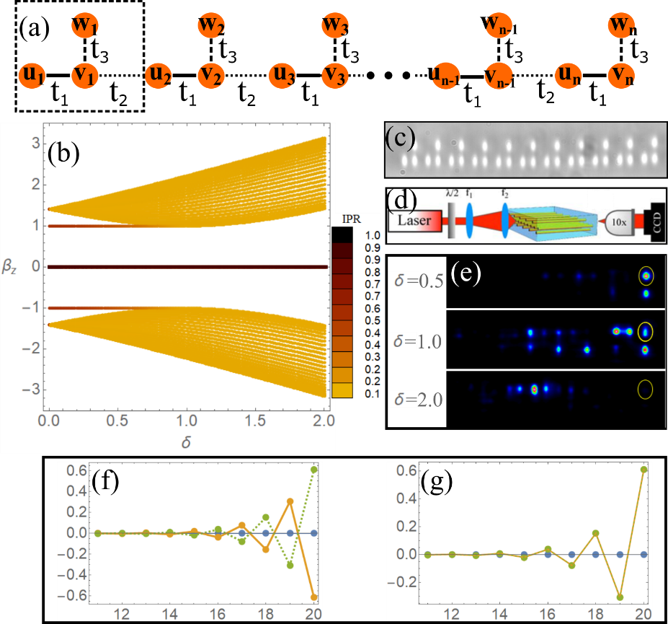

Figure 1. (a) A dimerized Stub lattice. (b) Numerical spectrum for a finite lattice, **t3 =?**. Color represents an inverse participation ratio (IPR). (c) Microscope image at the output facet of a photonic lattice. (d) Experimental characterization setup. (e) Experimental output intensity for a wn input excitation. (f) and (g) Numerical edge states for δ=0.5. Blue, orange and green dots are for “u”, “v” and “w” sites.

REFERENCES

[1] W. P. Su, J. R. Schrieffer, and A. J. Heeger, Phys. Rev.Lett.42, 1698 (1979).

[2] R. Vicencio. Advances in Physics: X, 6, 1878057 (2021).

[3] A. Szameit et al., Opt. Express 13, 10552 (2005).