Localization-delocalization transition in compressed Lieb ribbon lattices

D. Román¹, G. Fadic¹, C. Cid¹, B. Real², D. Guzmán-Silva¹, and R.A. Vicencio¹
¹Departamento de Física and MIRO, Facultad de Ciencias Física y Matemáticas, Universidad de Chile, Chile ²Université de Lille, CNRS, Laboratoire de Physique des Lasers Atomes et Molécules (PhLAM), Lille, France
e-mail: rvicencio@uchile.cl
A Lieb photonic ribbon lattice corresponds to a quasi-1D version of the well known 2D Lieb lattice [1]. Its unit cell is composed by five sites [see Fig.1(a)] and, therefore, the linear spectrum is formed by five bands. Relevant nearest-neighbor interactions are described by horizontal V_{x}, vertical V_{y}, and diagonal V_{d} coupling contants. Depending on the magnitude of coupling interactions, the linear spectrum induce localization or delocalization dynamics. We use a femtosecond-laser writing technique [2], as sketched in Fig.1(b), to fabricate several dimer configurations (vertical, horizontal and diagonal) and characterize the coupling constants versus distance. We identify the vertical separation distance as a critical parameter and find that horizontal and vertical couplings become equal for a constant difference of 1 μm. Then, we fabricated 14 ribbon lattices as the example shown in Fig.1(c). We analyze all fabricated photonic lattices by focusing a HeNe laser beam at the B-bulk site and measure intensity profiles at the output facet, after a propagation of 50 mm. Figs.1(e) show the output profile for different vertical distances, where we observe quite clearly how light is localized for distances larger than 18 μm, while it spreads out for smaller distances. This localization-delocalization transition is generated by a lattice compression that produces a homogeneous reduction of all lattice dimensions, implying an increment of the Fourier linear spectrum.
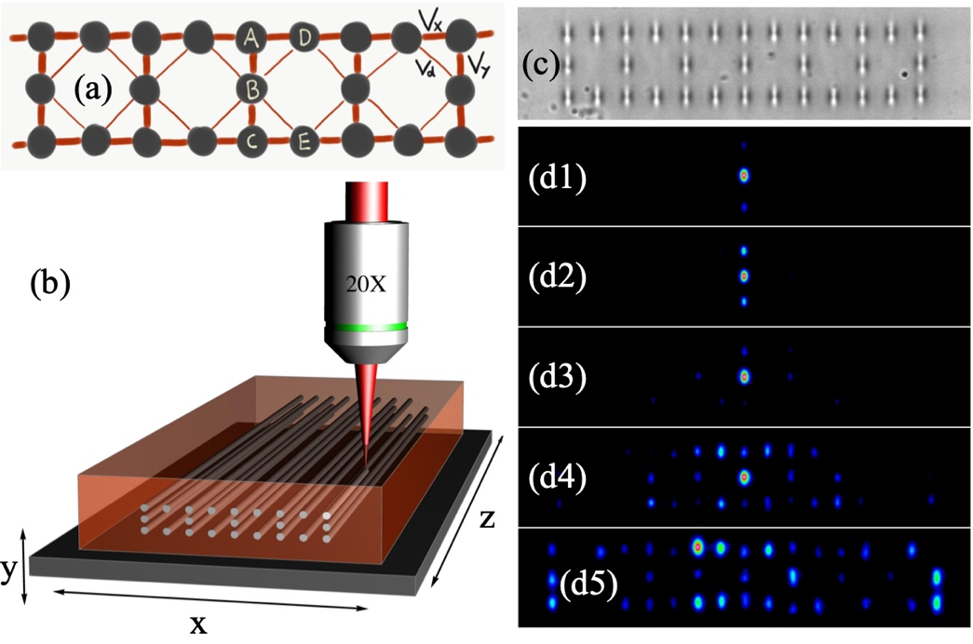
Figure 1. (a) Lieb ribbon lattice. (b) Femtosecond-laser writing technique. (c) White-light image of a Lieb ribbon photonic lattice. (d1)-(d5) Output intensity profiles for a nominal distance d = 22, 20, 18, 16, y 14 μm.

REFERENCES
[1] R.A.Vicencio. Advances in Physics: X, 6, 1878057 (2021).
[2] A. Szameit, et al., Opt. Express 13, 10552 (2005).

