Photonic and plasmonic semiconductor nanowire lasers

Carsten Ronning¹
¹Institute of Solid State Physics, Friedrich Schiller University Jena, Germany

carsten.ronning@uni-jena.de

The miniaturization of light sources, the confinement and manipulation of light on a sub-wavelength scale as well as the detection of single photons are key challenges for the realization of future photonic circuits. Here, semiconductor nanowires are of major interest as a serving material platform, since they do not only offer superior photonic properties, but can also bridge the interface to electronic circuits enabled by their semiconducting properties. The efficient and sub-wavelength waveguiding of light is one of such superior photonic properties specifying nanowires as truly one-dimensional systems for photons [1]. It is also an important prerequisite and defines the geometrical diameter limit for enabling lasing oscillations within nanowire cavities [2,3]. High pumping powers and gain values are necessary in order to overcome the thresholds for amplified spontaneous emission (ASE) and laser oscillations. We determined those thresholds for both ZnO and CdS nanowires as well as the geometrical limitations [3,4]. Furthermore, the laser output originating out of the end facet of a single nanowire was detected “head-on”, and a double pump technique was applied to measure the laser dynamics [5-7]. Finally, I will present in this presentation the possibility of coupling such lasing nanowires with plasmonic structures in order to accelerate the dynamics and confine the light field even into much smaller structures [8,9], which provides a useful benchmark for the future development of these nanoscale devices.

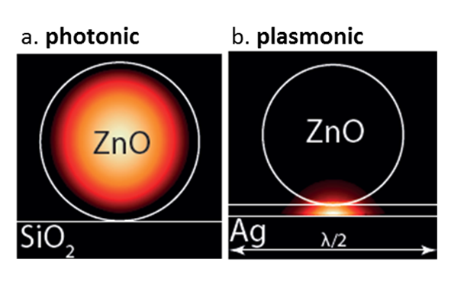

Figure 1. (left) Emission pattern, polarization and dynamics of photonic nanowire lasers as a function of their diameter, (right) field distributions in photonic and plasmonic nanowire lasers.
REFERENCES
[1] T. Voss, et al., Nano Letters 7, 3675 (2007)
[2] M. Zimmler, et al., Appl. Phys. Lett. 93, 051101 (2008).
[3] M. Zimmler, et al., Semi. Sci. and Techn. 25, 024001 (2010) - review.
[4] S. Geburt, et al., Nanotechnology 23, 365204 (2012)
[5] R. Röder, et a., Nano Letters 15, 4638 (2015)
[6] R. Röder, et al., Nano Letters 16, 2878 (2016)
[7] M. Zapf, et al., Advanced Optical Materials 7, 1900504 (2019)
[9] T.P.H. Sidiropoulos, et al., Nature Physics 10, 870 (2014)
[9] V. Sorger, et al., Nano Letters 11, 4907 (2011)

