Influence of UV radiation on the time response of a resistive gas sensor based on liquid-phase exfoliated graphene

M. V. Bošković¹, S. Andrić¹, M. Frantlović¹, I. Jokić¹, M. Sarajlić¹, T. Vićentić¹, and M. Spasenović¹
University of Belgrade - Institute of Chemistry, Technology and Metallurgy - Department of Microelectronic Technologies - National Institute of the Republic of Serbia, Belgrade, Serbia
e-mail:boskovic@nanosys.ihtm.bg.ac.rs

Graphene as an active surface for gas sensors attracts increasing attention. It has excellent intrinsic properties, such as high electrical conductivity and low electrical noise, and, since it is two-dimensional, all carbon atoms can react with the analyte [1]. These properties reduce the detection limit of graphene-based sensors down to a single molecule [2]. However, the aforementioned statement holds only for ideal graphene, without any impurities [3]. These impurities are typically a consequence of chemicals used for the synthesis and/or transfer process [3]. During the transfer process to the target substrate and before a gas-sensing experiment, graphene is in the ambient atmosphere, which inevitably results in the adsorption of water and other molecules from the air on its surface. Annealing at high temperatures (above 200 ˚C) is a well-established procedure for cleaning graphene surface [3]. As an alternative, exposing graphene films to the UV radiation of appropriate intensity was proposed [2].
Herein we investigate the influence of UV irradiation on the time response of a resistive gas sensor with a liquid-phase exfoliated graphene [4] as the active material. The effect of exposure to UV light on the baseline electrical resistance (in inert atmosphere) will be compared with the effect of the annealing process. The influence of various intensities of UV radiation on the response and recovery time, repeatability and detection limit of graphene will be discussed.

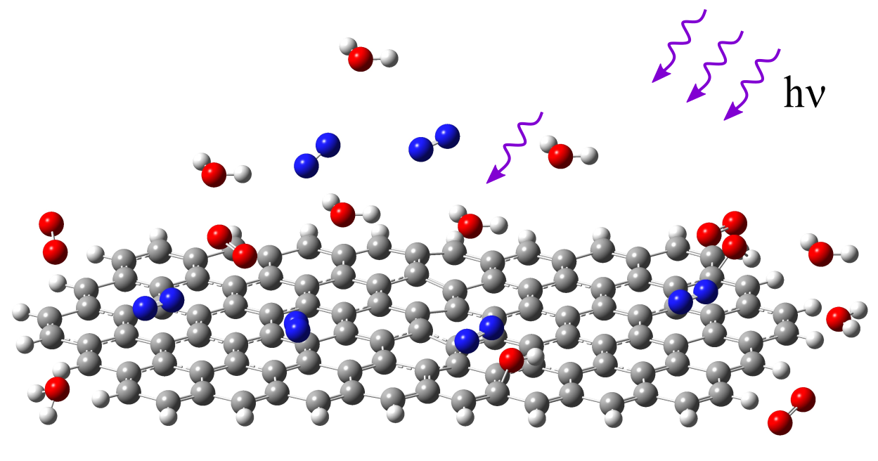
Figure 1. Illustration of UV-induced gas desorption from graphene surface

REFERENCES
[1] F. Schedin, A. K. Geim, S.V. Morozov, E.W. Hill, P. Blake, M.I. Katsnelson, and K.S. Novoselov, “Detection of individual gas molecules adsorbed on graphene.,” Nat. Mater. United Kingdom, 6 652 (2007)
[2] C.-M. Yang, T.-C. Chen, Y.-C. Yang, and M. Meyyappan, “Annealing effect on UV-illuminated recovery in gas response of graphene-based NO₂ sensors,” RSC Adv. United Kingdom. 9 23343 (2019)
[3] X. Yan, Y. Wu, R. Li, C. Shi, R. Moro, Y. Ma, and L. Ma, “High performance UV-Assisted NO₂ Sensor Based on Chemical Vapor Deposition Graphene at Room Temperature”, ACS OMEGA, USA. 4, 14179 (2019)
[4] S. Andrić, T. Tomašević-Ilić, M. V Bošković, M. Sarajlić, D. Vasiljević-Radović, M. M Smiljanić, M. Spasenović “Ultrafast humidity sensor based on liquid phase exfoliated graphene“, Nanotechnology United Kingdom. 32 025505 (2020)

