**The electron coherent transport in nonpolar m-plane ZnO/MgZnO resonant tunneling diodes**

X. Wang, A. Demić, Z. Ikonić, R. W. Kelsall and D. Indjin

*School of Electronic & Electrical Engineering, University of Leeds,*

*Woodhouse Lane, Leeds, LS2 9JT, U.K.*

*e-mail:* *el17xw@leeds.ac.uk ; d.indjin@leeds.ac.uk*

GaAs-based quantum cascade lasers (QCLs) are the most promising devices emitting in terahertz frequency range, but they lack significant improvements within recent years and are still limited to operation at low temperatures (~250K). They are fundamentally limited by electron-optical LO-phonon resonance at around 36meV in GaAs, causing parasitic non-radiative depopulation of the upper laser level at room temperature. Promising alternative semiconductors to solve this problem include new material systems like ZnO with their larger LO-phonon energy (~72meV) [1]. ZnO-based semiconductor compounds are promising materials not only because their high LO-phonon energy, but also due to their large bandgap and conduction band offset energy and resistance to the high breakdown electric field [1]. Moreover, it was established [2] that the ZnO-based terahertz sources can cover the spectral region of 5–12 THz, which is very important for THz imaging and detection of explosive materials, and which could be not covered by conventional GaAs-based terahertz devices. Recent progress in growth of non-polar m-plane ZnO-based heterostructures and devices with low density defects [3], opens a wide perspective towards design and fabrication of non-polar m-plane ZnO-based unipolar intersubband structures capable of operation at elevated temperature. We present the results of a simulation of coherent electron transport in non-polar m-plane ZnO/MgZnO double-barrier resonant tunneling diode by solving Schrödinger-Poisson equations self-consistently. It is found that in current density-voltage characteristics of such devices a region is present with negative differential resistance.

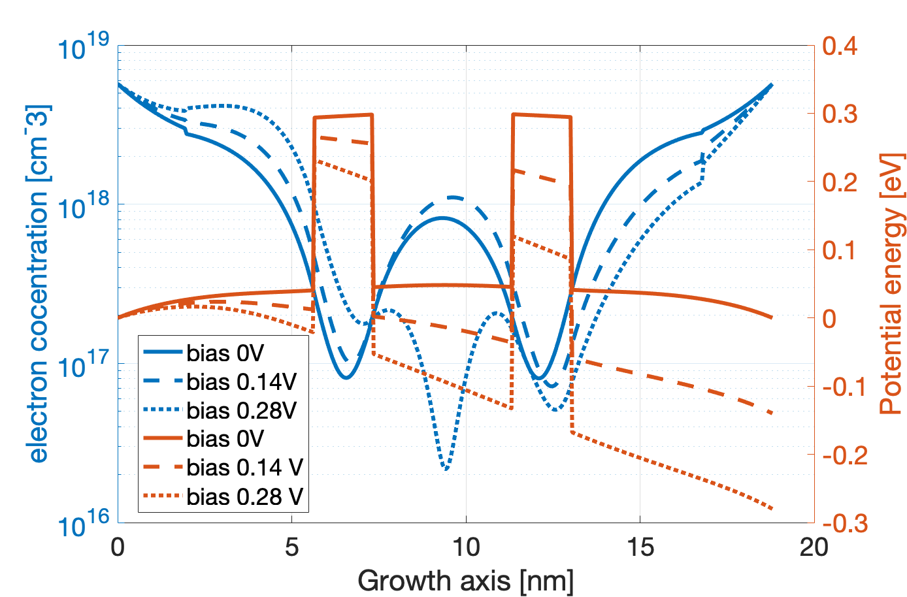We simulated the different combinations of ZnO/MgZnO resonant-tunneling diodes at room temperature. Calculation shows a high sensitivity of the tunneling current peak on monolayer-scale barrier structure fluctuation which strongly affects peak to valley ratio in the structure.

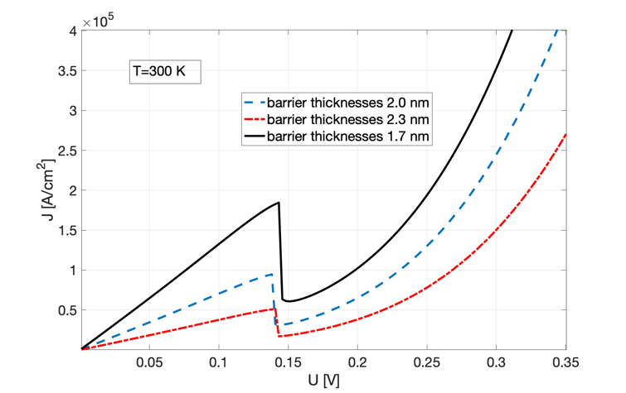

Figure 1. Left: Current denisty-voltage charactersitics of ZnO/Mg0.15Zn0.85O resonant tunneling diodes with monolayer-scale fluctuation of barrier thickness. Nominal layer thickness in nanometers are 5.7/**2.0**/4.0/**2.0**/5.7

Right: Self-consistant potential and corresponing electron concentartion for three different biasing

conditions. Emitter and collector layers (underlined) doping is used to be 1×1018cm-3

[1]. V.P. Sirkeli, H.L. Hartnagel, Opto-Electronics Review, **27**, 119-122 (2019). [doi:10.1016/j.opelre.2019.04.002]

[2] B. Meng et al, ACS Photonics, **8**, 343−349 (2021); [https://dx.doi.org/10.1021/acsphotonics.0c01641]

[3] N.Le Biavan et al, Appl. Phys. Lett. **111**, 231903 (2017); [https://doi.org/10.1063/1.5003146]