Determination of refractive index of ultrathin dielectric films prepared via layer-by-layer polyelectrolyte deposition

S. Nedić¹, S. Aškrabić¹, B. Vasić¹ and G. Isić¹
¹ Institute of Physics Belgrade, University of Belgrade, Belgrade, Serbia
e-mail:snedic@ipb.ac.rs

In this work, layer-by-layer polyelectrolyte deposition has been studied by alternately immersing the Si/SiO₂(300 nm) substrates into successive aqueous solutions of cationic poly(allylamine hydrochloride) (PAH) and anionic poly(sodium 4-styrenesulfonate) (PSS) polyelectrolytes with intermediate rinsing steps [1]. Base piranha approach was adopted for the surface functionalization (SF) of the substrates by dipping them into the NH₄OH/H₂O₂ mix for 2 h at 50°C in order to create an OH⁻ terminated surface prior to exposing the samples to the positively charged PAH.

Due to their thickness at the nanometer scale, the characterization of polyelectrolyte multilayer films requires highly sensitive techniques such as spectroscopic ellipsometry (SE) and atomic force microscopy (AFM). Both techniques verified the presence of polyelectrolyte multilayer films. Particularly, SE measurements demonstrated consistent shifts in the most prominent tanΨ peak resulting in an increase in the peak’s wavelength shift with the increasing number of bilayers (Figure 1), whereas the SF and PAH/PSS bilayer thicknesses were established by AFM scratching and are approximately ~0.5 nm and ~1.1-1.4 nm, respectively.

The empirical Cauchy model can be used for approximation of the real part of the refractive index within spectral regions for which the material has very low or non-existing absorption [2]. Furthermore, complex refractive index of a layer in a multilayer structure can be extracted by direct inversion when the thickness of the layer is known. In accordance with this, the thicknesses of the polyelectrolyte multilayer films established by AFM were used to calculate the complex refractive indices. Finally, direct inversion and parametric fitting based on the Cauchy model have been utilized in order to fully determine the real and imaginary parts of the refractive index of ultrathin polyelectrolyte multilayer films in the wavelength range of 200-800 nm.

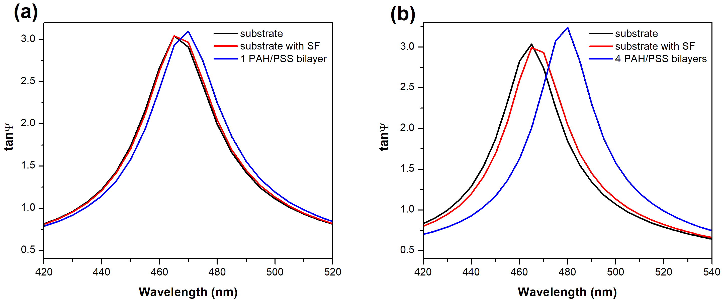

Figure 1. Experimentally measured ellipsometric spectra of two different Si/SiO₂(300 nm) substrates with SF and (a) one, and (b) four PAH/PSS bilayers.

REFERENCES
[1] P. T. Hammond, “Form and function in multilayer assembly: New applications at the nanoscale,” Adv. Mater. 16, 1271-1293 (2004).
[2] H. G. Tompkins, E. A. Irene, "Handbook of Ellipsometry,"William Andrew Publishing - Springer (2005).

