**Searching for topological defects of bosonic ultralight field with optically detected magnetic resonance: design, calibration and sensitivities of Belgrade GNOME station atomic optical magnetometer**

Z. D Grujic1 and S. Topic1,2

1*Institue of Physics, Belgrade, Serbia*

2*Faculty of Physics, University of Belgrade, Serbia*

e-mail:sasa.topic.sale@gmail.com

In this poster we present the design and calibration of caesium atomic magnetometer and estimate its ultimate reach in terms of mass and interaction strength of hypothetical axionic or axion-like dark matter in the form of topological defects. Hypothetical axions or Axion Like Particles (ALP‘s) are form of ultralight bosonic matter that are postulated in order to solve strong CP problem, matter-antimatter imbalance in the Universe and may well solve current ΛCDM observational discrepancies and H0 tensions. Dark matter problem, exuberated by negative results of search for WIMP‘s, core-cusp problem, missing satellites problem and others may be solved by a type of ultralight matter model which can reconcile GR and MOND paradigms. This model has a number of detectable signatures, one being in the form of axionic field coupling to fermions that results in formation of pseudomagnetic fields during passage through topological defects. The GNOME experiment is designed as a GPS referenced worldwide distributed network of quantum cross-correlated sensors that increases its sensitivity reach and excludes false positives by methodology similar to LIGO network. Belgrade GNOME station is built around a double resonant RF optical cesium magnetometer in Mx configuration and is capable of functioning as a scalar magnetometer with a sensitivity less than 100fT/√Hz. We will present different modes of operations, give an overview of atomic magnetometry and quantify various noise contributions. Special space will be given to PSD, sensitivities, and stability over short and long baselines of the setup. Guidelines for future work and a series of easy to do improvements shall also be mentioned.

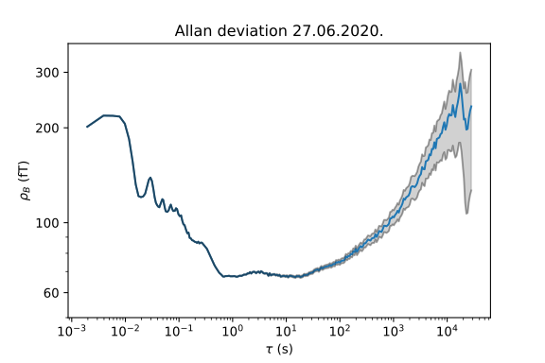

Figure 1. Allan deviation plot for magnetometer in phase locked loop.

REFERENCES

1. D. Budker and M.V. Romalis, *Nat. Phys*., **23** (2007), 229
2. M. Pospelov, et al., *Phys. Rev. Lett.,* **110** (2013), 021803
3. J. Preskill, M. B. Wise and F. Wilczek, *Phys. Lett*., **B120** (1983), 127
4. S. M. Carroll, *Phys. Rev. Lett.,* **81** (1998), 3067
5. Pustelny et al., *Ann. Phys.,* **525** (2013), 659-670
6. M.P. Ledbetter, M.V. Romalis and D.F. Jackson Kimball, *Phys. Rev. Lett.,* **110** (2013), 040402