**Optimization of Optoelectronic Properties of Electrochemically Exfoliated Graphene by Cascade Centrifugation**

T. Vićentić1, S. Andrić1, M. Bošković1, J. Stevanović1, I. Pašti2 and M. Spasenović1

1*Center for Microelectronic Technologies, Institute of Chemistry, Technology and Metallurgy, University of Belgrade, Serbia*

*2Faculty of Physical Chemistry, University of Belgrade, Serbia*

e-mail: teodora@nanosys.ihtm.bg.ac.rs

Graphene dispersions produced by the process of electrochemical exfoliation were used for preparing multi-layered graphene films for transparent conductor applications. In order to achieve homogeneous films with defined particle sizes from a solution with a wide distribution of initial particle sizes, cascade centrifugation was used. The particle size was selected by low-speed centrifugation, with rate values: 2, 3, 3.5, 4 and 5 krpm. After each step of centrifugation, supernatants were used as initial solutions for the following steps, while the sediments were collected and redispersed by using N-methyl-2-pyrrolidone as a solvent [1]. To study optical properties of produced graphene films, the dispersions were deposited onto glass substrates and UV/VIS spectroscopy was performed. Films with the best optical properties were selected and the same dispersions were deposited onto substrates with electrodes, to examine electronic properties of the films. Films had an optical transparency of ~83% in the visible part of the spectrum, and initial resistances between 8∙103 and 1.6∙107 Ohms. In order to improve electronic properties, the active surface was treated with nitric acid. After the treatment, sheet resistance decreased by a factor of 1,000, which makes these films good candidates for transparent electrodes. Scanning electron microscopy was used to analyze the surfaces of both treated and non-treated films.

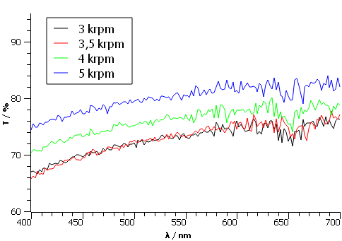

Figure 1. UV/VIS spectra for different graphene films.

REFERENCES

[1] C. Backes et al, Production of Highly Monolayer Enriched Dispersions of Liquid-Exfoliated Nanosheets by Liquid Cascade Centrifugation, ACS Nano 10, 1, 1589–1601 (2016).