Multiphysics modelling of infrared photodetectors based on graphene

E. Lidorikis
Department of Materials Science and Engineering, University of Ioannina, 45110 Ioannina, Greece
Institute of Materials Science and Computing, University Research Center of Ioannina, 45110 Ioannina, Greece
e-mail: elidorik@uoi.gr

Graphene’s optical response is characterized by constant absorption in the visible, electrically tunable absorption in the NIR-SWIR and plasmonic excitations in the midIR-LWIR spectrum. These traits make for interesting applications in photodetection, light modulation and sensing. To make the response more efficient and competitive, however, the small overall absorption in graphene must be overcome by integrating graphene with resonant photonic or plasmonic cavities. Strong light absorption within the resonators creates hot electrons and temperature gradients. In a comprehensive modeling and design scheme of graphene-based optoelectronic applications, the optical, thermal, and electrical responses must be considered within a self-consistent approach: absorption creates hot carriers, whose temperature distribution is determined by the thermal properties of graphene and the appropriate relaxation pathways and corresponding rates. But the thermal properties and the absorption in graphene are themselves functions of the temperature. After a short introduction in graphene physics and computational methods, we will go over our recent studies on several graphene-based optoelectronic devices. An example is shown in Fig. 1, where a free-space MIR detector based on hBN-encapsulated graphene with plasmonic antenna and p-n lateral split gates was simulated, with modelled responsivities showing remarkable agreement to experimental measurements [1].
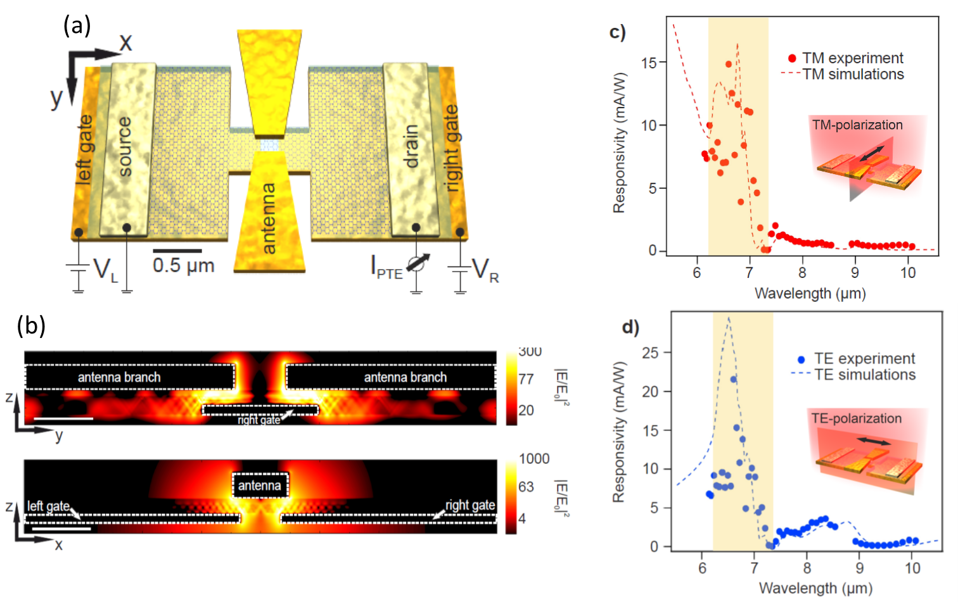
Figure 1: (a) schematic of a free space MIR photodetector based on hBN-encapsulated graphene with plasmonic antenna and p-n lateral split gates. (b) Plasmonically enhanced field intensity, where the transmission lines of hBN hyperboliv phonon-polaritos are shown. (c)-(d) Measured and simulated responsivities for the TM and TE polarizations respectively.

REFERENCES
[1] S. Castilla, I. Vangelidis, V.-V. Pusapati, J. Goldstein, M. Autore, T. Slipchenko, K. Rajendran, S. Kim, K. Watanabe, T. Taniguchi, L. Martín-Moreno, D. Englund, K.J. Tielrooij, R. Hillenbrand, E. Lidorikis, F.H.L Koppens, “Plasmonic antenna coupling to hyperbolic phonon-polaritons for sensitive and fast mid-infrared photodetection with graphene”, Nature Communications 11, 4872 (2020).

