Nanoscopy of van der Waals heterostructures fabricated by the wet transfer method

J. Obradović¹, S. Aškrabić², D. Čapeta³, U. Ralević²
¹School of Electrical Engineering, University of Belgrade, Serbia
²Institute of Physics Belgrade, University of Belgrade, Serbia
³Center for Excellence for Advanced Materials and Sensing Devices, Institute of Physics, Zagreb, Croatia
e-mail: uros@ipb.ac.rs

Two dimensional crystals have been in the focus of the scientific research for almost two decades, since the discovery of their first representative, graphene [1]. Among other properties which make these materials interesting for various applications ranging from tribology to optoelectronics, the possibility to combine them at will into vertical stacks, called van der Waals heterostructures (VdWhs), has opened the door to a world of new, equally interesting, and unique materials whose electronic and optical properties can be tailored by changing the VdWh constituents [1].

In this work we investigate VdWhs fabricated from 2D transition metal dichalcogenides (WS₂ and MoS₂, in particular), which are considered to be strong candidates for various applications in the fields of optics and optoelectronics [2]. The fabrication of these heterostructures was done using a modified variant of the wet transfer method which has proven to be superior to the commonly used procedures in terms of its simplicity and quality of the produced VdWh [3]. The structural and optical properties of the VdWh fabricated by this method were thoroughly investigated by atomic force microscopy, Raman and photoluminescence spectroscopy. The analysis of the results obtained from the afore mentioned characterization techniques shows that VdWh have low amount of surface contaminants, unmodified crystal structure, high and uniform photoluminescence intensity. The issue of interlayer contamination, which is inevitable due to the transfer procedure itself, was mitigated by low temperature annealing.

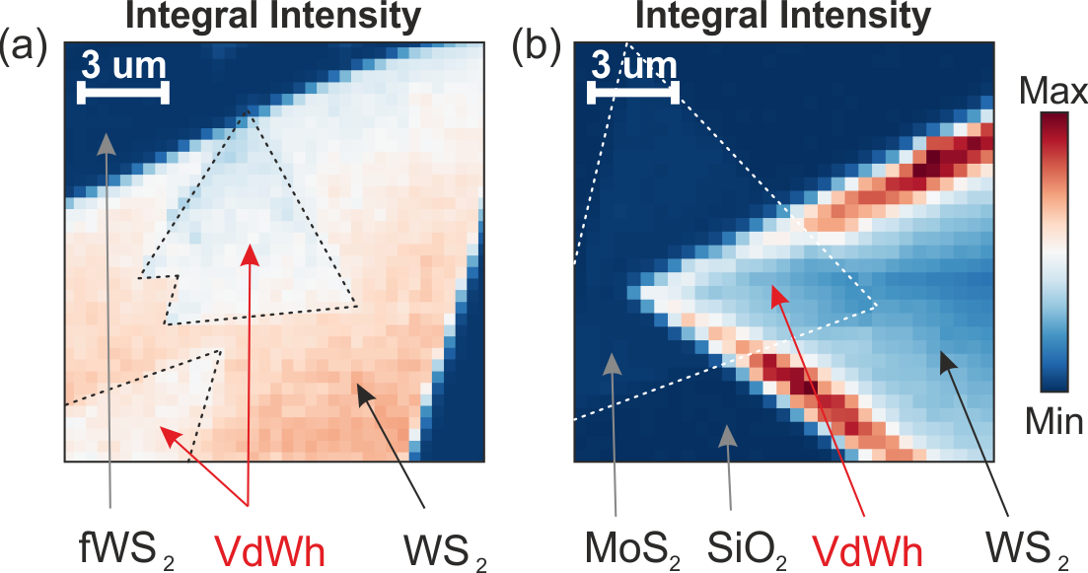

Figure 1. PL maps of MoS₂ / WS₂ VdWh recorded for the VdWhs (a) in the center, (b) at the edge of the large WS₂ monolayer.

REFERENCES
[1] K.S. Novoselov, A. Mishchenko, A. Carvalho, A. H. Castro Neto, Sicence 353, 9439 (2016)
[2] Y. Liu, N. O. Weiss, X. Duan, H.-C. Cheng, Y. Huang, X. Duan, Nat.Rev.Mater. 1, 16042 (2016)
[3] I. Niehues, A. Blob, T. Stiehm, R. Schmidt, V. Jadriško, B. Radatović, D. Čapeta, M. Kralj, S. M. de Vasconcellos, R. Bratschitsch, 2D Mater. 5, 031003(2018)

