Light absorption in two-dimensional crystals covered by randomly distributed plasmonic nanoparticles

G. Isić^{1,2}, U. Ralević¹ and M. R. Belić²
¹Institute of Physics Belgrade, University of Belgrade, Belgrade, Serbia
²Texas A&M University at Qatar, Doha, Qatar
e-mail:isicg@ipb.ac.rs

The discovery of many thermodynamically stable two-dimensional crystals attainable, amongst others, by the mechanical exfoliation method [1] has, since the 2000s, been inspiring the investigation of a range of electronic and, more recently, optoelectronic systems featuring such atomically thin layers either individually or stacked into so-called van der Waals heterostructures. In case of van der Waals heterostructure photovoltaics [2], light trapping strategies gain in significance as the active layer thickness is typically two orders of magnitude smaller than the wavelength.

We pursue ways to increase the light absorption efficiency using plasmonic nanoparticles randomly distributed on top of two-dimensional crystals [3]. To study the light absorption in disordered systems, we employ Smuthi [4,5], an open-source T-matrix based Python package for simulating light scattering on particles embedded in arbitrary layered systems. In numerical simulations, we assume that a number N_{p} of nanoparticles is arranged over a square area A with a uniform distribution. As macroscopic clusters (such that A ~ 1 mm² or more) are way too large to simulate numerically, our method relies on simulating sufficiently large (typically N ~ 100) ensembles of smaller randomly generated clusters and estimating the absorption enhancement of a macroscopic system from the ensemble average. In the example shown in Fig. 1, we study how the nanoparticle concentration n affects the observed enhancement and find that, typically, the enhancement grows with increasing n, but, somewhat unexpectedly, only to a certain point after which it starts to decrease.

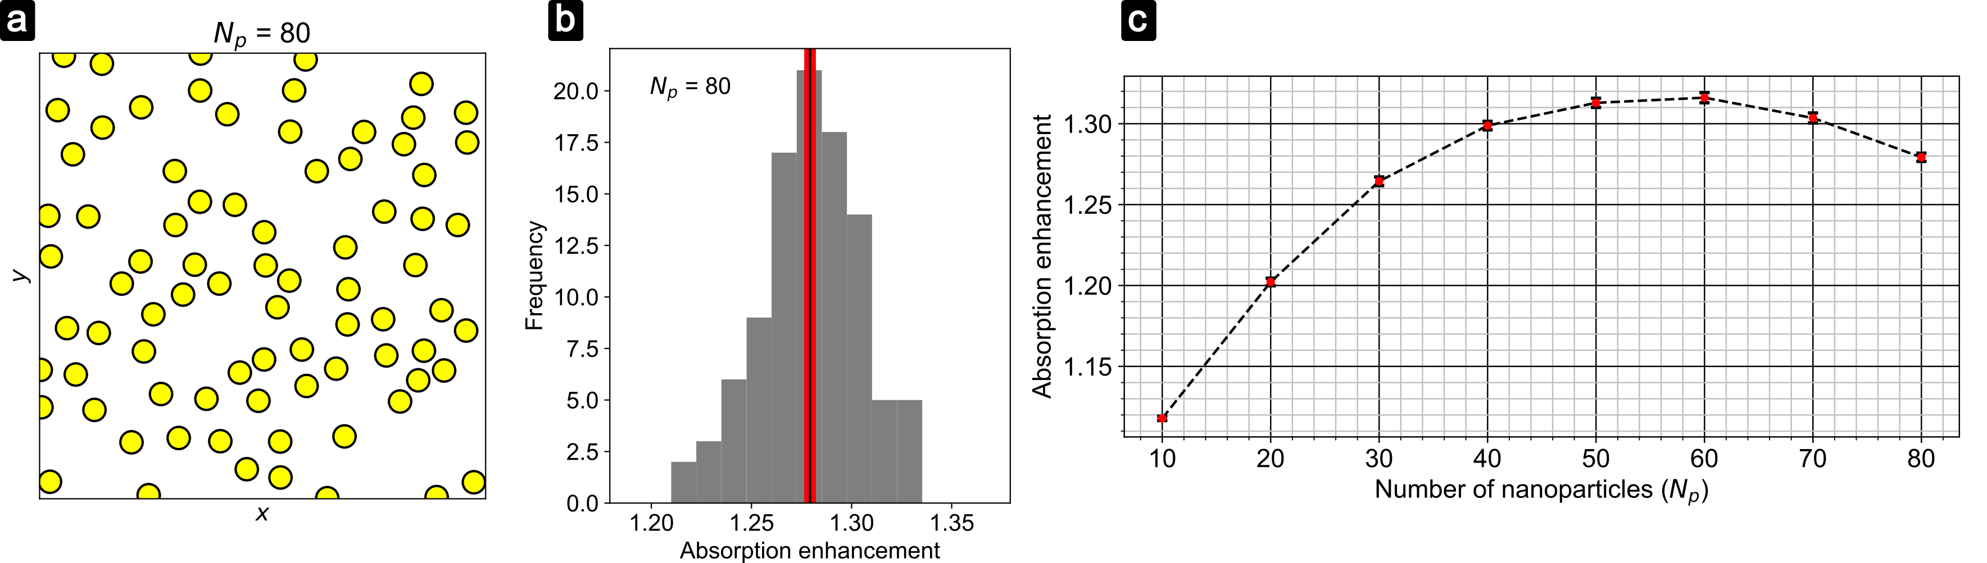
Figure 1. Absorption enhancement at λ = 550 nm in a 1 nm layer of MoS₂ sitting on top of a gold film (a) A typical cluster of 80 gold 100 nm nanoparticles randomly distributed over an area of 2 x 2 μm². (b) Absorption enhancement histogram obtained by simulating 100 randomly generated clusters. The vertical black line represents the ensemble mean, while the mean error is indicated by the red band. (c) Absorption enhancement (ensemble mean) as a function of the number of nanoparticles with A = 4 μm². The mean error is indicated by error bars which are hardly visible on this scale.
REFERENCES
[1] K. S. Novoselov, D. Jiang, F. Schedin, T. J. Booth, V. V. Khotkevich, S. V. Morozov, A. K. Geim, PNAS 102, 10451 (2005)
[2] D. Jariwala, A. R. Davoyan, J. Wong, H. A. Atwater, ACS Photonics 4, 2962 (2017)
[3] http://pv-waals.com
[4] SMUTHI Available: https://smuthi.readthedocs.io [Accessed June 22, 2021]
[5] Amos Egel: "Accurate optical simulation of disordered scattering layers for light extraction from organic light emitting diodes", Dissertation, Karlsruhe, DOI: 10.5445/IR/1000093961 (2018)

