Design and optimization of fiber-optic colorimetric probe based on ANN for estimating spectrum of color samples

B. Batinic¹, J. Bajic¹, M. Arbanas¹ and M. Vasiljevic Toskic¹
¹Faculty of technical sciences, University of Novi Sad,
Novi Sad, Serbia
e-mail: banebb@uns.ac.rs

A new, optimized colorimetric probe used for color estimation of printed samples obtained using digital printing is presented in this paper. Colorimetric probe is based on non-contact measurement of the intensity of light transmitted by optical fibers from light sources to a measuring point and then reflected to a photo-detector. ANN (Artificial Neural Networks) based algorithm is used in order to predict the shape of the spectral curve in the range of 380-730 nm with resolution of 10 nm [1].
Given that the way the light reflects depends on the texture and gloss of the surface, reflection can be roughly divided into two types: specular and diffuse reflection. The first one represents reflection from a smooth surface at a definite angle, and the second one from rough surfaces that tend to reflect light in a multitude of directions. Even though the law of reflection is completely valid in both cases, during the diffuse reflection the incident angle is changing as the beams of incident light hit the rough surface at different angles.
The proposed colorimetric probe [2] is designed to measure the color of printed samples obtained using digital printing, which was performed using calibrated Xerox Versant 80 Press machine. Identical 9x9 mm color patches were printed on matte and gloss coated white papers, according to the ISO Fogra Coated 39 profile.
Specular reflection can have significant impact in case of measuring gloss samples, since the specular light reflected from a gloss surface follows the same angle from the normal, as the incident light. Fig. 1a shows the previous design of the probe which was used to measure color on matte coated white paper. The probe consists of plastic optical fibers which transmit light from six discrete LED sources (arranged in a circle) whose wavelengths are equidistantly distributed within the visible range to color patches and returns the reflected part of the light from the color patches to a single wideband photo-detector positioned in a center of the probe [2]. All LED sources, as well as the photo-detector, are perpendicular to the illuminated surface, therefore the reflected light returns at the same angle as the incident light. This set-up is not suitable for measurement on gloss coated paper since it would cause a mirror-like reflection of light from the surface. Furthermore, since the used LED sources are discrete components without heatsinks, the temperature effect should be taken into account. By increasing the temperature, peak wavelengths shift to longer wavelength [3,4]. Instead of the aforementioned limited concept, a new colorimetric probe with implemented geometry 45/0 and integrated LED sources with common heatsink (Fig. 1b), optimized for measurement on both matte and gloss coated paper will be presented in this paper.

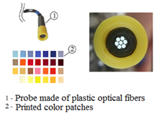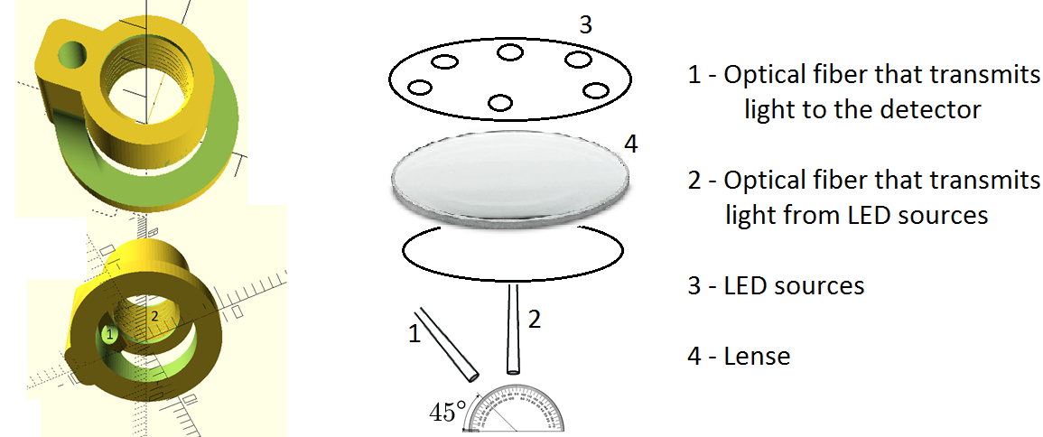
Figure 1a) Basic concept of colorimetric probe designed in our previous work [1] | Figure 1b) Proposed colorimetric probe design with implemented geometry 45/0
REFERENCES
[1] Batinic, B.; Arbanas, M.; Bajic, J.; Dedijer, S.; Rajs, V.; Lakovic, N.; Kulundzic, N. (2020). Using machine learning for improvement of reflected spectrum estimations of colorimetric probe. IEEE Transactions on Instrumentation and Measurement, (), 1–1. doi:10.1109/TIM.2020.3011763
[2] Batinic, B.; Bajic, J.; Dedijer, S.; Kulundzic, N.; Joza, A.; Lakovic, N.; Rajs, V. (2020). Colorimetric fiber-optic sensor based on reflectance spectrum estimation for determining color of printed samples. Optical and Quantum Electronics, 52(7), 342–. doi:10.1007/s11082-020-02458-7.
[3] Yadav, A.; Titkov, I. E.; Sokolovskii, G. S.; Karpov, S. Y.; Dudelev, V. V.; Soboleva, K. K.; Strassburg, M.; Pietzonka, I.; Lugauer, H-J.; Rafailov, E. U. (2018). Temperature effects on optical properties and efficiency of red AlGaInP-based light emitting diodes under high current pulse pumping. Journal of Applied Physics, 124(1), 013103–. doi:10.1063/1.5020266
[4] Reynolds, K. J.; De Kock, J. P.; Tarassenko, L.; Moyle, J. T. B. (1991). Temperature Dependence Of Led And Its Theoretical Effect On Pulse Oximetry. BJA: British Journal of Anaesthesia, 67(5), 638–643. doi:10.1093/bja/67.5.638

