Thermoresponsive, biocompatible hydrogels for rapid prototyping of biomimetic microchannels

M. Radmilović¹, B. Murić¹ , D. Grujić¹, B.Zarkov², M. Nenadić³ and D. Pantelić¹
¹Institute of Physics, Belgrade, Serbia
²Directorate for Measure and Precious Metals, Mike Alasa 14, 11000 Belgrade, Serbia
³Institute for Biological Research "Siniša Stanković" National Institute of Republic of Serbia, University of Belgrade, Serbia
e-mail: mihajlo.radmilovic@ipb.ac.rs

Single-step prototyping of biophotonic structures that effectively mimic tissue microchannels is a complex task. A wide range of techniques is used for microchannel fabrication such as photolithography, silicon molding, etc. [1] However these techniques possess a high degree of manufacturing complexity and cost [1, 2].

We present technology that is based on locally melted nontoxic, environmentally friendly gels, and a homemade laser writing system. Microchannels are fabricated by local laser irradiation and spatial control is obtained using coordinate stage. The physical properties of microchannels are determined by: gels absorbance, surface tension and laser energy density.

Several in vitro assays were performed to establish biocompatibility of the gel materials. In vitro studies on the spontaneously immortalized human keratinocytes (HaCaT) cell line showed that the tested material had no toxic effect. Likewise, different ATCC (American Type Culture Collection) and resistant strains of pathogenic bacteria and micromycetes were cultivated. After application of the tested materials no inhibition of bacterial colonies and micromycetes growth was observed.

As a proof of concept, applicability of biomimetic microchannels (BM) was tested using a digital image of a human retinal blood vessels. Digital model is then translated to the set of G-code coordinates and imprinted in gel material by laser writing.

BM has significant potential for a wide range of applications such as noninvasive medical diagnostic, biomedical testing, security, etc. Here we suggest a retinal vascular model to study blood flow in different pathophysiological conditions. Moreover, our gel based material can be used for fast and efficient fabrication of BM and also for micro-optical components generation [3].
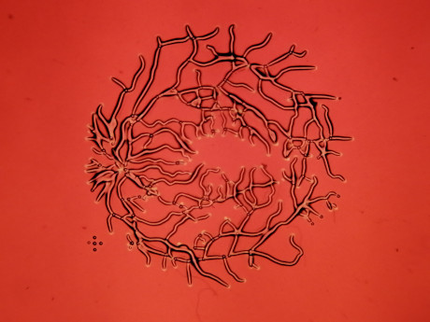

Figure 1. Biomimetic model of human retina blood vessels.
REFERENCES
[1] P. Ghassemi, J. Wang, A. Melchiorri, J. Biomed. Opt. 20, 121312 (2015).
[2] R.Long, T.King, T.Aki, Biomed. Opt. Exp. 2, 1887 (2011)
[3] B.Murić, D.Pantelić, D.Vasiljević, Appl. Opt. 46 8527 (2007)

