Direct laser writing waveguides in CR-39 polymer

S. Gündogdu^{1,2,3}, and T. Schröder^{1,2}
¹Department of Physics,
Humboldt-Universität zu Berlin, Berlin, Germany
²Ferdinand Braun Institut, Berlin, Germany
³Center for Theoretical Physics of Complex Systems,
Institute for Basic Science, Daejeon, South Korea

e-mail: sinang@physik.hu-berlin.de

We present a simulation model for laser writing waveguides into a bulk polymer using a low-power UV laser. CR-39, an organic polymer commonly used as a lens material, is transparent to visible light and has a small extinction coefficient in the ultraviolet spectral range (k~0.004 at 400 nm). Its refractive index and ultraviolet extinction coefficient, however, increase when thermally heated. Previous experiments involving oven annealing showed an up to 10% refractive index change at 600 nm [1]. Such an intrinsic index change can be optically explored, making CR-39 an interesting candidate as a direct laser writing medium. To model the induced refractive index change under laser illumination, we use the Arrhenius equation for the rate with which the absorption coefficient changes for a moving Gaussian beam as a heat source. We calculate the refractive index profiles of the annealed zones using finite element methods. Our simulations show the feasibility of writing 3D embedded waveguides with a CW laser in contrast to high-power pulsed lasers that are commonly used in laser writing. At high laser powers, catastrophic instabilities can occur. We discuss a stabilization mechanism which may prevent instability and enable even higher index contrasts. This platform could offer a low-cost alternative to femtosecond laser writing techniques [2].

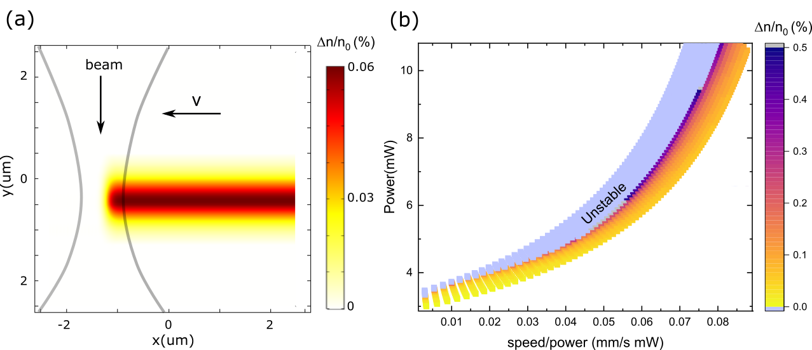
Fig.1 (a) Simulated steady-state change of refractive index of CR-39 due to a moving Gaussian laser beam. (b) Change of refractive index as a function of laser power and writing speed/power ratio for a 410 nm beam with a numerical aperture of 0.5.

REFERENCES
[1] V. Kumar and P. K. Goyal and S. Mahendia and R. Gupta and T. Sharma and S. Kumar, Radiation Effects and Defects in Solids 166, 109-113 (2011).
[2] K. M. Davis, K. Miura, N. Sugimoto, and K. Hirao, Optics Letters 21, 1729-1731 (1996).

