How to create 2D magnets from non-magnetic 2D crystals

S. Stavrić^{1,2}, B. N. Šoškić³ and Ž. Šljivančanin²
¹Physics Department, University of Trieste, via A. Valerio 2, Trieste 34127, Italy
²Vinča Institute of Nuclear Sciences, National Institute of the Republic of Serbia,
University of Belgrade, P.O. Box 522, RS-11001 Belgrade, Serbia
³Faculty of Natural Sciences and Mathematics, University of Montenegro,
Džordža Vašingtona bb, 81000 Podgorica, Montenegro
e-mail: stavric@vinca.rs

The introduction of point defects offers manifold possibilities to induce a magnetic response in intrinsically non-magnetic two-dimensional (2D) materials. In graphene, the presence of vacancies leads to notable paramagnetism, yet no long-range magnetic ordering has been experimentally achieved due to low defect concentration. Another approach to induce magnetism in 2D crystals is to adsorb magnetic transition metal atoms. However, when deposited on graphene, transition metal atoms tend to cluster due to strong metal-metal attraction [1], making it challenging to control the shape and size of obtained nanostructures and their magnetic properties. One route to suppress the unfavorable clusterization is to attach the metal adatoms to the vacancies, acting as the trapping sites. The embedded metal atoms might carry out non-zero magnetic moments, yet the random distribution of these defects across the 2D sheet makes the long-range ordering of localized magnetic moments highly unlikely. In this lecture, we show that with the use of borophene, a 2D boron crystal recently synthesized on Ag(111) substrate, these obstacles can be overcome [2]. Borophene, unlike graphene, possesses a regular pattern of hexagonal holes which can be used as a template to grow 2D magnets when filled with Fe atoms. We show that the obtained Fe nanostructures are composed of close-packed Fe wires featuring ferromagnetism within the chain and the inter-chain antiferromagnetic coupling. Using density functional theory calculations, we extract the exchange and single-ion anisotropy constants needed to describe the magnetic properties of these systems with the classical Ising and Heisenberg models. The corresponding Monte Carlo simulations revealed finite temperature magnetic ordering, with the estimates of critical temperatures of 105 K and 30 K derived from the anisotropic Heisenberg model, for the Fe-based magnets grown above and under the borophene.

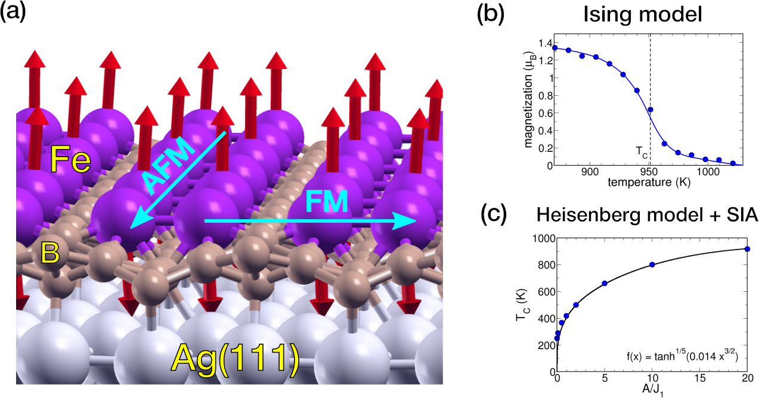

Figure 1. 2D magnet made from Fe wires grown above borophene/Ag(111) (a) and the critical temperatures
obtained from Monte Carlo simulations employing Ising (b) and anisotropic Heisenberg model (c).
REFERENCES
[1] S. Stavrić, M. Belić, Ž. Šljivančanin, Carbon 96, 216 (2016)
[2] B. N. Šoškić, S. Stavrić, Ž. Šljivančanin, accepted for publishing in Phys. Rev. Materials (2021)
Biography

Srdjan Stavrić is the Assistant Professor at the Vinča Institute in Belgrade after obtaining Ph.D. in computational condensed matter physics from the Faculty of Physics, University of Belgrade. SS is currently carrying research as a postdoctoral fellow at the Physics Department, University of Trieste. SS’s main expertise are first-principles simulations of structural, electronic, and magnetic properties of two-dimensional materials, surfaces, and metallic nanostructures deposited on them. His current work focuses on the modulation of reactivity of metal surfaces under a graphene cape. SS is particularly interested in magnetic properties of systems with reduced dimensionality, such as magnetic anisotropy of metallic clusters and wires deposited at surfaces as well as magnetism of 2D materials.

