Proposal for realizing quantum scars in the
tilted 1D Fermi-Hubbard model

J.-Y. Desaules¹, A. Hudomal^{1,2}, C. J. Turner¹, Z. Papić¹
¹School of Physics and Astronomy, University of Leeds, United Kingdom
²Institute of Physics Belgrade, University of Belgrade, Serbia
e-mail:ana.hudomal@ipb.ac.rs

Understanding how closed many-body quantum systems evolve in time when taken out of their equilibrium state is an active field of research. While many such systems rapidly return to their equilibrium state, in accordance with fundamental principles of quantum statistical mechanics, much of recent work has focused on systems that fail to do so as a consequence of ergodicity breaking. The inability of nonergodic systems to act as heat reservoirs for their smaller parts has been traditionally known to affect the entire spectrum of the system. However, there has been a flurry of interest in weak ergodicity breaking phenomena. The latter refers to the emergence of a dynamically decoupled subspace within the many-body Hilbert space, in general without any underlying symmetry, spanned by ergodicity-breaking eigenstates. In recent experiments on interacting Rydberg atom arrays, weak ergodicity breaking was observed via persistent revivals following the global quench of the system, prompting the name “quantum many-body scarring” by analogy with the phenomenon of quantum scars in single-particle system.

Motivated by recent observations of ergodicity breaking due to Hilbert space fragmentation in 1D Fermi-Hubbard chains with a tilted potential [1], we show that the same system also hosts quantum many-body scars in a regime U≈Δ≫J at electronic filling factor ν=1 [2]. We numerically demonstrate that the scarring phenomenology in this model is similar to other known realizations such as Rydberg atom chains, including persistent dynamical revivals and ergodicity-breaking many-body eigenstates. At the same time, we show that the mechanism of scarring in the Fermi-Hubbard model is different from other examples in the literature: the scars originate from a subgraph, representing a free spin-1 paramagnet, which is weakly connected to the rest of the Hamiltonian’s adjacency graph. Our work demonstrates that correlated fermions in tilted optical lattices provide a platform for understanding the interplay of many-body scarring and other forms of ergodicity breaking, such as localization and Hilbert space fragmentation.
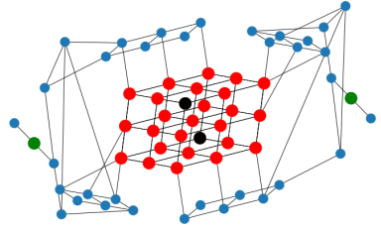
Figure 1. Adjacency graph of the effective model.

REFERENCES
[1] S. Scherg et al., arXiv:2010.12965 (2020).
[2] J.-Y. Desaules, A. Hudomal, C. J. Turner, Z. Papić, Phys. Rev. Lett. 126, 210601 (2021).

