Sulphur concentration influence on morphology and optical properties of MoS₂ monolayers
A.Senkic^{1,2,3}, A.Supina^{1,2,3} , J.Bajo⁴, V. Jadrisko^{1,3}, B. Radatovic^{1,3} and N. Vujicic^{1,3}
¹Institute of Physics, Zagreb, Croatia
²Department of Physics, University of Rijeka, Rijeka, Croatia
³Center of Excellence for Advanced Materials and Sensing Devices, Institute of Physics, Zagreb, Croatia
⁴Department of Applied Physics, KTH Royal Institute of Technology, Stockholm, Sweden
e-mail: asenkic@ifs.hr

MoS₂ in its two-dimensional (2D) form is one of the most studied materials in the last decade due to its promising applications in semiconducting industry (photosensors [1], optoelectronics [1], photovoltaics [1] etc.). One of the main approaches in synthesis of semiconducting 2D materials is chemical vapour deposition (CVD) technique, schematically shown in Fig. 1. In this work we have systematically investigated how synthesis parameters (growth temperature T_{G}, sulphur temperaure T_{S} and carrier gas flow) influence sample quality. As a result, correlation between synthesis parameters and sample's morphology and optical response were obtained.
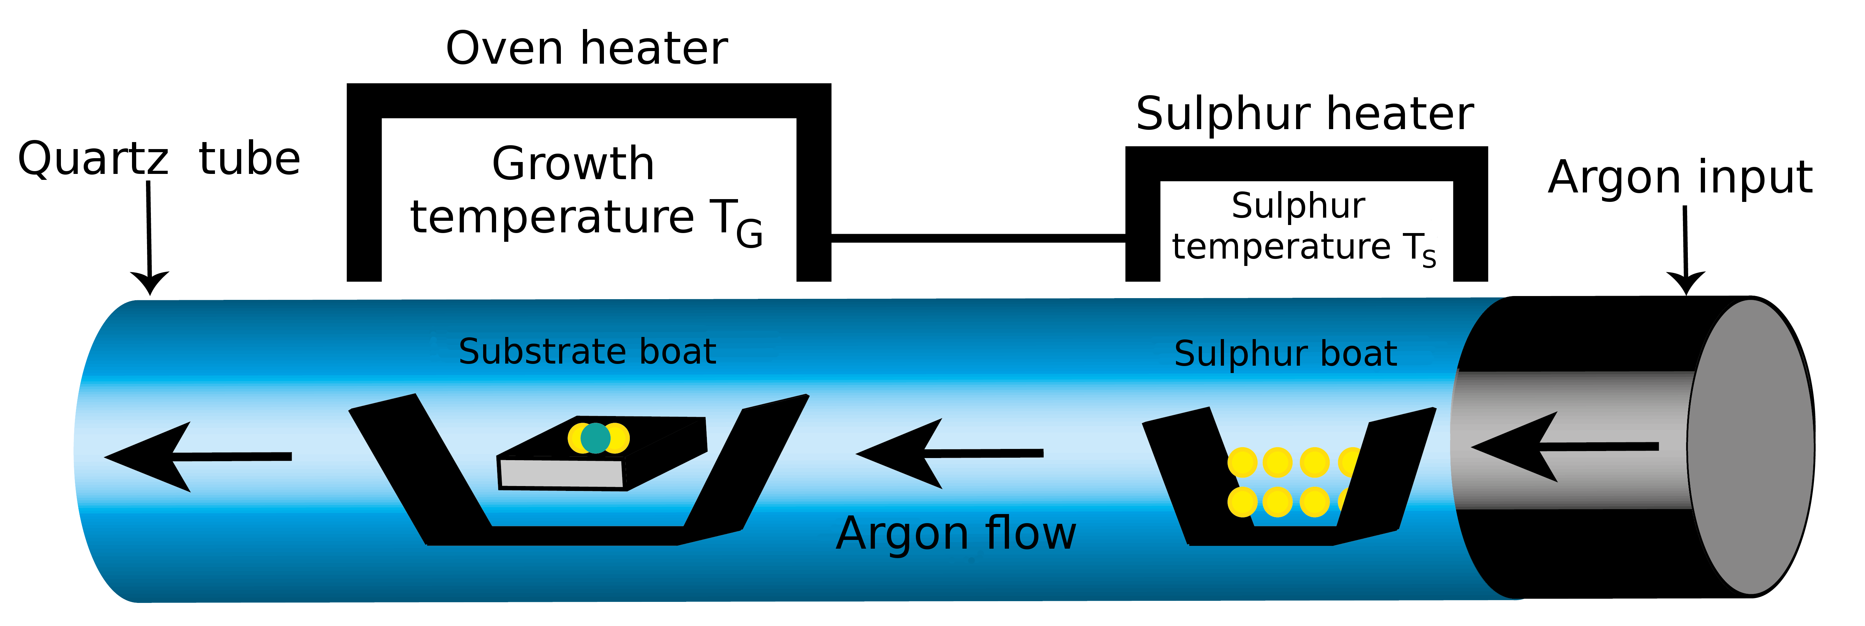
Figure 1. Schematic illustration for the CVD setup.
By changing mentioned synthesis parameters, the Mo:S ratio was consistently tuned which, in turn, modified both morphology and optical response of the sample (Fig. 2). As the ratio is approaching to the ideal value of 1:2, the morphology of samples becomes more symmetric, triangular with even edges while the PL and Raman spectra intensities for given sample increase. If the sulphur concentration is increased compared to the ideal stoichiometric ratio, the samples become dendritic with uneven edges and optical response is poor. On the other hand, if the molybdenum concentration is increased by increasing T_{G} vertical growth is preferred rather than lateral, and bilayers or multiple-layered islands are formed.
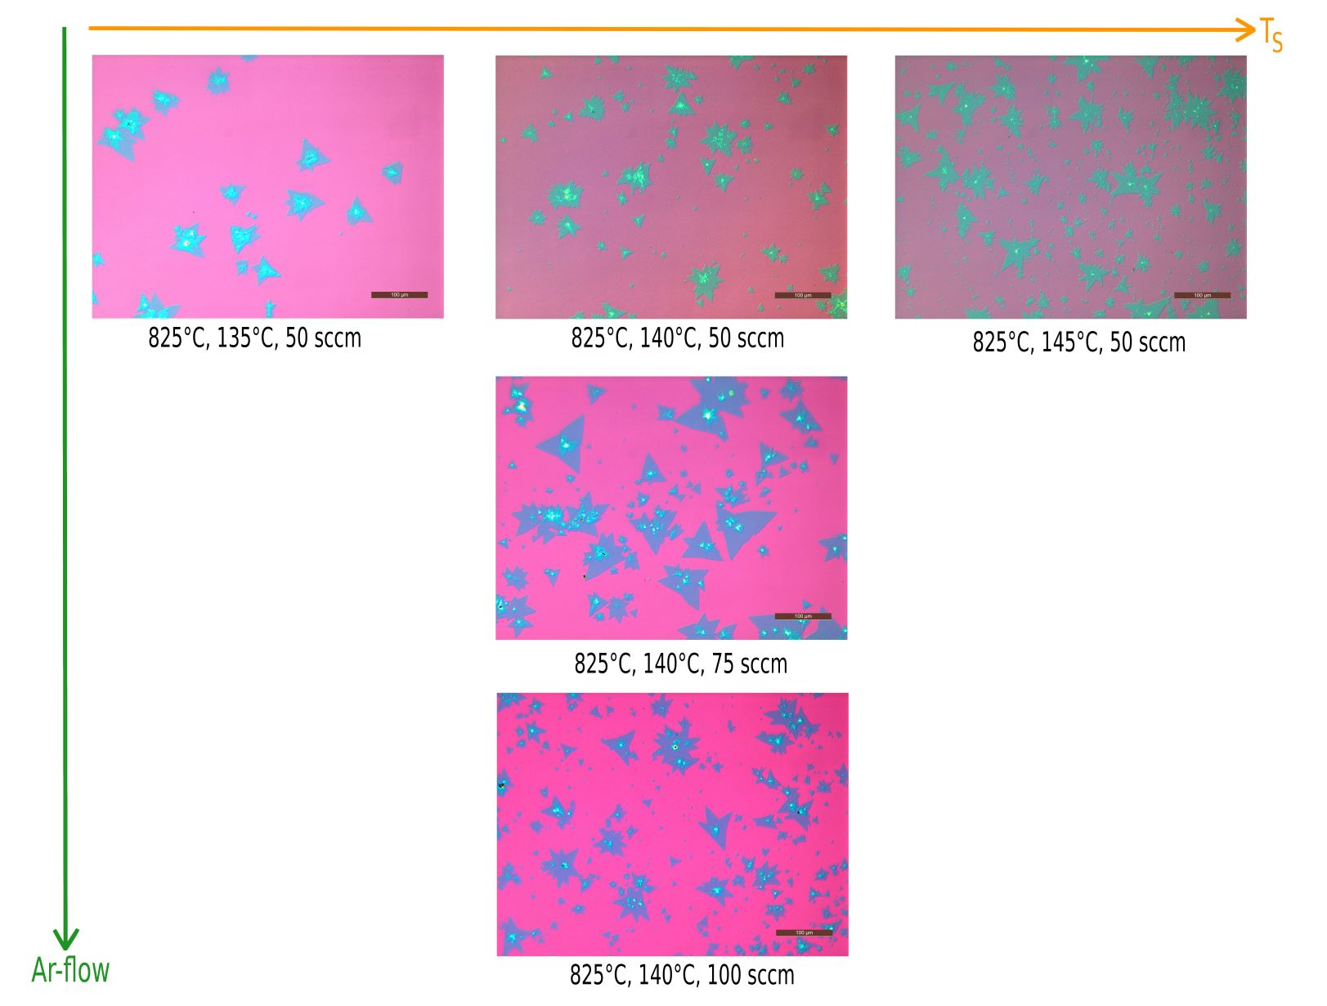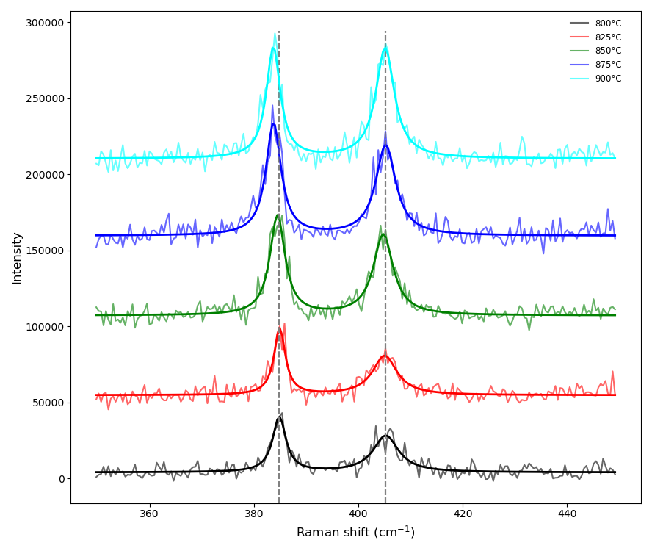
Figure 2: Left: Morphological evolution of CVD grown MoS₂ islands. Given synthesis parameters are in following order: growth temperature, sulphur temperature, argon flow. Scale bar is 100 μm. Middle: Evolution of photoluminescence spectra of MoS₂ islands. Solid black lines represent non-linear fit using two Lorentzian functions. Right: Raman spectra of samples made at different growth temperatures. Sulphur temperature is 140°C and argon flow 75 sccm. Solid lines represent non-linear fit using two Lorentzian functions. Vertical grey lines are only eye-guides.
Raman spectra of samples grown at different T_{G} (800-900°C) are shown on the right side of Fig. 2. The difference between centers of these two Raman modes increases with the growth temperature increase [2]. One possible explanation for this behavior is increased induced tensile strain resulting from the high-temperature growth process. Complementary structural characterization by atomic force microscope (AFM) and scanning electron microscope (SEM) were used to determine existence of grain boundaries and cracks in crystal basal plane, showing that optimization of synthesis parameters leads to high-quality crystal morphology. Our further work will focus on exploring the optical properties of crystals in low-temperature limit.
REFERENCES
[1] Q.H. Wang, K. Kalantar-Zadeh, A. Kis et al. Nature Nanotech 7, 699-712 (2012).
[2] Zusong Zhu et al. Mater. Res. Express 6 095011 (2019).

