**2D silver-bismuth-iodide rudorffite nanomaterials for photovoltaic devices: a novel route for chemical synthesis of Ag3BiI6 nanosheets**

Danijela Danilović1*, Dušan K. Božanić1, Aleksandar R. Milosavljević2, Radovan Dojčilović1, Dragana Tošić1, Vladimir Djoković1, Pitambar Sapkota3, Sylwia Ptasinska3, Nenad Vukmirović4

*1Vinca Institute of Nuclear Sciences, University of Belgrade, P.O. Box 522, 11001 Belgrade, Serbia*

*2 Synchrotron SOLEIL, l’Orme des Merisiers, St.Aubin, BP48, 91192 Gif sur Yvette Cedex, France*

*3Radiation Laboratory and Department of Physics, University of Notre Dame, Notre Dame, Indiana 46556, United States*

*4 Institute of Physics Belgrade, University of Belgrade, Pregrevica 118, 11080 Belgrade, Serbia*

*e-mail:* [*danijeladanilovic92@gmail.com*](mailto:danijeladanilovic92@gmail.com)

Silver-bismuth-iodide (Ag-Bi-I) rudorffite hybrid materials have gained an immense interest in the research for a lead-free, chemically stable and low-cost absorber material in photovoltaic devices [1]. These materials can be fabricated in the form of macroscopic crystals or as thin films, in which case they can be integrated into solar cells that show good photoconversion efficiency [2]. Fabricating Ag-Bi-I in nanocrystal form could facilitate further their integration in the photovoltaic devices and enhance device performance due to size confinement effects. In our previous study, we successfully fabricated ligand-free Ag3BiI6 nanoparticles in the form of aerosols [3]. Here, we report on the fabrication procedure of 2D Ag-Bi-I nanomaterials in the colloidal form. The results of the structural and morphological investigation of the nanosheets will be presented, as well as reconstruction of the electronic levels of the Ag3BiI6 nanoparticles from the combined UV-vis absorption and X-ray photoelectron spectroscopy data. In addition, an analysis that shows the relation between the positions of the bands in the Ag3BiI6 nanosheet absorption spectra and the thickness of the nanosheet will be discussed.

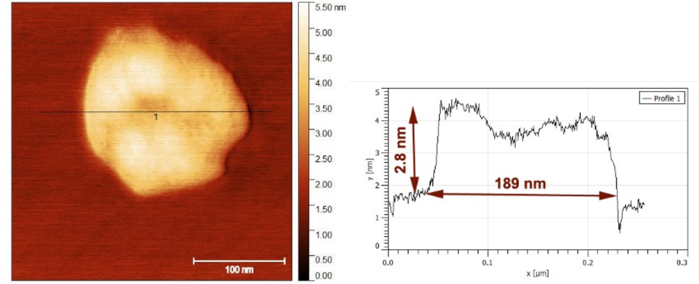

Figure 1. AFM image (left) and corresponding height profile (right) of Ag-Bi-I nanosheets

REFERENCES

[1] Kim, Y., Yang, Z., Jain, A., Voznyy, O… Angew Chem. Int. Ed. **55**, 9586 (2016).

[2] Turkevych, I., Kazaoui, S., Ito, E… ChemSusChem **10**, 3754 (2017).

[3] Danilović, D., Božanić, D. K., Dojčilović… J. Phys. Chem. C **124**, 23930 (2020).