Microspectroscopy and adaptive laser tools for fluorescence based retinal tissue diagnostics and therapy

R. Podlipec^{1,2}, Z. Arsov¹, I. Urbančič¹, T. Koklič¹, J. Mur³, R. Petkovšek³, J. Štrancar¹
¹ Laboratory of Biophysics, Condensed Matter Physics Department, Jožef Stefan Institute, Ljubljana, Slovenia
² Helmholtz-Zentrum Dresden-Rossendorf e.V., Ion Beam Center, Dresden, Germany
³ Faculty of Mechanical Engineering, University of Ljubljana, Ljubljana, Slovenia
e-mail: rok.podlipec@ijs.si

New autofluorescence-based imaging and spectroscopy techniques have been found particularly useful for many diagnostics applications in ophthalmology due to their molecular sensitivity and non-invasiveness. Besides improved diagnostics, the ultimate goal in this field for the coming years presents also an improved and automated laser-induced therapy coupled with the recognition of pathologies by highly resolved imaging using reliable algorithms for image processing. In our talk, we will present two of our recent studies focused on the applications of advanced microspectroscopy and adaptive laser approaches for detailed retinal pathology diagnostics and treatment based on tissue autofluorescence detection and image analysis.
By fluorescence hyperspectral imaging of whole fresh ex-vivo porcine eyes exposed to laser treatment inducing rupture of the retinal vessel to mimic blood leakage, we characterized blood coagulation dynamics in relation to oxygenation and found new insights into the active role of erythrocytes in the coagulation cascade (Figure 1A) [1]. This study was important within the scope of an early diagnosis and better understanding of blood leakage and coagulation mechanisms which are the key to prevent critical illness of e.g. diabetic retinopathy. The disease can cause visual loss and affects 80 percent of those with diabetes for more than 20 years and it progresses through vessel leakage, abnormal vessel growth and is accompanied by coagulation disorders. Another severe eye disease causing the visual loss is age-related macular degeneration (AMD). It is commonly treated by short laser pulses inducing thermal and mechanical stress that can as well cause unwanted damage to the surrounding retinal tissue. To properly adapt the laser treatment to minimize side effects, real-time controlled diagnostics and therapy should be applied. In our latest study, we show a new smart approach for real-time retinal theranostics based on tissue fluorescence lifetime information and adaptable pulsed laser therapy (Figure 1B).

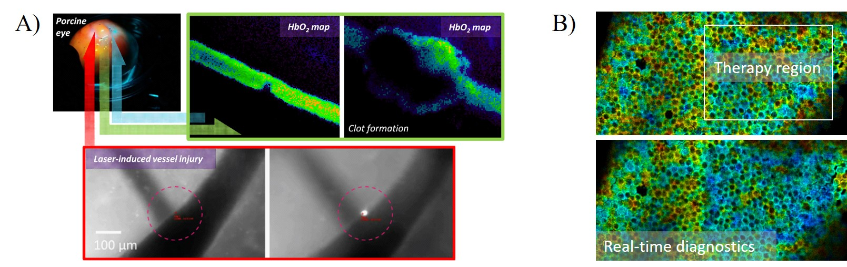
Figure 1. A) real-time fluorescence hyperspectral monitoring of blood coagulation in intact retinal vessels; B) real-time fluorescence lifetime based diagnostics of retinal tissue therapy

REFERENCES
[1] R. Podlipec, Z. Arsov, T. Koklič, J. Štrancar, Journal. of Biophotonics, e202000021 (2020).

