Dynamic interference of photoelectrons at multiphoton ionization of atoms by short laser pulses

A. Bunjac, D. B. Popović and N. S. Simonović
Institute of Physics, Belgrade, Serbia
e-mail:simonovic@ipb.ac.rs

The dynamics of atomic levels resonantly coupled by an intense short laser pulse is studied by calculating numerically the time-dependent amplitudes for the populations of atomic states (both discrete and continuum) [1, 2]. Here we consider the resonant multiphoton ionization of atoms which can be described within the single active electron approximation (hydrogen, alkali), studied earlier using other methods [3, 4]. It is demonstrated that the laser pulse gives rise to two wave packets emitted with a time delay with respect to each other (at the rising and falling sides of the pulse) which interfere in the time domain (see Fig. 1). The interference effects are observed in the energy spectrum and momentum distribution of photoelectrons.

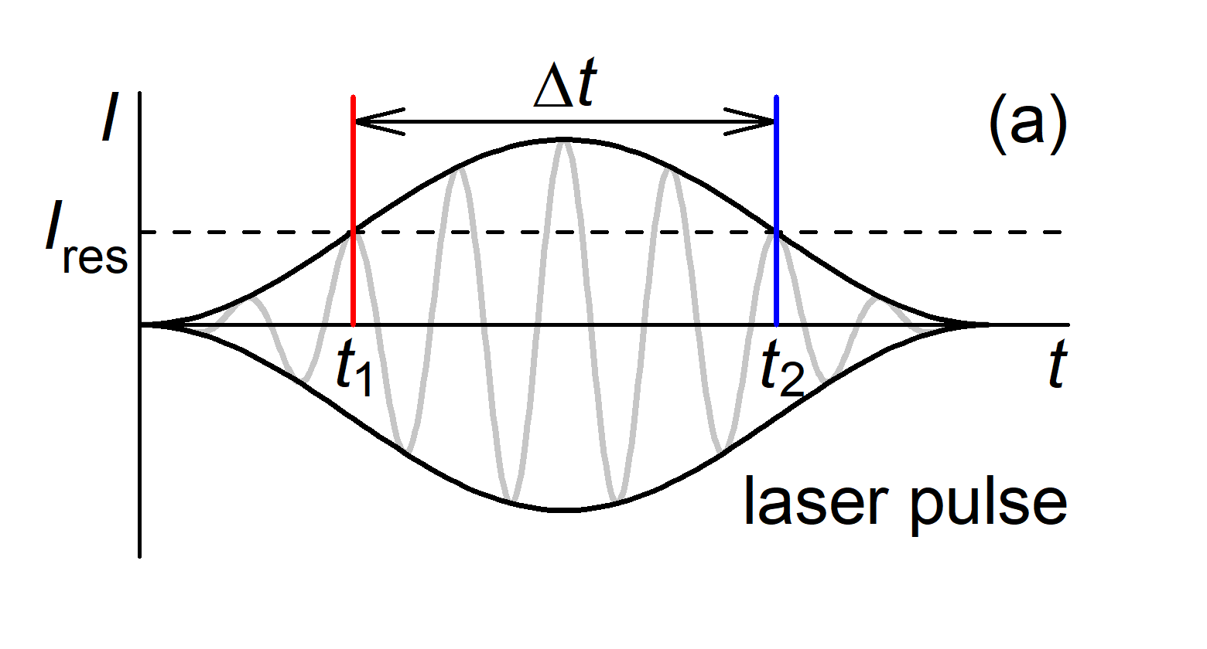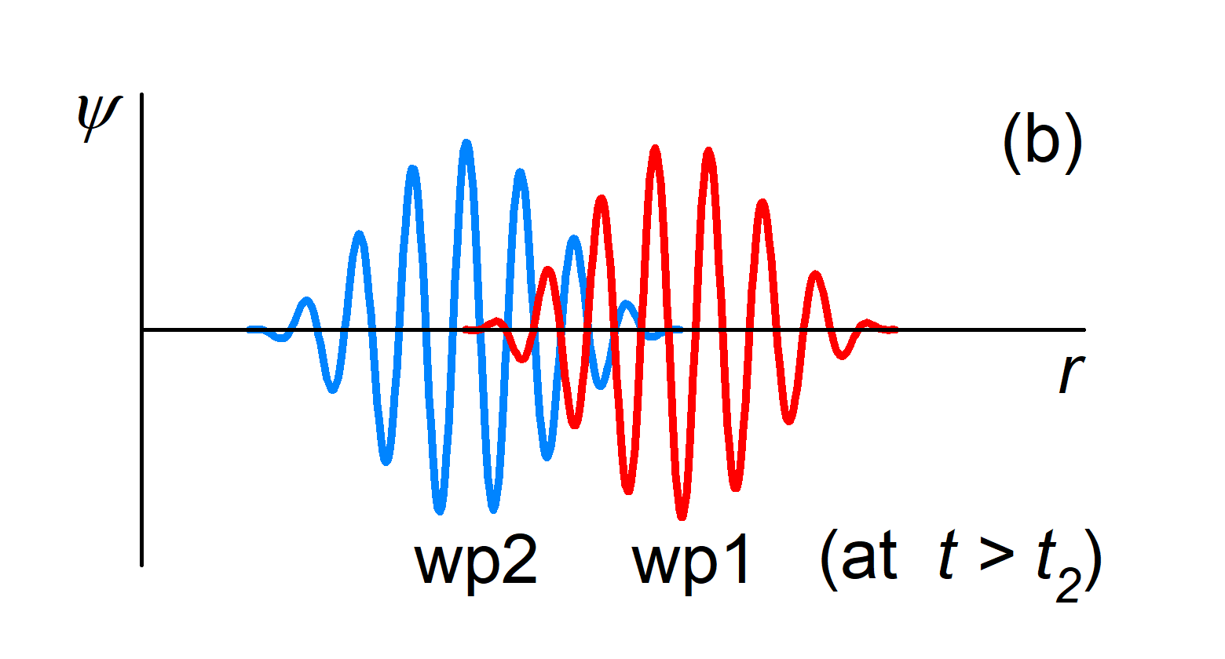

Figure 1. (a) If the intensity I of applied laser field varies, an atomic state can (due to the dynamic Stark shift) transiently shift into resonance, that ocurrs two times during the pulse (at t₁ and t₂ when I = I_{res}). (b) Then the photoelectrons emitted at the rising and falling sides of the pulse (electron wave packets wp1 and wp2, respectively) interfere due to a time delay Δt = t₂ – t₁.

REFERENCES
[1] P. V. Demekhin and L. S. Cederbaum, Phys. Rev. A 83, 023422 (2011).
[2] P. V. Demekhin and L. S. Cederbaum, Phys. Rev. A 86, 063412 (2012).
[3] A. Bunjac, D. B. Popović and N. S. Simonović, Phys. Chem. Chem. Phys. 19, 19829 (2017).
[4] A. Bunjac, D. B. Popović and N. S. Simonović, Phys. Lett. A 394, 127197 (2021).

